What do you think of our project? | 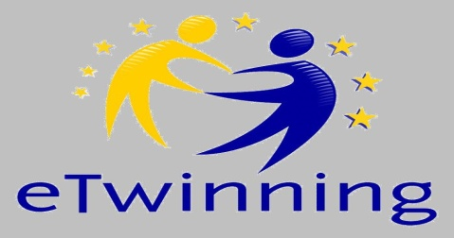

Hi! This year you joined an eTwinning Project working with pupils from different European Countries and carrying out a lot of different activities and tasks. We would like to know if you liked it, So, please, could you answer the questions of the following questionnaire? It could help your teacher to even better plan the next year project. Thanks a lot for your help!
18 students took part

- How much did you like the following activities?

Exchanging letters to speak about you and your country | 16 | 2
Exchanging Christmas Cards | 18
Christmas Multimedia Presentation | 14 | 3 | 1
Traditional dishes: making posters | 10 | 8
Traditional dishes: cooking at school | 18
Sending Easter cards and parcels | 18

1.b. Generally speaking, what did you like most?

Searching for information to share/post |  | 9 | 5 | 4
Making posters |  | 10 | 8
Making Power Point Presentations |  | 15 | 3
Making videos | 4 | 18
Making photos |  | 18
Working with my class-mates | 6 | 16 | 2
Getting to know different countries | 5 | 18
Getting to know different cultures |  | 18
Receiving parcels | 1 | 18
Sending parcels to friends | 2 | 18
Looking at my friends’ reaction while opening my parcel | 3 | 18

- And … which one did you like best? Color it with red in the list above.

- Why the activity you have coloured with red was your favourite? Choose and circle 3 of the following words/sentences:

interesting (2) – engaging (8) – fun (4) - allowed me to learn many new things (6) – allowed me to work in group with my friends (5) – allowed me to get to know new friends (1) – allowed me to get to know new cultures and languages (3) – I had the chance to speak and improve English (7) – I had the chance to use ICT (9)

(you can also add some words here --------------------------------------------------------)

- What did you learn during these activities? Circle 3 of them

- More English words
- More English structures
- How to write a letter/ a card
- How to do researches using internet
- How to use the camera
- How to make Power Point Presentations /Videos
- How to cook different dishes
- More about some countries in Europe
- More about different traditions and Festivals all around Europe
- More about different European Cultures and Languages
- That learning could be very fun when we work all together

- Can you shortly write what you most fixed in your mind?

The activities that the students enjoyed the most were the ones they could actively participate, especially by making or watching videos. They were thrilled to watch students from other countries at their age present new information or open a parcel.

- Did you find any difficulty to understand your friends’ work?
16

NO
2
YES

- If you answered YES, why? Circle with red the most appropriate answer/s (from 1 to 3).

- English words were sometimes difficult
- English structures were sometimes difficult
- My partners’ pronunciation was sometimes difficult
- Sometimes there were many mistakes
- The topic was difficult to understand
- The task was difficult to do

- Did you find any other difficulty along the course of the project?

NO
16

2
YES

- If you answered YES, why? Circle with red the most appropriate answer/s (from 1 to 3).

- I was worried to do mistakes
- It was difficult to say what I wanted to in English
- Some topics bothered me
- I can’t use the computer at home
- I can’t use internet at home
- I’m not very good at using ICT
- There was too many information to keep in mind
- I do not like working in group
- I do not like talking about myself

Thanks a lot for having filled the questionnaire!

