The Queen of Serpents and the Mythical Doctor
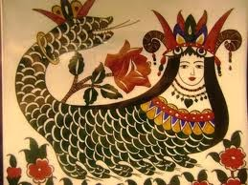
Simin Uysal
"Once upon a time, there was a young man named Tahmasp who fell into a well and accidentally passed to an underground cave and fell asleep in despair. When he opened his eyes, he found himself surrounded by many snakes. Feeling terrified, he closed his eyes and prayed this to be a dream. When he gathered his courage and opened his eyes, he saw a beautiful woman, in the form of half woman and half snake. She was Shahmaran, the Queen of Snakes, who knew many secrets of the history of mankind, had eternal life and deep wisdom.
Shahmaran takes the young man as a guest, feeling scared that he would tell her place to humans. She tells him stories about the history of mankind day after day for years which he greatly enjoys. They fall in love but one day, when she has no more stories to tell, the young man wishes to return to his parents. Shahmaran releases him upon one condition. He would not tell anyone where she is living. She also advises him not to bathe in the presence of others otherwise his secret would be revealed because his skin would turn into snakeskin, covered with scales. He accepts and returns to parents.
He keeps his secret for many years until one day the sultan of his country becomes very sick. His vizier insists that the only cure is eating the flesh of Shahmaran and sends soldiers around the country searching for the person who knows her place. The vizier is a very ambitious man who does not really care about the sultan but wants to acquire the secrets of the world and long life through eating Shahmaran's flesh. A wise man advises that people be ordered to go into water or baths in groups so the one who knows Shahmaran's place will be caught. Tahmasp is caught and has to reveal Shahmaran's place when he is forced to get into water by the soldiers where his skin gets covered with snake scales which is a sign that he had seen her.
Shahmaran is captured and brought to sultan's palace where they see each other with Tahmasp again. She consoles her lover who is feeling very guilty and ashamed for revealing her secret. She has a secret plan for passing her wisdom and secrets to her lover and announces that whoever eats from her tail will acquire all her secrets and wisdom, the one who eats from her body will be healed and whoever eats from her head will die instantly. Upon hearing her words, the vizier chops her into three pieces with his sword and orders the pieces be cooked immediately. When the meat is cooked, the greedy vizier eats from the tail, Tahmasp who is feeling guilty and ashamed eats a piece from her head so he could die, too and the sultan eats from the body. Shahmaran's wise plan works and the greedy vizier dies instantly, the sultan is healed and Tahmasp acquires all the secrets and wisdom of Shahmaran and becomes the Lokman Hekim, the mythical doctor and pharmacist to whom the plants and trees sing and talk revealing their medicine."
Shahmaran is the only symbol which is widespread in all parts of Anatolia. Her pictures are hung on the bedroom walls of young girls and women especially in south and southeastern regions. One can find it rather surprising to see the survival of Shahmaran who has an identity resembling a mother goddess in a shamanistic form in the folklore and belief system of Turco Muslims of Anatolia until today. I believe this is due to a number of reasons: First of all, she could easily be merged with the Mother Goddess cult of Anatolia, something which has been widespread throughout the geography for thousands of years. When we turn to Persia, for example, where the story is also told, we see Shahmaran depicted as a male figure. Secondly, the half human half snake figure has an important place in the mythologies of Turkic tribes. The males are called Erbüke, while the females are called as İşbüke and they are ruled by the Mother Snake, a goddess who lives in the underworld and knows the secrets of everything.
I came across this well known story after having an interesting dream where I was served the cooked meat of a snake, seasoned with herbs. It was the most delicious meal I had and the taste lingered in my mouth for weeks. Snake meat is NOT and has never been a part of my diet and I actually have no idea what it tastes like. While the idea of eating snake meat does not feel even remotely possible for me, it led me to research on snakes to understand the dream.
After spending days to think and research about the dream from Asklepios, the god of healing and his snakes at Bergama (ancient Pergamon) in İzmir to the ancient Hittite myth of the Storm God Teshub slaying the giant serpent Illuyanka, nothing seemed to fit until reading this ancient story from Anatolian mythology from the south a few days ago. I was able to find (or find again) and share this beautiful Anatolian story thanks to my dream.

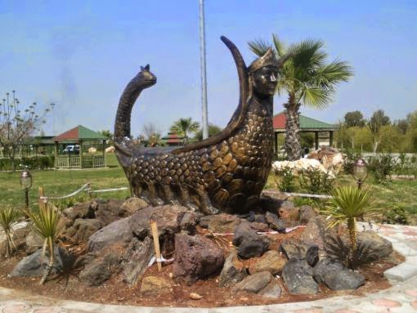
Shahmaran statue in Tarsus - Southern Turkey
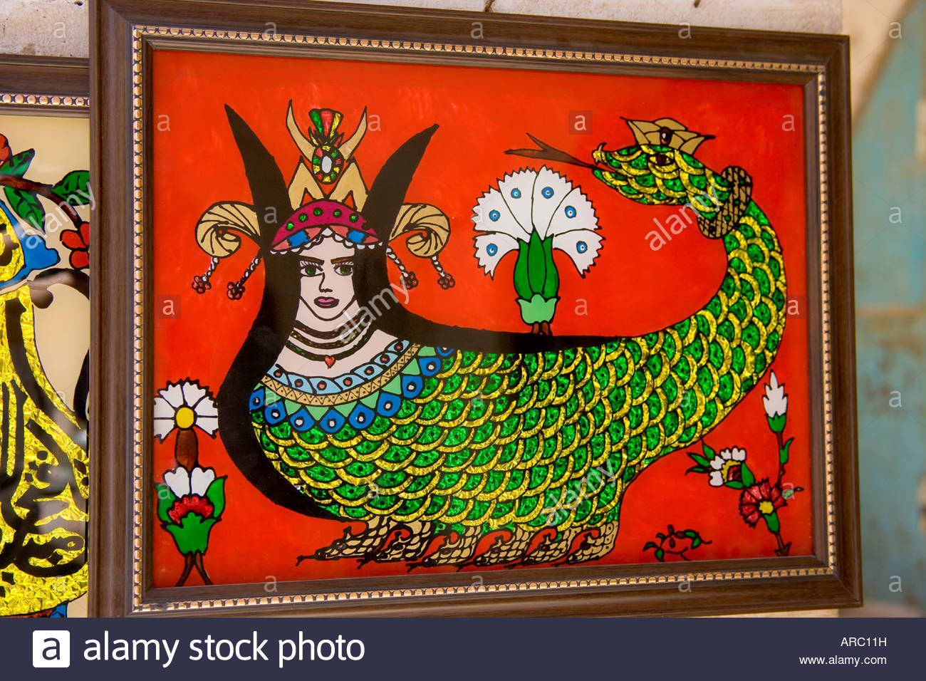
https://www.youtube.com/watch?v=2uMsLPlPfJo

