Nasreddin Hodja and His Stingy Neighbor
From Turkey our Nasreddin Hodja was quick to respond and knowledgeable, as well as generous and helpful.
For this reason, guests often come to his house, eat, drink, stay there, and these guests never want to go.
people are strange. some people do good in return of goodness and some people always want favors done to them.

Nasreddin Hodja had a neighbor. Their house was in the same garden. For this reason, he knew everyone who entered the Hodja's house. When the hodja bought a new item, the neighbor knocked on the door and asked to borrow it before using it.
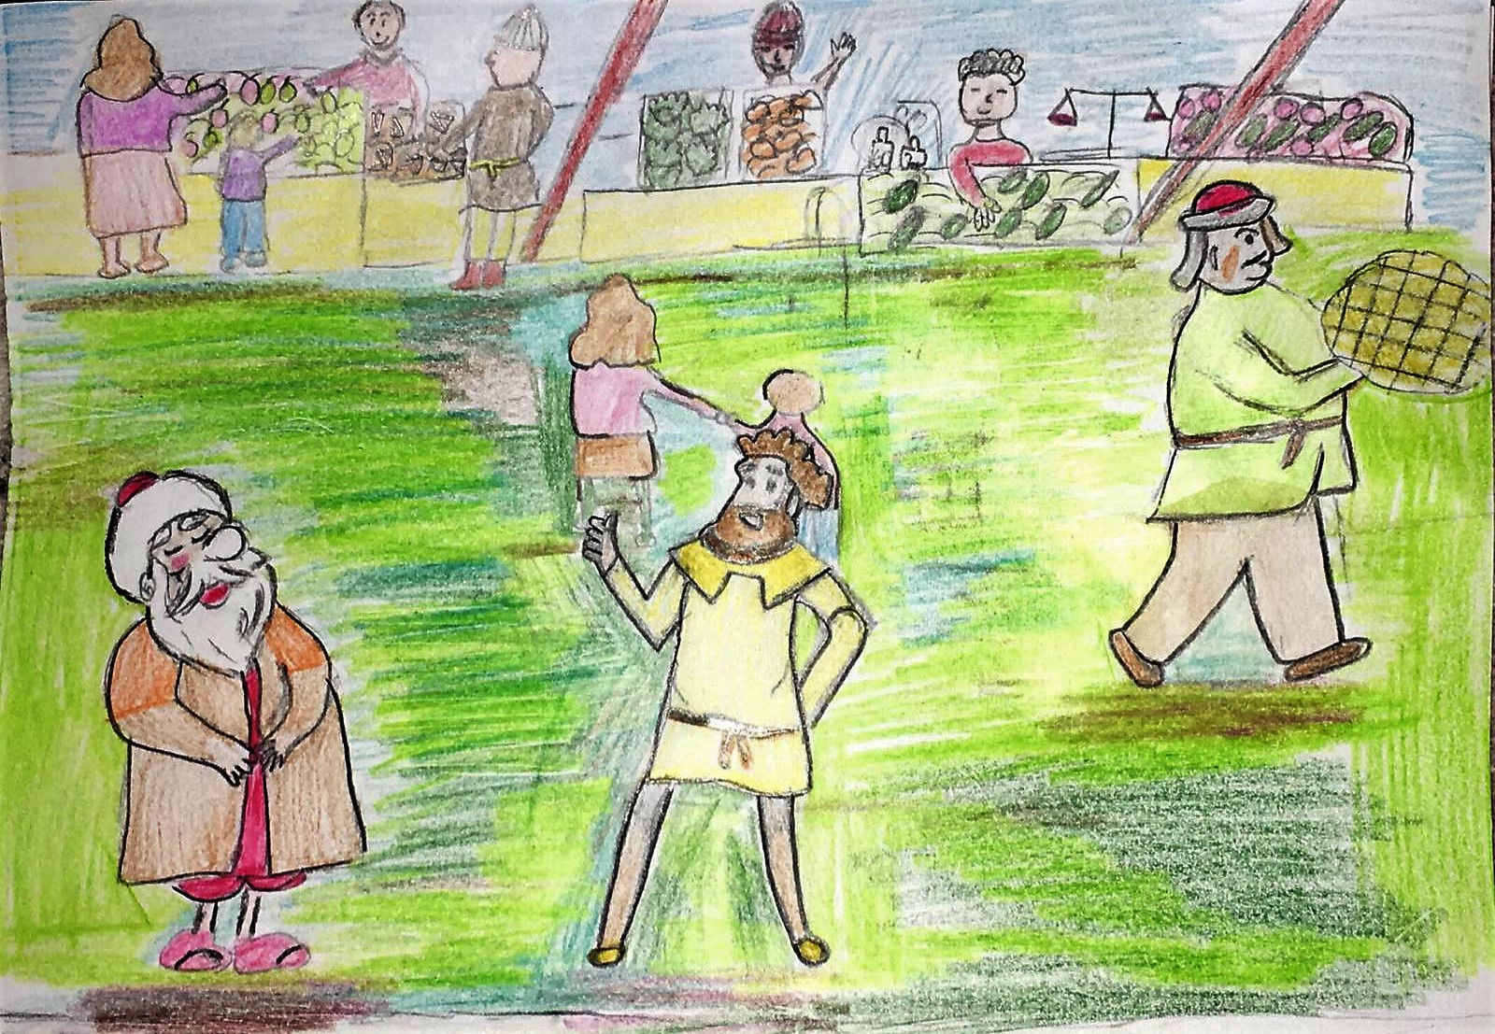
One day, the neighbor knocked on the hodja's door and :
"Hodja, a man just passed by with a tray of baklava," he said.
Nasreddin Hodja said, " it's none of my business’’
"I think he came to you," said his neighbor.
"Then it’s none of your business ." said the hodja and closed the door.

One day, the neighbor came to the Hodja's door again and said, "I will go to the mill. Can you lend me your donkey. Hodja said, "No, I won't, the donkey is not at home."

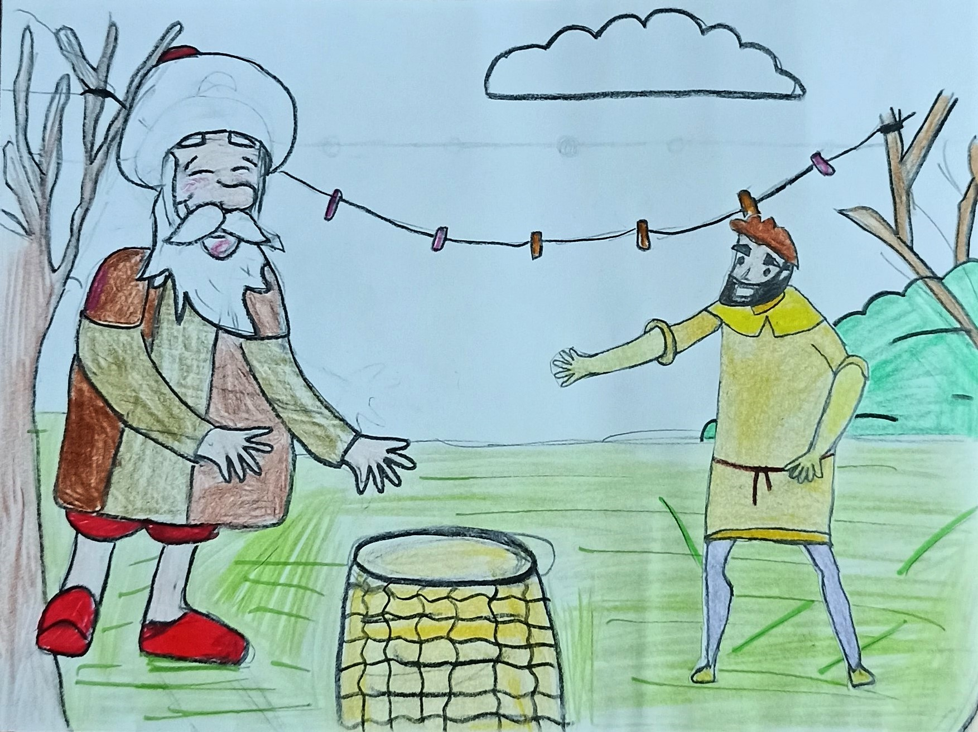

Another time, his neighbor knocked on the teacher's door again. Sir, I need a rope. “Can you borrow it?” he asked.
Nasreddin Hodja said no. I hung the flour on rope so I can't give it. The man was surprised and "Can you hang flour on the rope?" she asked. “Of course I can hang it if I don't want to give the rope,” he said.
He could not understand what Nasreddin Hodja wanted to do. In the following days, either he or his son came to the door and kept asking questions. While Nasreddin Hodja was trying to find a solution to this situation, an idea came to his mind.

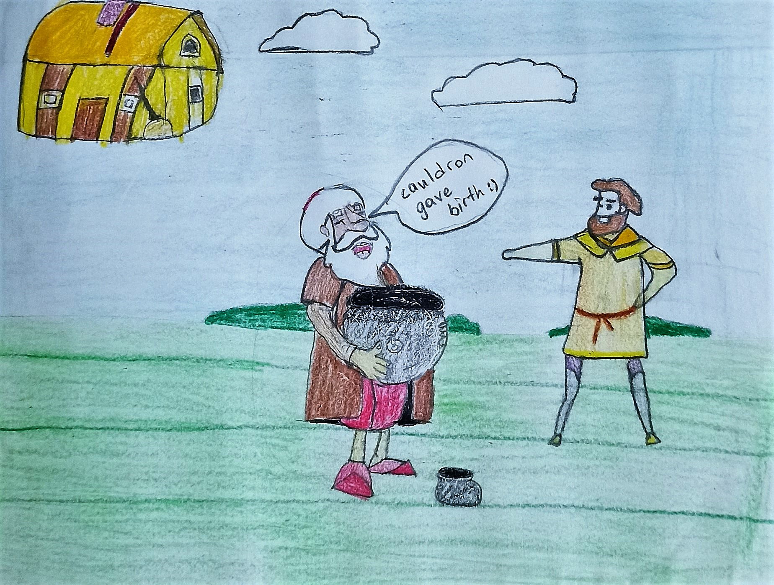
Nasreddin Hodja came to the neighbor's door and asked him for a big cauldron. His neighbor hastily brought the cauldron and gave it to the Hodja thinking that if I give him something, I will get more from him.
The next day, Nasreddin Hodja put a small saucepan in the cauldron and gave it back to his neighbor. His neighbor was surprised and asked Nasreddin Hodja what is this?
Hodja said the cauldron gave birth and this was her baby. The stingy neighbor was so happy that he didn't even think about whether it would give birth to a cauldron.
The next day, Nasreddin Hodja knocked on his neighbor's door again and said, "i still need a cauldron, can I have it?" he asked.
This time, his neighbor immediately brought the cauldron with the excitement of what the Hodja would bring. The neighbor waited a few days, but the cauldron did not come back, finally knocked on Nasreddin Hodja's door. “He asked the Hodja what happened to my cauldron? Hodja was very upset. He offered his condolences to his neighbor and said him : your cauldron is dead.

His neighbor got angry and said: What are you doing, Hodja ? This is not a human, how can the cauldron die?
Nasreddin Hodja took a long look at his neighbor's face and asked: "Why do you believe that the cauldron gave birth, but not that it died?" and closed the door.
It is not known whether his neighbor noticed stinginess of his own after that day or not, but it is known that the life of the Nasreddin Hodja with his neighbor has been told by word of mouth for centuries, and eventually it has become a story and this book meets the reader.

