Student Instagram Diaries from Student Exchanges to Spain and Scotland
Can be found at:
oiserasmus

Links to City Tour of Oulu Padlet Pictures
Can be found at:
https://padlet.com/anusha_bhowmik06/911z0bnc6bo5
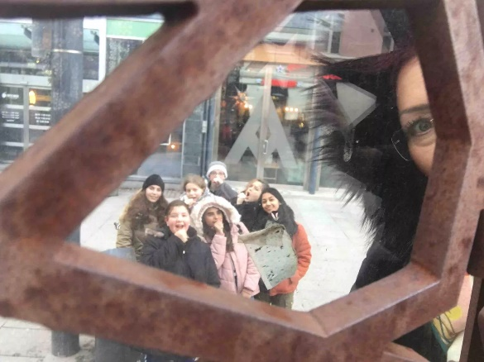

https://padlet.com/tom_mackay04spam/pa914onqs2dy
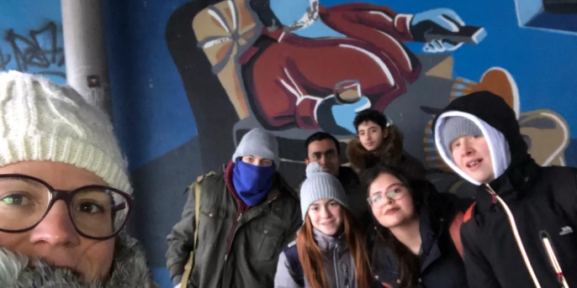

https://padlet.com/kaika_niskakangas/6vfu9fzma4r1
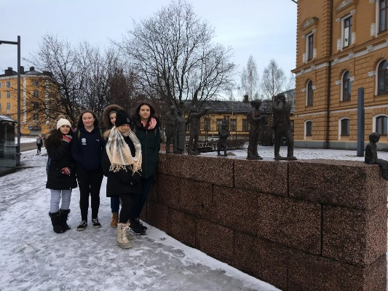

https://padlet.com/kaostu123/vmn41rs7lovb
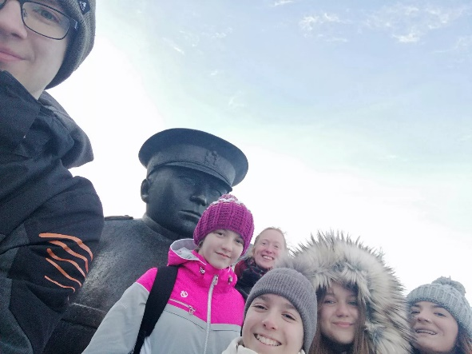

https://padlet.com/iirisgathogo/wa85x2ebqwmi
