Erasmus+ 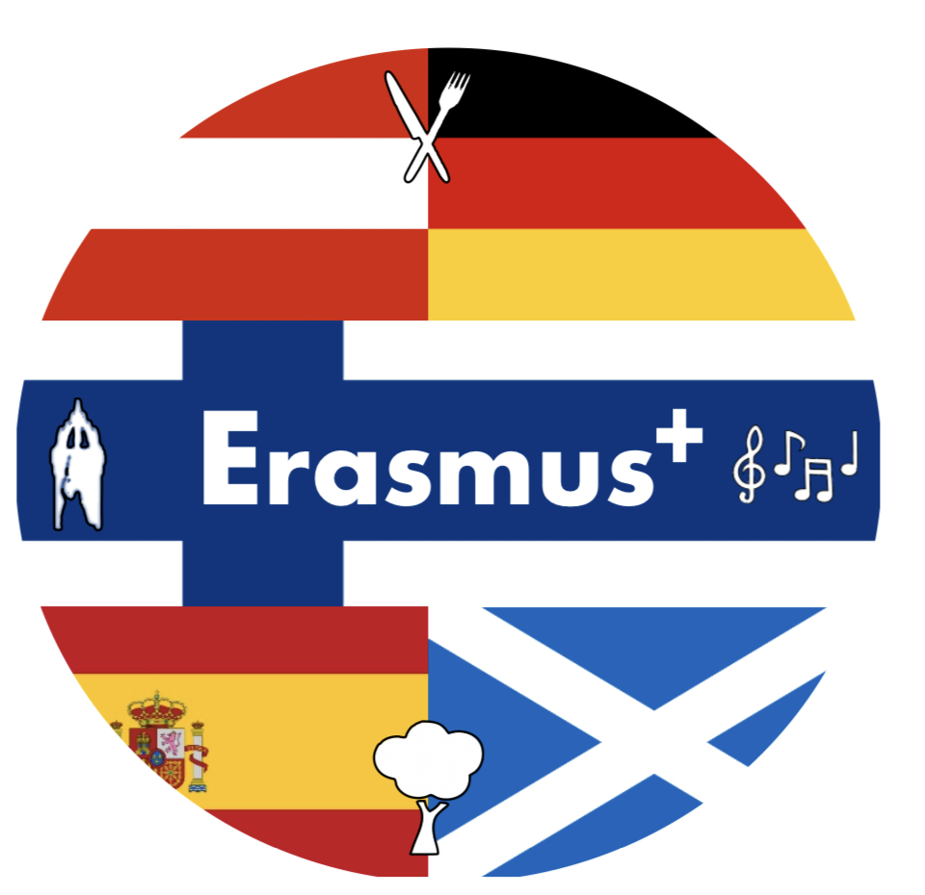
„WHAT’S YOUR HERITAGE-WE ARE YOUROPE“

PROJECT PARTNERS:

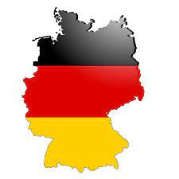 GERMANY

Theodor Heuss Realschule
Wintersheide 30, 33689 Bielefeld, Germany

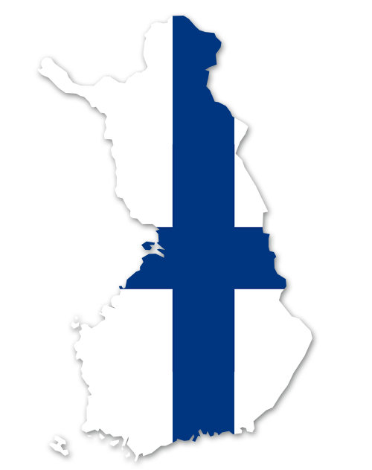FINLAND

Oulu International School
Kasarmintie 4, 90130 Oulu, Finland

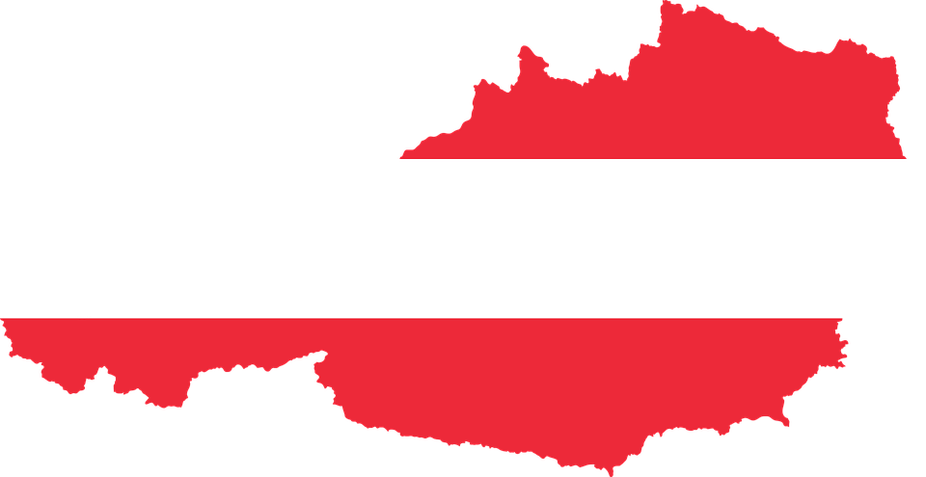AUSTRIA

Mittelschule mit musisch kreativem Schwerpunkt
Staudingergasse 6, 1200 Wien, Austria

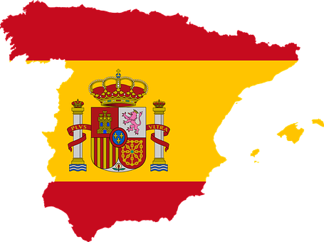SPAIN

Sierra Blanca Institute of Secondary Education
Av. Dr. Maíz Viñals, 24, 29601 Marbella, Málaga, Spain

SCOTLAND

Wallace High School
Airthrey Rd, Stirling FK9 5HW, UK

When we were planning the project and the project meetings we established a project timetable, so every partner knew about the activities for each meeting and what to work on during the school year.
This is our timetable.
Unfortunately we could not fullfill it like planned because of the Corona pandemic.

Project Timetable
September 2018-December 2018
- Preparing presentations for the first LTT about the partner schools
- Working on the jubilees of 2018
Austria: First Republic, Anschluss, song „Silent Night“, Death years of Falco and Klimt,……..
- Establishing Erasmus walls at schools, prepare posters with information about the partner cities-will be given to the partners at the 1st LTT
December 2018
1st LTT in Germany (C5) –by clicking the wrong letter I deleted the C1 activity and had to rewrite it, could not change the number to C1 again.
-Creation of a Project Logo in international groups, logo voting in the partner schools back home
-Activities according to the description in C5
January 2019-April 2019:
cultural history of giving presents to each other
-why do we give presents to each other? (occassions, reasons like Xmas, birthday, Valentine’s day, Wedding, etc........)
-rituals of taking and giving
-symbolism of giving presents
-all kinds of wrapping-why do we wrap gifts?
-Why do you give flowers to sb?
-questionnaire: which presents pupils are expecting for which occasion; presents parents/grandparents were happy with......
-excursions i.e. to companies producing gift wrappings, to museums to see what presents kings and queens exchnaged in former times,……
-poetry writing/contest-my present, with illustration; every partner chooses the best 3-5 poems, which then are compiled in a poetry book as a shared result.
-preparation of a presentation for C1 about this topic
-Activities according to the description in C1

May 2019-June 2019/September 2019:
-biosphere areas in each partner country (every partner has got several ones, I have already checked) which are under UNESCO protection; why are such areas important-what does that kind of heritage mean to all of us?
-Every partner visits at least one biosphere area in the home country to see and compare
-pupils take pictures and prepare a presentation and posters about the area for C2
-Activities according to the description in C2

October 2019-January 2020:
-tangible cultural heritage:
-which particular tangible cultural heritage has each partner got?
-what needs to be done to protect and maintain the cultural heritage?
-Which peculiarities can be found in the partner country/town?
-Each partner visits some places of tangible cultural heritage and documents those visits either with short videos or with photos -teams of pupils that do some research about one particular tangible piece of cultural heritage and then they present their „cultural godchild“ (Where is it? What is it? Why is it important? What needs to be done to maintain it?,.........)
-How does restauration work work? Excursion to the Antiquities and Monument Office for more information
-Conservation and archiving :
-How are things conserved? Like furniture,paintings,books?......... visit places according to those points where you can gather information
-Also: the conservation of food: like jams, vegetables, meat, ........ cooking workshops in every school
-Kids do also some research in their families:
they should look for heirlooms/things that are important for their families like old photos, tablecloth, China, .......
-they should either bring the piece to school or take a picture of it and then present it to the others and tell the story of the object.
-Preparation of presentations for the partners for C3
-Activities according to the description in C3

February 2020-April 2020
intangible cultural heritage
customs, dishes, music, paintings, traditional costumes, dances,......
- Pupils present a typical song, recipes or verdicts and we can compare if there are similarities/differencies between the partner countries-what do we know from each other? (stereotypes?)
-cooking workshops of some typical dishes, eating together, compilation of recipes, cooking book
-performing of typical dances and learn a dance from each partner-dancing workshops
-preparation of presentations according to the topic for C4
April/May 2020:
- Preparation and collection of material for the exhibition and the celebration that will take place during C4
-rehearsing of dances
-preparation for the discussion about Erasmus+
-invite local media for the project celebration
-invite parents, partner schools, school board, district head, the National Agency of Austria,……
-Activities according to the description in C4

PREPARATORY MEETING IN VIENNA:
Erasmus + project:
preparatory meeting of teachers in Vienna (8.10-11.10.18) Day 1 - Monday - arrival day: On Monday, October 8th, the European partners traveled to Vienna to meet the teachers and principals of the partner schools in Austria, Spain, Finland and Scotland and to plan the Erasmus + project. Our Hotel Niu Franz was located near the New Middle School and in the 20th district of Vienna. What the numbers are all about is quickly explained:
Example: • Vienna - Inner City (center) = No. 1;
• Brigittenau (where our hotel and the new middle school were located) = No. 20; etc.
[Brief explanation: In Vienna the individual districts have both names and numbers. The numbers help to have an approximate idea of ​​where a district is. Once you become familiar with this system, it is actually very helpful.] During the day all Erasmus partners arrived in Vienna, which is why we took one of the old vintage trams to the meeting point. We met in a restaurant at 8:30 p.m. to get to know each other and to have dinner together. Two teachers came from the Spanish school Sierra Blanca School, who had already been with the last project and were familiar faces to us. There were two teachers from Austria, the new secondary school in Staudingergasse. We already knew the coordinator from the last project. New additions were two teachers and the headmistress from Oulu International School in Finland and one teacher and deputy headmistress from Wallace High School in Stirling, Scotland. Mr. Gerald Grois promised us very nice and exciting experiments in the science room the following day. We were very excited.
Day 2 - Tuesday: On Tuesday, October 9th, we met around 9:00 a.m. in front of the New Middle School on Staudingergasse and admired the old building, which could only be identified as a school on closer inspection. In the entrance area we were already expected by two groups of schoolchildren and received in a very friendly manner. When all the participants in the Erasmus + project had arrived, there was a guided tour through the school in English, divided into two groups. We learned from Ms. Andrea Lady that some students had only come to Austria as refugees a few years ago and some had only had English lessons for two years. But they did their job very well and proudly showed us their school. We noticed straight away that the students were wearing slippers and that the building appeared to be very clean. Among other things, we admired the beautiful banister. Then we were expected in the science room by Mr. Gerald Grois and some students. Different experiments were set up at six tables, which when tried out aroused great astonishment among all those involved. There was a lot of laughter. As a conclusion, Gerry had thought of a color spectacle. What a grand finale. After the experiments, we sat down with the Erasmus + project planning group in the planning room again to discuss many points. Among other things, the dates were coordinated, corrected and planned in more detail. The next meeting will take place in December in Bielefeld, so that Ms. Stebbing presented the planning for the week and was able to answer questions from the participants. The intensive planning time was followed by a 90-minute city tour in District 1 in the afternoon to marvel at the sights and learn about historical events. Ms. Lady, the coordinator, had chosen a very special place for dinner. We were able to enjoy typical Austrian specialties at lofty heights, with a great view over the Danube and over the city of Vienna. In a park, directly on the Danube in the Donau Tower.

Day 3 - Wednesday: On Wednesday, October 10th, we met again at the New Middle School to plan the project more precisely. Ms. Andrea Lady had booked a coffee seminar in the coffee museum for the afternoon. We found that we could still learn a lot about the bean. The moderator led us through the individual rooms and told exciting stories about the coffee bean. There were also many exhibits on display in the rooms, collected over many years. To see who had listened carefully and memorized important facts, the moderator conducted a quiz. The 1st to 3rd prize went to Finland. (We thought that was unfair and joked that Finland always takes first place in terms of the education system anyway!) In the evening we were invited to the headmistress Monika Wenzel. She and her husband had cooked delicious Austrian specialties for us. Thank you for the very cozy and great evening.

Day 4 - Thursday - departure day: On Thursday, October 11th, the participants left during the day. We would like to thank our Austrian coordinator Ms. Andrea Lady for the great days and her warm manner. We all took back many wonderful memories from Vienna and got to know our great Erasmus + partners. The planning work was very easy for us. We look forward to December (December 9th - December 15th, 2018), where we can welcome the students and teachers of the Erasmus + project group from Austria, Finland, Spain and Scotland as guests.

Impressions from the meeting in Vienna:

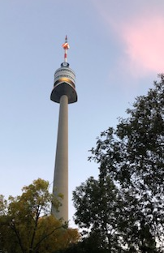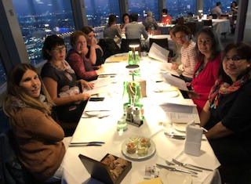
Dinner at the Danube Tower
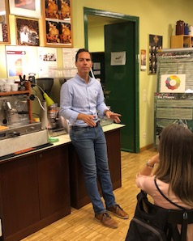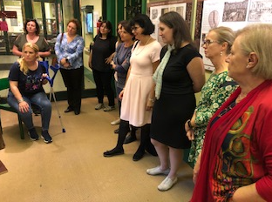
Workshop at the coffee museum

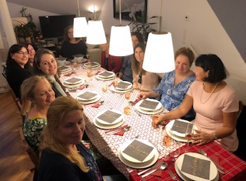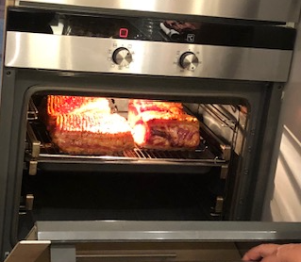
Dinner at the home of the headmistress

