Things that Finnish students enjoyed in the Erasmus project
Finnish students love to bake and cook. It seems that our students overall favourite subject is home economics because they get to learn about and make food. Here are our favourite foods from the project.
Christmas and Gingerbread Houses
Making gingerbread houses is an important part of Christmas in Finland. During this project we shared our gingerbread making skills in Germany during the Christmas themed student exchange. We make gingerbread houses each year just before Christmas at school in home economics class.
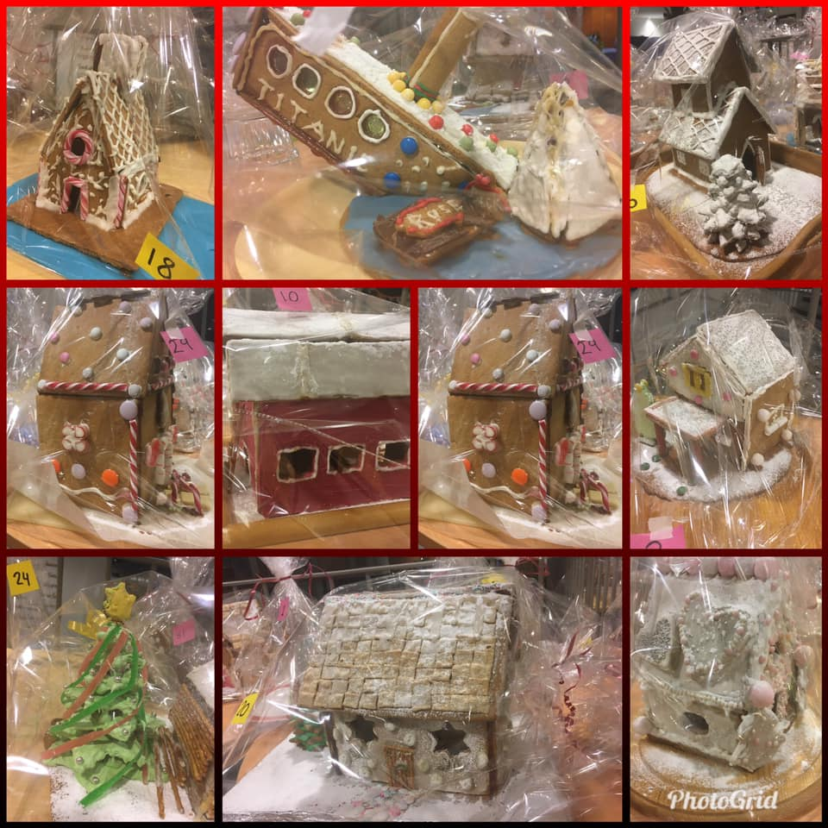
Conserving Jams
One of the Erasmus topics was “conservation”. We discussed different types of conservation and one of them is conserving foods. In Oulu, conserving produce from the forest is important in Finland. During late summer and early autumn, we can go into the forest and pick mushrooms and berries for free. There are lots of things you can make from them. We conserve our berries for later use so that we can eat the super nutritious berries during the dark winter months to help us stay healthy. We freeze them for smoothies, or to make pies, or even just to eat them with yoghurt. We boil them to make juice or boil them to make jam. Here is our recipe for blueberry jam – a popular Finnish conserve.
Ingredients:
2 litres blueberries from the forest that have been cleaned up
50 ml water
600 ml jam sugar
What to do:
1. Place the blueberries and water into a saucepan
2. Heat up the berries and water until steam can be seen and then slowly mix in the sugar.
3. Decrease the heat when it starts to boil.
4. Boil over moderate heat for about 10 minutes, stirring once and a while. If foam forms on the top, scoop it off.
5. Cool for about 30 minutes and stir several times as it is cooling.
6. Place into clean glass jars when the berries do not float to the top – this shows that the jam has set.
7. Store in a cool place.

In the early autumn months, our students go out to pick blueberries in local forests. We learn about Every Man’s Rights. This Finnish law gives us the freedom to pick berries anywhere in nature. Freedom to get our hands blue from blueberry juice.
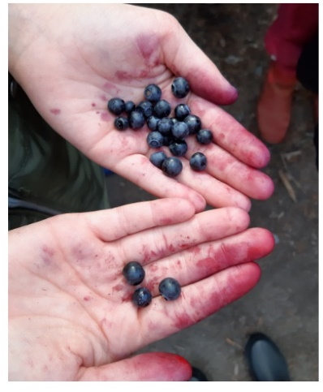

Here is our blueberry pie made with our partners when they visited Finland and the recipe:
Easy Blueberry Pie
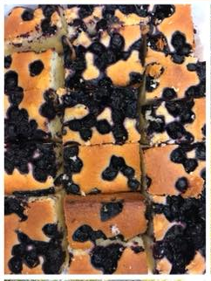
Ingredients
4 eggs
300 ml sugar
700 ml flour
1 tablespoon baking powder
1 tablespoon vanilla sugar
200 grams butter
200 ml milk200 grams blueberries

What to do:
1. Mix the eggs and butter together until they are a stiff foam
2. Add all of the dry ingredients to the egg and butter mix and stir together
3. Melt the butter and stir it and the milk in last to the mixture until the dough is of an even consistency
4. Mix half of the blueberries into the dough
5. Place the dough evenly into a 25 x 35 cm baking dish
6. Place the rest of the blueberries on top
7. Allow the pie to bake on the lower rack of a 200C oven for about 35 – 40 minutes

