Highlights from the Project:

Austria:

This project-trip our pupils liked best:

The Wachau is the landscape in and around the valley of the Danube between Melk and Krems an der Donau in Lower Austria, about 80 kilometers west of the federal capital Vienna. In 2000 it was added to the list of UNESCO World Heritage Sites as the Wachau Cultural Landscape with the Melk and Göttweig monasteries and the old town of Krems.
We took a boat trip from Krems to Melk and then visited Melk Abbey on a great sunny day in September.
The most famous sites of the oldest traces of human presence in the Wachau are in Stratzing and Willendorf. This also includes the locations of the two oldest Austrian works of art, the figurative depictions of women of the so-called Venus vom Galgenberg and the Venus von Willendorf. They are assigned to the Upper Palaeolithic, the time when anatomically modern humans immigrated to Europe, which was previously only inhabited by Neanderthals.
Enjoy our pics!
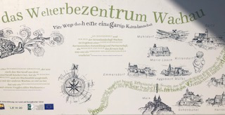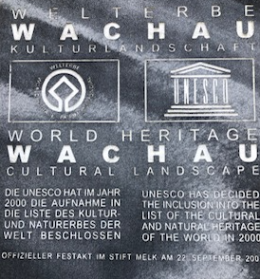
The Wachau is a Unesco World Heritage
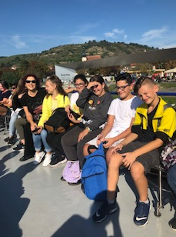Views from the boat

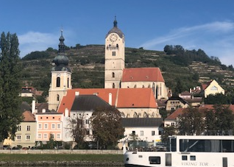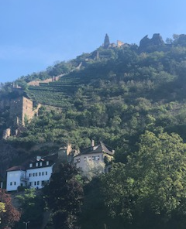 Wine is cultivated on terraces here for a long time
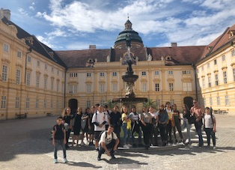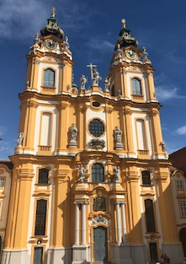
Melk Abbey
The Federal Monuments Office

We worked together with the Federal Monuments Office and there we learned a lot about conservation, restoration and maintaining. The tasks of the authority include, among other things,
the preservation,
restoration and cataloging of architectural and art monuments, archaeological sites and historical gardens, but also the monitoring of export regulations according to the Monument Protection Act.
The Federal Monuments Office works together with the Monument Advisory Board provided by the Federal Ministry for Education, Art and Culture.
The Federal Monuments Office is now divided into the Presidium in Vienna and eight state conservatoires - today departments with department heads - for each state in the state capitals.
Central specialist departments are at their disposal:
Architecture and construction technology (also photogrammetry)
Archeology (soil monuments) with archeology center Mauerbach
Movable monuments - international transfer of cultural goods (export matters, such as export permits for cultural goods)
Inventory and monument research
Garden architecture
Technical monuments
Sound monuments
Another important task is to look after the museums and libraries. Internal services include legal matters and the like. The two restoration workshops are: Chemical central laboratory of the Federal Monuments Office in the Vienna Arsenal and the restoration workshops Monument maintenance in the Kartause Mauerbach.

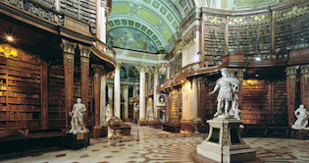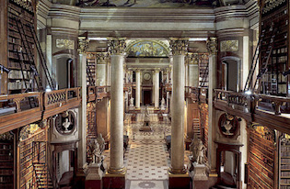
The National Library-here small scorpions live in the old books and they help preserving these books by eating bookmites
We had preparotory workshops at school where we learned about the different means of conservation and also about restoring and maintainance.
The we visited the National Library where we learned how old books are preserved and restored.
In the books there live small scorpions which help to keep the books in good condition-a weird story, isn’t it???

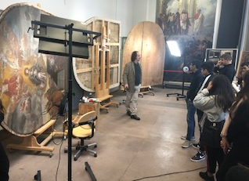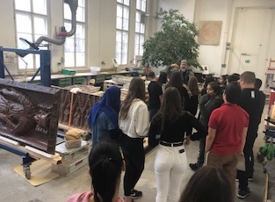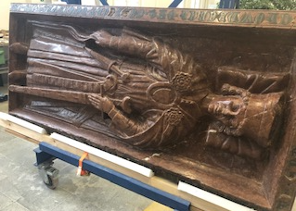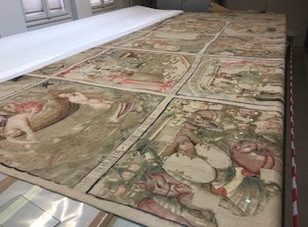
In the Arsenal we were shown how the different methods of conservation work

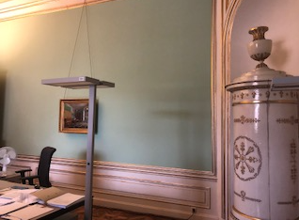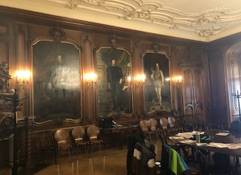
In the main office located in the Hofburg we learned about the organisation of the Federal Monuments Office and we learned about the famous colour Schweinfurter Grün which was a popular, but deadly colour in former times.
My precious thing:

Pupils presented one thing that is of importance for them or for their family.
We heard a lot of interesting, funny, moving, various presentations and got to know many different precious things and we also saw another „side“ of our students.
Here are some of the great examples for you:

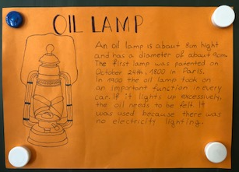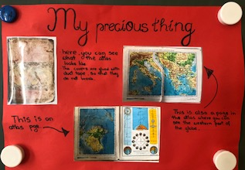
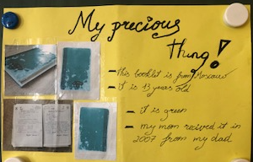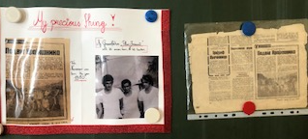
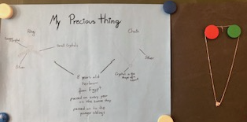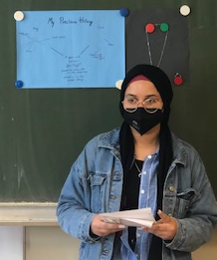

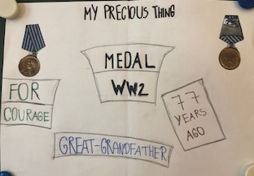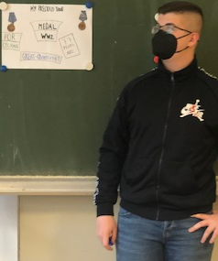

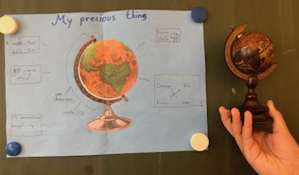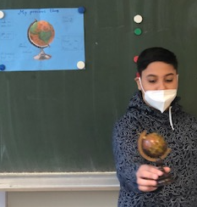

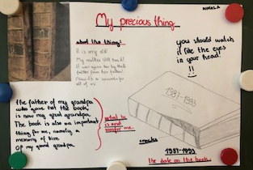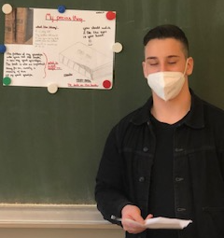

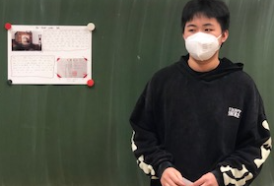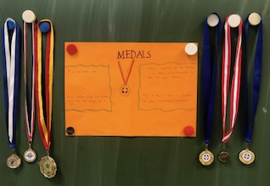

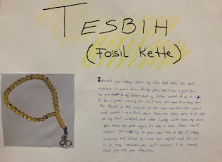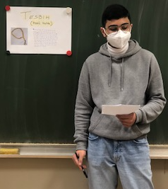

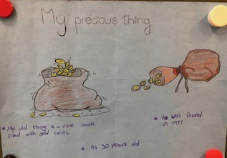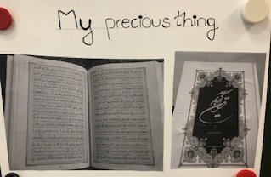

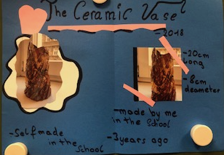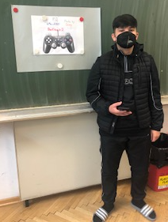
Spain:
One Highlight – The big, beautiful Spanish Erasmus Corner:
The spacious Spanish partner school deeply impressed the Austrian partners coming from an old, really tiny school with limited space:

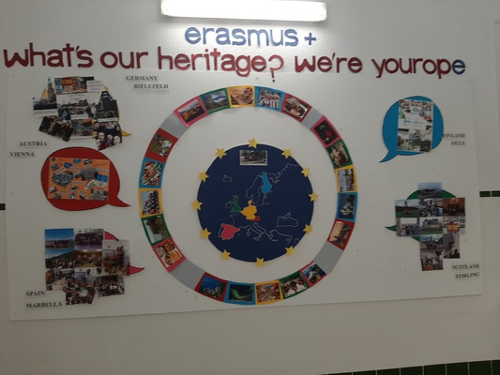

POEMS - “My Gift”
Surprise
A gift
Always makes you happy
No matter what it is
Thank him (Shemsi Moreno)
Grateful
When receiving,
But even happier,
There’s no such feeling
As giving. (Kajsa Sabrina)
Misterious,
Special day.
Give or receive?
What will it be?
Happiness. (Eduardo Guijosa)
Feelings
In gifts
In each birthday
You give and get Love (Pablo Infantes)
Gift,
One Word,
Show of affection,
Don ́t need explanation,
Only the love. (Alba Pinto)
Dream,
Your birthday,
With friends and family,
Happiness. (Lucía Jaén)
Intriguing
Wrapped feelings
Graceful decorated box
What do you expect?
Surprise! (Jéssica Torales)
Present
Wonderful surprise
Something very nice
Something that brings hapiness
Gift (Patricia González)
Your gifts inspire mine
They are only details
That brighten the day
From morning to night
An unforgettable gift (Nazaret Vargas)
They are very small gifts for such a large value.
But it is in my hands to give it, what I do
With a happy heart and with the hope
That you do not keep them so much
For their value but for what they mean
As a memory. (José Antonio Romero)

Germany:
Excursion to the Rieselfelder

How are squeaky yellow rubber boots, catching masks and a picnic in a tree house connected?
On Wednesday, June 12, 2019, an excursion of the Erasmus+ AG and the biocourse Technology II took place. As part of our project theme "What`s your heritage - we are Yourope" we also deal with the topics environment and nature. Therefore we visited the Rieselfelder of the Biological Station Bielefeld - Gütersloh as an extracurricular place of learning and took part in the workshop "Ecosystem stream and pond - animals and plants and their adaptations to the habitat water".
27 students and 2 teachers (Mrs. Bainski and Mrs. Stebbing) took the bus to Niederheide in Senne at 8:30 am. We arrived at the biological station on time at 8:55 and were welcomed by Mrs. Noack-Füller, who was to accompany us that day.
First, everyone had to put on their rubber boots and rain jackets. Dressed as a very colorful learning group in all the colors of the rainbow, we set off for the water. Ponds and streams serve as nurseries for many animals before they leave the water as frogs, dragonflies or mayflies.
In pairs, we caught small aquatic animals with landing nets and observed them with the help of a magnifying glass. Each pair also had a small plastic aquarium into which the caught animals were carefully placed. We worked with fine brushes so that no little animal was hurt. Several students even caught some fish that Ms. Bainski immediately identified as three-spined sticklebacks. All the students were eager and absolutely focused.
Eventually, we had caught quite a collection of aquatic animals: Mayfly larvae, ball shells, roller angels, plate snails, water striders, caddisfly larvae, tadpoles, aquatic isopods, stonefly larvae, snails, dragonfly larvae, sticklebacks, and psyllids. Mrs. Noack-Füller patiently answered all questions and there were some surprising findings: The male psyllid actually hooks up with the female for 8 days until she matures and the dragonfly larva has a catching mask, which is the extended lower jaw and with that it is able to catch its prey in a split second and pull it right into its mouth.
Finally, we determined water quality and discussed pollution and water quality. Water as a source of life and the drinking and sewage cycle were also discussed, as the habitat of many animals has been altered by humans.
Then there was time for a picnic and a short tour through the Rieselfelder, during which Mrs. Bainski was able to identify all the birds and explained fascinating ornithological relationships to us. Biology lessons with a difference!
In any case, we will also remember soggy sneakers, too short rubber boots and the inevitable consequences, sweets in the tree house, pouring rain and shells of dragonfly larvae that we were allowed to take back for biology class.

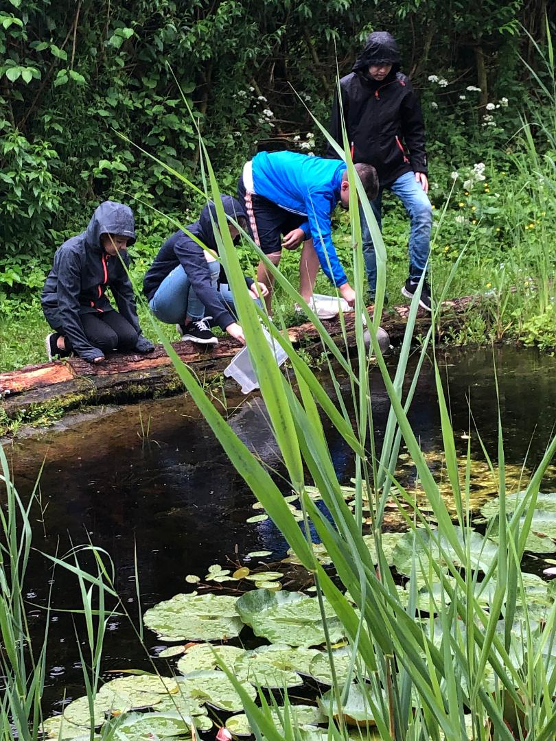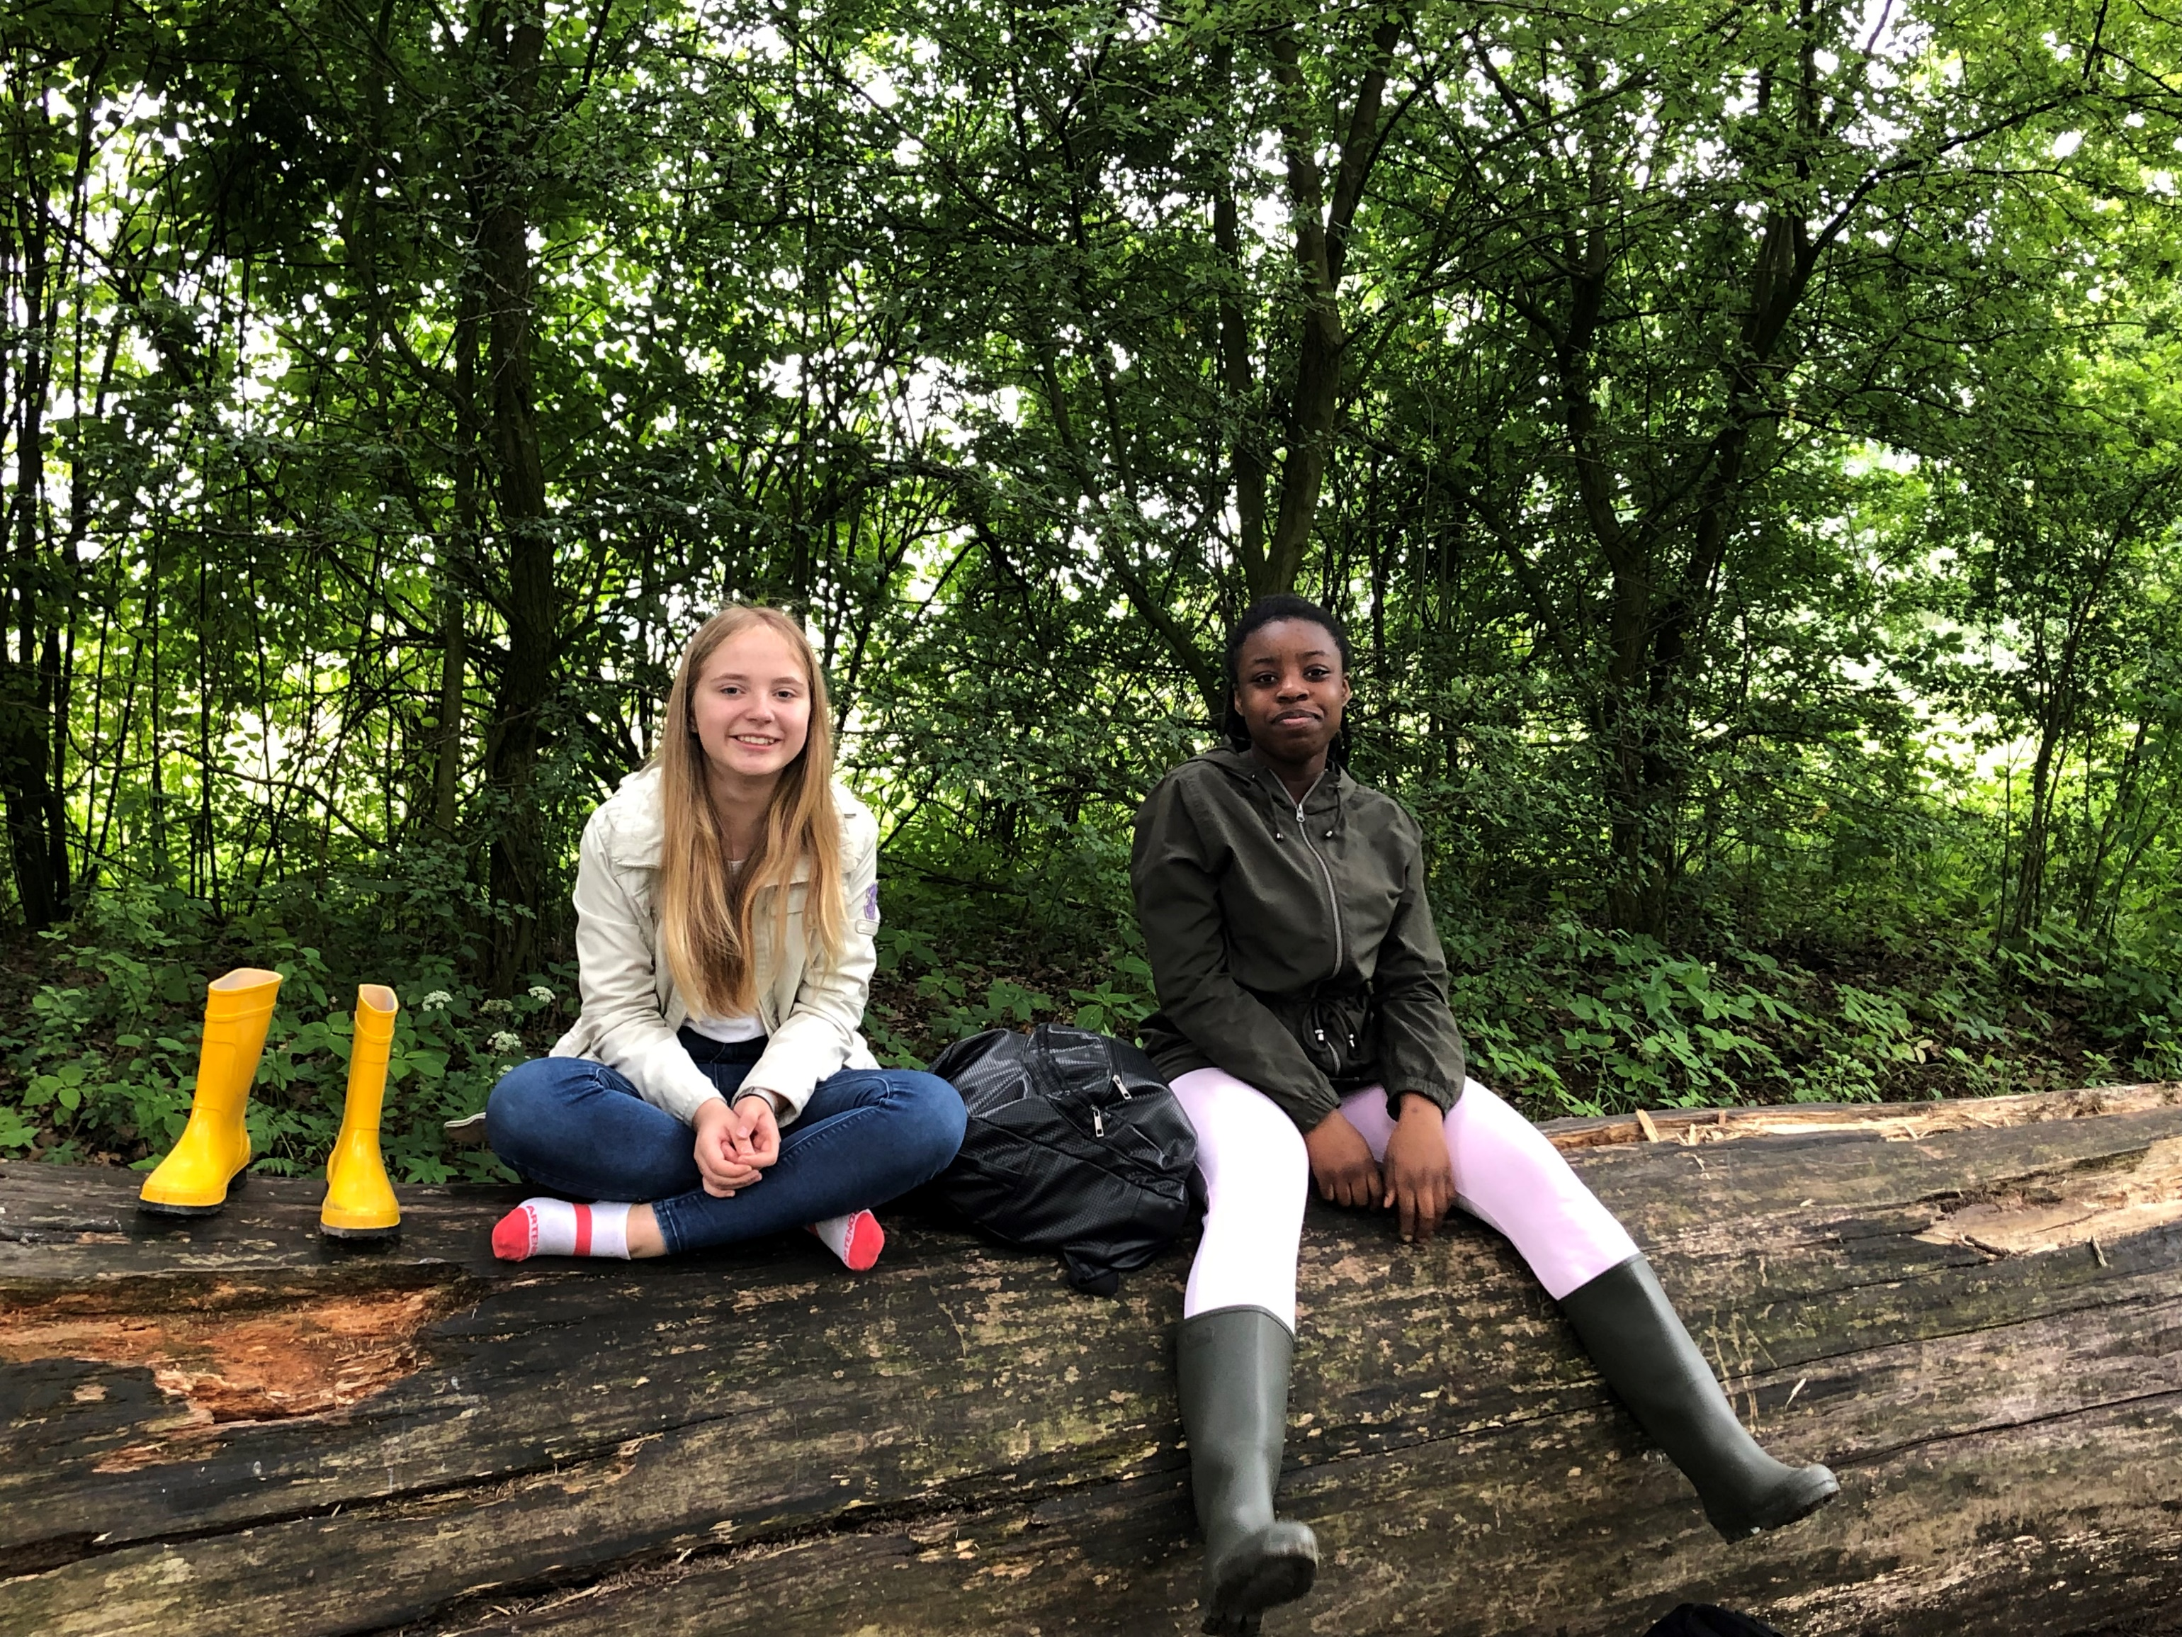
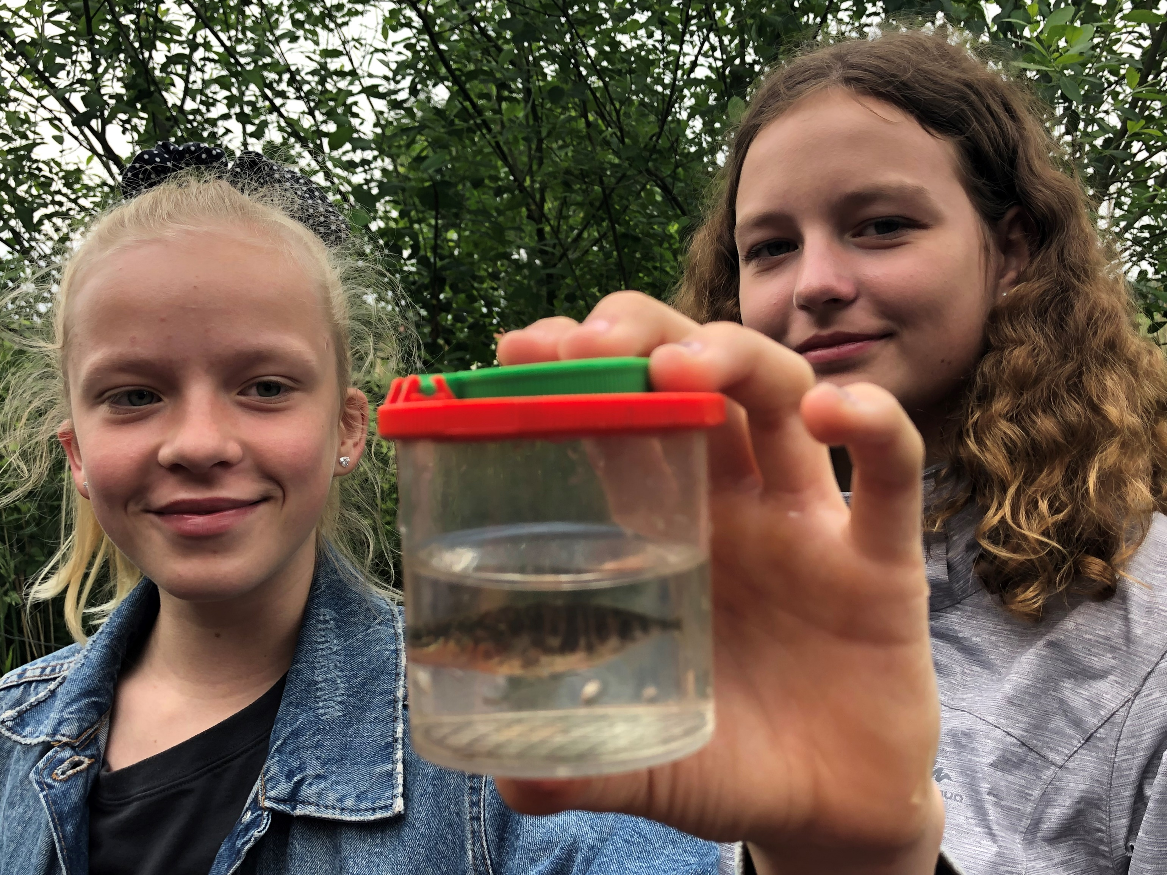We had a great day!

One report from a student:

How she experienced the week with a girl from Finland:
My host student was from Finland. Her name was Vivii and we got along very well right away because we had already exchanged ideas and had written messages beforehand.
The motto of the Erasmus project was: World Heritage!
Because of this we visited many sights in the surrounding area:
- Witch Museum in Lemgo
- Castle Corvey in Höxter
- Zeche Zollverein in Essen
Since the exchange students visited us in the pre-Christmas season, we also got to know different Christmas markets. Vivii was quite impressed by this, because in Finland there is no such kind of Christmas markets.
Not only did I get along well with my host student, but also with the people from other countries: Spain, Scotland, Finland and Austria. Our language of communication was English!
At school we had a full program to get to know each other: Christmas carols in several languages, baking together, board games, basketball and creating an Erasmus logo.
At the end there was a party with buffet, fun and disco.
I liked the Erasmus project very much! I am looking forward to visiting the other countries and getting to know the different cultures.

Questionnaire:

The German Erasmus team created a questions survey about presents:

Questions Survey "Presents" German Erasmus Student Team

Do you prefer to give or receive presents?

Are you happy about any type of present?

How do you express your gratitude about a present?

Do you sometimes get presents in between, for no apparent reason?

Do you give self-made or bought presents?
When do you get the biggest/most valuable presents?

When do you get and give presents?

What type of presents do you give and on what particular occasion?

FINLAND:
Things that Finnish students enjoyed in the Erasmus project
Finnish students love to bake and cook. It seems that our students overall favourite subject is home economics because they get to learn about and make food. Here are our favourite foods from the project.
Christmas and Gingerbread Houses:
Making gingerbread houses is an important part of Christmas in Finland. During this project we shared our gingerbread making skills in Germany during the Christmas themed student exchange. We make gingerbread houses each year just before Christmas at school in home economics class.
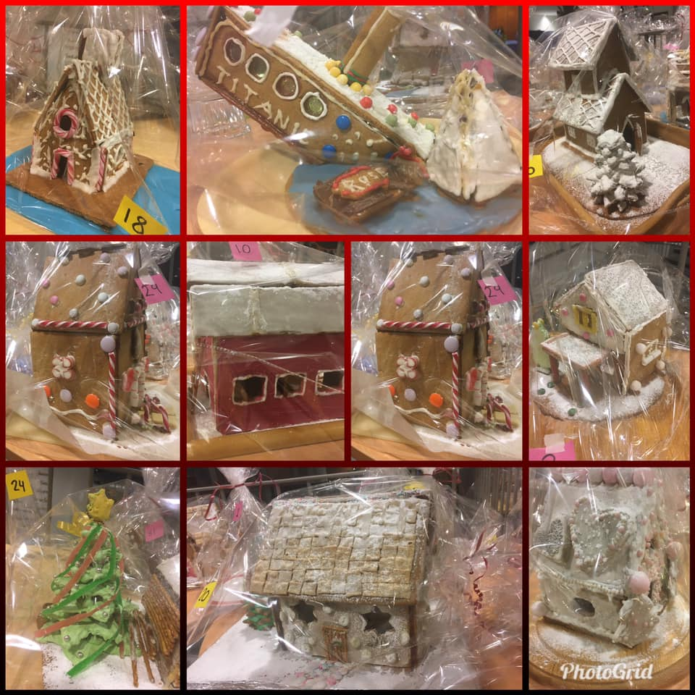
Conserving Jams:
One of the Erasmus topics was “conservation”. We discussed different types of conservation and one of them is conserving foods. In Oulu, conserving produce from the forest is important in Finland. During late summer and early autumn, we can go into the forest and pick mushrooms and berries for free. There are lots of things you can make from them. We conserve our berries for later use so that we can eat the super nutritious berries during the dark winter months to help us stay healthy. We freeze them for smoothies, or to make pies, or even just to eat them with yoghurt. We boil them to make juice or boil them to make jam. Here is our recipe for blueberry jam – a popular Finnish conserve.
Ingredients:
2 litres blueberries from the forest that have been cleaned up
50 ml water
600 ml jam sugar
What to do:
1. Place the blueberries and water into a saucepan
2. Heat up the berries and water until steam can be seen and then slowly mix in the sugar.
3. Decrease the heat when it starts to boil.
4. Boil over moderate heat for about 10 minutes, stirring once and a while. If foam forms on the top, scoop it off.
5. Cool for about 30 minutes and stir several times as it is cooling.
6. Place into clean glass jars when the berries do not float to the top – this shows that the jam has set.
7. Store in a cool place.
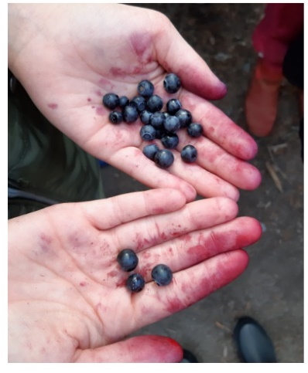
In the early autumn months, our students go out to pick blueberries in local forests. We learn about Every Man’s Rights. This Finnish law gives us the freedom to pick berries anywhere in nature. Freedom to get our hands blue from blueberry juice.

Here is our blueberry pie and the recipe:
Easy Blueberry Pie:
Ingredients:
4 eggs
300 ml sugar
700 ml flour
1 tablespoon baking powder
1 tablespoon vanilla sugar
200 grams butter
200 ml milk
200 grams blueberries
What to do:
1. Mix the eggs and butter together until they are a stiff foam
2. Add all of the dry ingredients to the egg and butter mix and stir together
3. Melt the butter and stir it and the milk in last to the mixture until the dough is of an even consistency
4. Mix half of the blueberries into the dough
5. Place the dough evenly into a 25 x 35 cm baking dish
6. Place the rest of the blueberries on top
7. Allow the pie to bake on the lower rack of a 200C oven for about 35 – 40 minutes
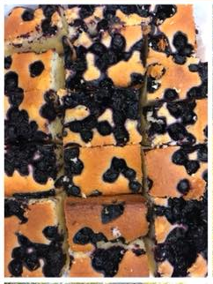

Student Instagram Diaries from Student Exchanges to Spain and Scotland Can be found at:
oiserasmus
Links to City Tour of Oulu Padlet Pictures can be found at: 4
https://padlet.com/anusha_bhowmik06/911z0bnc6bo5
https://padlet.com/tom_mackay04spam/pa914onqs2dy
https://padlet.com/kaika_niskakangas/6vfu9fzma4r1
https://padlet.com/kaostu123/vmn41rs7lovb
https://padlet.com/iirisgathogo/wa85x2ebqwmi

Some student’s feedbacks:
The students were asked to give some feedback about the proejct work and about the trips to the partner countries. Here are some examples:

Anastasia:
In my opinion, such a project is a fantastic idea because you can work with children from other countries, you get to know many new friends, you can learn some important words in another language and you get to know the culture of other countries. I liked the project very much and I enjoyed the time very much. I am very grateful to the teacher and also to my parents for letting me go to all the project meetings. My first flight in my life was to Düsseldorf. I also was allowed to go to Spain, that was a great experience for me, my host family was very nice and I could also spend time at the beach. I liked it best in Germany. Unfortunately, all good things come to an end, and so did this project. For me, working with European partners means building bridges and making new friends. I have made many new friends, we write Whatsapps and we are on Instagram. I was sad I could not see them again in Vienna.
Sarah:
At school we learned a lot about conservation and preservation, we visited different places where people work to keep old things and preserve it for the future. It was really interesting to learn about deadly colours and about scorpions that eat insects in old books.
The trip to Marbella was amazing-I had a great host family and I loved going to Cordoba. I am from Egypt myself and I loved the beautiful buildings there.
We could not meet our friends in Vienna any more, it is a pity, because we would have planned a surprise beach party for them.
Lara:
When we flew to Spain, it was the first flight of my life. My Spanish host family was very friendly and great, I felt very comfortable there. My best experience there was when all the kids met at the beach in the evening. Learning to dance Flamenco was something new for me. I also liked the workshop with the Picasso painting and I ate Paella with chicken and vegetables for the first time in my life. It tasted good!
Aleyna:
I liked Finland very much, although the trip there was very long and exhausting. There, I liked the trip to the Husky farm and to Santa Claus that we had, the most. We had so much fun there, but it was so extremely cold there. On the coldest day we were having a barbecue in a park near the school.
I found many new friends there and I was very sad that they could not come to Vienna. We often send photos on Whatsapp and are in contact. It is nice to have friends in other countries.
Nikola:
Going to Scotland was a great experience for me, but I did not like the Haggis there. For me the trip to the Edinburgh Dungeon was the most exciting part of the trip and I also loved seeing Glasgow and the statues which were glasgowed-that was great fun! As this was my first trip away from my family I was very homesick at the beginning.
Osman:
I did not travel anywhere because I was not allowed to go.
What I liked were the cooking workshops at school. We cooked delicious jam at school that we were allowed to take home. Also the different excursions were fun and interesting. I especially loved the trip to Salzburg to trace „Stille Nacht“.
Kathi:
When I was in Germany, I saw many things there that I liked. The thing I liked the most was the Zollverein Essen. During the guided tour we had to go up and down a lot of steps until we got to the balcony there, but the view of Essen was great. We also went to a beautiful place called Lemgo which I loved. The houses there were really beautiful. This place was also interesting because we heard there about the cruel witch trials which happened some centuries ago. There was a museum where we heard about those times. Also the Christmas markets we visited were really beautiful. Bielefeld is a nice small town and my host family was really friendly and cool, they cared a lot about me. Our partner school was really big and we had fun doing the workshops and singing together and I also liked preparing the exhibition stall about Austria.
I liked it extremely well in Germany.
Sofia:
From the project activities at school I liked the trip to the Wachau a lot because it was my first boat trip on the Danube river.
I also liked the meetings and the working with the partners, those were my first trips alone and to another country. I liked the huskies in Finland so much and also Helsinki was so beautiful.
Alesia:
Before my first experience of traveling and staying with a host family for a whole week, I was very, very nervous and shy. But as time went on, I felt better and better and living with a host family was exciting and fun. I made a lot of friends during my travels and I wish I could meet them all again someday. It was also great that I could learn some important words in Finnish and Spanish. These languages are not taught at our school.
In Scotland it was so cold in September, I did not have enough warm clothes with me-that was not good, but that was the only thing. One of the moments I remember very fondly was the final party in Oulu. Everyone got very emotional and cried, it was very touching.
In Marbella, I was very sad when I had to leave my host family because they had taken me in as if I were a family member. I also like that the project made me more open-minded, outgoing and self-confident.
At school we had to do many presentations for the project in English, there I learned a lot and my English became better. I want to become an Artist after school, so after the Secondary school I want to attend a grammar school for Art and Design, so it is important for me to be good at English and to work on my own- I think that the project helped me with both.
Mia:
I loved being in the project and working for it. I got to know many new things and the highlight for me was traveling to Finland.
It was cold there but it was special. I loved meeting Santa Claus.The school there is much bigger that our school and they made a nice party for us as well.
Nikoletta:
My parents did not allow me to travel, but the things we did at school were very interesting. I would like to have such a proejct again and then also travel to the partners.
Angeli:
I was looking forward to the trip to Finland. Then my suitcase was lost and I did not get it for the whole week. My host family gave me some clothes from their kids. Apart from that I had fun during this week. When we flew back to Helsinki I got my suitcase in Oulu at the airport and when we took it in Helsinki and went to the other counter my suitcase broke and I could not close it again-it was crazy. My treacher then searched a shop where she could buy a tape. With the tape we then fixed the suitcase again. I will never forget this trip!
Dragana:
My parents did not let me travel because they did not want me to be in a host family. I always was jealous when other kids from my class went away and then told about their experiences. The work for the project was interesting.
Anjeza:
I did not travel to another country, but here in Austria I saw places I did not know before like the Wachau. I also was not in the National Library before and it was the first time I heard about the Federal Monument office and their work. So I learned many things that were new to me. I liked the cooking workshops at school.
Remus:
I was not allowed to travel, but I did a lot of work for the videos (I spoke in almost every video) and I liked the project work. Now I think I am better at presenting things and at talking English.

VIENNA:

And then –as everybody knows- Corona came in 2020 and ruined all our project plans.
In May 2020 we would have planned a final project meeting in Vienna.
The programme would have included many cultural highlights for our partners and we also had planned a big final project celebration in Vienna.

This would have been the planned activites for the
Meeting in Vienna:
Sunday: arrival of the partners

Monday:
9:00 meeting at school, guided tour of the school in mixed groups
We divide the guests in three groups:
10:30 cooking lunch in our school kitchen in mixed groups
10:30 theatre workshop with Mrs. Lodjn from our school
10:30 workshop with Mrs. Böhm from the Federal Monuments Office Vienna
12:00 Lunch in the school kitchen

13:00 The workshops are swapped
In the school kitchen now jam and fruit sirup are cooked with the guests

14:30 again swapping of the workshops

16:00 end of the day
free time for the guests

18:30 dinner in a typical Viennese Heurigen where the guests get a buffet dinner and where they can experience „Heurigenmusik“

Tuesday:
7:30 meeting in front of the school
Trip to Hallstatt, a famous Austrian Unesco World Heritage place, visit of the saltmine and the pittoresque village of Hallstatt, boat trip on the Lake Hallstatt,
Guests get a packed lunch from the school
Late Dinner at an Italian restaurant straight after getting back to Vienna

Wednesday:
9:00 meeting in the „Haus der Begegnung“ all partners have time for preparing international stalls and exhibitions about the project and about the partner country.
Rehearsals for the project celebration.
Every partner chose highlights to present live on stage.
Invitations for local media, the district head, the Austrian National Agency, the Bildungsdirektion....
12:30 Lunch-students prepare sandwiches and different spreads

14:00 Project celebration
17:00 end of the project celebration
freetime for the partner teachers
Teachers and interested students have the opportunity to visit a concert at the Konzerthaus or the Musikverein or a musical
Some Austrian teachers take the international and the Austrian students to the Prater which is a well known funfair.

Thursday
9:00 meeting at school
Trip to the Niemetz Schwedenbomben-factory where the students and teachers are invited to make their own Schwedenbomben.
This is a traditional Austrian company that already exists for a long time.
12:00 lunchbreak at a Schnitzelplace
13:00 guided tour of the 1st district, getting to know some major sights, the whole district a Unesco World Heritage, optional climbing of the tower of St. Stephen’s Cathedral
15:00 Workshop in the Museum for Art History-special guided tour
16:30 free time, opportunity to visit a typical Viennes Cafe

Students take care of the guest students in the first district.
19:00 meeting in the Gulaschmuseum for dinner

Friday:
7:00 meeting at the Franz Josefs Bahnhof
Train to Krems
In Krems we take the boat to go through the Unesco World Heritage place Wachau on the river Danube to Melk, tour of Melk Abbey
Train from Melk back to Vienna
about 17:00 arrival back in Vienna,
19:00 meeting in the gym of the school for having dinner and a disco for the participants.

Saturday:
Freetime until departure
In June 2020 we would have planned a meeting in Marbella for working on the final report together-this would have been great. We had experienced in the last project where we also had met in Marbella for working on the final report that it makes things a lot easier when you can meet and work face to face.....but we didn’t have that option this time.

We tried to make the best out of this special situation and also making the project longer did not give us the opportunity to carry out the meeting in Vienna or to write our final report together.
The students were really disappointed that they could not meet their friends again-they already were planning a lot for Vienna and were looking forward to meeting their friends again.
Hopefully we will have the opportunity for collaborating again as it was a fantastic project for all the participants.

