BIELEFELD:
MEETING IN BIELEFELD:

 | Sunday  9th Dec | Mon  10th Dec | Tue  11th Dec | Wed  12th Dec | Thur  13th Dec | Fri  14th Dec | Sat  15th Dec
 | Individual  arrival of  partners  trains arrive  in Bielefeld  Finnland:  13-14 Uhr  Österreich:  14:15-15:00  Spanien:  17.30-18 Uhr | 8:30 reception in assembly  hall headmaster  9-10 guided tour of school  10:30-11 fun and games to get to know  each other  11-11:30 presentation of posters about  City  12 lunch (canteen)  12:45-13:45 Sing a song - typical  Christmas songs  14-15:30 development of project  logo  In mixed groups | 8.30-9:30 reception in  assembly hall  Christmas songs  9:30-11:30 Workshop  A Christmas decoration  B Treasure chest  12 lunch in canteen  12:30-15:30 Santa`s kitchen:  Christmas biscuits  4 pm leave for  5pm Dr. Oetker guided  tour and buffet  return to school at 8:30 pm | 07:30 am train station Bielefeld  1. 07:58 Train to Essen  Zeche & Zollverein  Listed as Unesco Cultural Heritage  guided tour:  "Coal and chums"  10:45-12:45  12:55/1:55 train to Dortmund (30 Min)  Christmas market and  Germany`s tallest  Christmas tree  Train to Bielefeld  Leaves 4:55  Arrival Bielefeld train station 5:58 pm | 8:30 am school  Bus  1. 10 am Palace Corvey  Listed as Unesco Cultural Heritage  Guided tour  2. 2.15 pm Lemgo-see a bewitched town  hall and visit Christmas market  English Tour  3. Herrmann, the German  Return to school: 18:30 | 8 am end of week celebration  10 am with local media (topic: Christmas)  1.National Christmas stalls (sweets, biscuits, decorations etc)  Every partner needs to bring national material/food/deco etc.  2. Film of week highlights  3. Logo presentation  4. Christmas songs on stage  5. Dancing: presentation of each country  6. coordinator speech  12:30: leave for  1:30 Reception by mayor in town hall  Free time  7-11pm: leaving party  Disco, barbecue all host families, teachers and guests | Individual  departure of  partners  Trains at:  Schottland  05:58  Spanien  05:58  Finnland  05:58/06:58  Österreich  10:58

Report on our Erasmus + Meeting in Germany 9th-15th December 2018
This was our first meeting with students and everyone was really excited. On Saturday 8th December the Scottish arrived at 6:30 pm and thus managed to spend all Sunday with their host family. The teachers discovered the German Christmas market. All other partners arrived on Sunday, 9th December, starting with Finland at 2pm, followed by Austria at 3 pm and finally Spain - who had to fend for themselves as Deutsche Bahn had problems and just cancelled all of their trains.
On Monday morning we all met in our games room at school and our headmaster Mr. Norkowski greeted all guests from 4 countries. 32 students and 9 teachers had travelled to Germany to spend one week at our school. Following some speeches by coordinators and teachers, students had a guided tour around our school, and German students tried give their best and speak fluent English. Then it was time to play games in our games room, try out the slide, the climbing wall, our pool and table football. Everyone got on really well, and we soon had international football, pool and board games going on. We were very impressed with this, as fun and laughter were seen everywhere and regardless of age or nationality, there was teamwork and harmony.
Everyone had lunch in the school canteen and this led to astonishment: There is and there will never be any water or other drinks in our canteen. That is due to hygienic rules, as water dispensing machines would be potential grounds for bacteria.
In the afternoon we had a fantastic singing lesson with Mr. Tegeler, who got everyone to relax and stretch and feel their inner voice. We all loved the humming exercise - s.th. to try on a stressful day in the future. After the initial singing practice we soon realized that we would need to reduce our intended range of songs and narrow it down to one or two traditional Christmas songs.
We chose "Silent Night" and "Feliz Navid" as it was everyones favourite and easy to sing along to.
Next we had a logo workshop with Mrs. Riechert and Mrs. Janas. They had prepared all types of paper and different pens to choose from, so that we could all get really creative. And the first thing that happened: It was snowing! Unbelievable but true. We suspect that Finland has something to do with this nice weather.
Feeling rather wintery and Christmassy everyone went to work on designing logos in international groups - we had to come up with a good logo for our project! And we were not disappointed, the results were stunning. Really amazing. From very simple and clever to very detailed and arty designs, everyone had worked hard and was fully concentrated.
Finally at 3:30 pm it was time to go home to the host families. We had had an eventful first working day.
On Tuesday, 11th December, we all met in the assembly hall to practice our Christmas songs. Mr. Tegeler managed to wake up all of us by getting us to do some physical exercises that are supposed to be good for singing. It opens up your vocal cords and stretches your chest muscles. Again, we had lots of fun. We were singing and dancing and had to practice our performance on stage, which proves rather difficult when 64 pupils have to sing and work together and all purely by using our project language English.
Soon it was time for more creativity: Decorating and creating Christmas decorations. Mrs. Gündüz and Mrs. Moser had prepared two rooms for all students and soon one could watch intense work and tons of glitter and stars covering all work surfaces. The treasure chest group was very busy, because they had to paint their wooden chests before they could decorate it. The group working on Christmas baubles had a more peaceful time and were listening to Christmas music while working.
Both groups came up with stunning results-our students certainly know how to turn 90 minutes into unique great products.
Soon it was lunch time and by now everyone knew what to do: Get your tray and queue up, find some cutlery and choose between 2 menus, one of them vegetarian.
Fairly full up we had a work session in Santa`s kitchen - Mrs. Milfeit had done some magic and prepared lots of recipes and ingredients for all of us to get started and make wonderfully tasty specialities.
All partners had brought recipes and ingredients too, so it was a mega big and loud baking event.
In the history of the THS we have never had so many people in one kitchen before. Soon we were allowed to taste the first biscuits and it was heavenly. So many cookies and designs - glitter and colour and fancy shapes and sizes. The atmosphere was so good that some of our students started to dance in and around the kitchen. Music and singing and a big mess- but it was certainly worth it.
In the end the kitchen looked nearly back to normal- after all, we don`t want to upset the head of the kitchen, Mrs. Schilp, who was kind enough to let us use the facilities.
On that day we had a really long day and we all walked to the bus stop and managed to squeeze into one bus, followed by filling up nearly one compartment of the tram, which took us into town to Dr. Oetker. 2 groups had a guided tour in English, interrupted by a muesli and pudding tasting session and followed by a big buffet with pizza, cake, pudding and yoghurt.
Wednesday morning was very exciting: We all took a train at 7:58 am to get to Essen to Zeche Zollverein, a UNESCO World Heritage site. In Essen we had to find the right tram to get us to the Zeche and this was probably the smallest tram any of us had ever been on. At our destination we walked across the grounds and it was freezing cold. Finally we found the mega steep escalator, one of the biggest and highest in Germany, and entered the UNESCO site. We had some spare time and decided to have a short break for a snack. 2 groups than had a tour in English and 1 group had a German guide. It was amazing to see all the tools and sites where people had worked not so very long ago. And who knew that the British had invented most of the tools and machines? And that the Germans had been a bit hesitant about trading and exchanging goods? And did you know that a typical worker never really got older than 35 years and therefore was advised to find a wife and have kids very early on? And we found out how important coal was to everybody's life. The interactive films and displays were fascinating and will also stay in our memory.
Then we hopped back on to the mini tram to get back to Essen and we continued our travels with a train to Dortmund. After this 20 minute ride we walked for an eternity led by Silas and Leon to the biggest Christmas tree in Europe, which consists of over 77 single trees constructed together to form one giant tree. This is where we took a group photo and people bought the first typical Christmas food and souvenirs. Soon it was free time-all students had to stay in groups of 3 or more and it was great to see that some of the Spanish and Austrian kids were already in mixed groups with the Germans. Christmas presents were bought and Glühwein/Kinderpunsch and Bratwurst tried by all. At 4:55 pm we took a train back to Bielefeld, which turned out to be punctual for once and so we all got back to Bielefeld on time at 5:58 pm. Some students had eaten pancakes at the Christmas market, not realizing they contained lactose. So we had some young people that had to go straight to bed to recover, ready for the next day.
Thursday, 13th December:
A brand new bus was ours for the day. During our last Erasmus project we had a few technical issues with one bus so this time Germany was well prepared: This bus was really just a few weeks old.
At 8:30 am we left school for the UNESCO World Heritage Site Palace Corvey. We had a 90 minute tour and just like the day before, 2 tours in English and one in German. The palace is still being renovated and restored and we saw many workmen and numerous painters, that have to re-paint or preserve the many valuable and historic sites and pictures, statues and ornaments. The variety of rooms, jewels, crowns, pictures and furniture was an eye opener. One or two of us were certainly wishing to have been a princess in those times.
Our next destination was Lemgo- the little town with the bewitched mayors house. The teachers had a lovely meal in a small restaurant at the market place and got on really well, listening to Finnish and Scottish teachers telling us about their schools and countries. We can`t wait to visit them!
Students used their free time for some shopping and finding places for lunch (no fast food places available). At 2:30 we met at the Mayors house and had 2 guided tours in English, leading us all around Lemgo and its beautiful houses. The students asked many questions and it was great to see their interest. A day out like this can probably achieve more than a normal standard school day.
Finally we were about to visit our last location for the day, Hermann the German. And we were so disappointed: All lights were off, it was completely dark and only the car park was lit. Due to safety reasons we decided to stay on the bus and give this one a miss. it seemed that Hermann had gone to sleep-what a shame.
Friday, 14th December:
Unbelievable - this week has flown by. Now it was time for our end of week celebration. Students started to prepare their national Christmas stalls at 8am and we had another singing practice. By 10 am the assembly hall was filled up with expectant students and some parents and teachers. We heard a speech from Mr. Norkowski, thanking everyone for their hard work and empathizing our friendship across borders and countries and then saw two films with highlights of the week. Students then presented their Christmas songs and traditions with films, PowerPoint Presentations and eventually, the songs by all Erasmus+ participants. Germany presented two dances performed by Mrs. Seidel`s dancing girls and it was amazing to watch. We then had tremendous fun with the Spanish, Finish and Scottish Dances. Students and teachers were twirling and circling around the hall, dancing and jumping and singing. The Scottish managed to get everyone involved and shyness was not an excuse. Then it was time to hit the stalls and try all the food and delicacies that were on offer. Decorations were admired and leaflets of schools and countries looked at and questions asked.

Next it was time to travel into town again, using public transport and not losing one another. Not an easy task with 75 people. We arrived at the mayor`s office and were greeted by Mrs. Karin Schrader, Bielefeld`s 1st Mayor. She seemed genuinely interested in our Erasmus+ project and asked everyone about their impressions of Bielefeld. A great number of students asked questions and those were followed by more questions-we could have stayed there for many hours. One of the points intensely discussed was the new restrictions around our center piece the "Jahnplatz". The younger pupils were sure: If you close off one part of the town, the other parts of town will have a higher amount of harmful emission and only displace the problem.
And the question that tends to turn up repeatedly: Why does our school not have fast internet and whiteboards in each class? Our partner schools have not seen chalk and boards for many years.
Mrs. Schrader`s answers were honest and authentic and we are grateful for the reception and say thank you for taking time for our project and all our guests.
it was time to go back to school, but many students decided to stay in town for last minute Christmas and present shopping.
In the evening we met again at 7 pm, that is when the final party started. We had a super disco organised by Mrs. Moser and a whole van with drinks, organized by parents. Decoration, photos and films were organized by Mrs. Moser, Mrs. Janas , Mrs. Riechert, Mrs. Reckefuß and Mrs. Milfeit. Meat and barbecue were in the capable hands of Mr. Tegeler, Mr. Storck and Mr. Robrecht.
And it was a super evening! Parents, students, siblings and teachers were eating, talking and dancing. And everyone had a special photo taken in the photo booth: Mrs. Moser had prepared a surprise corner and we all posed for funny pictures. Around 11 pm it was time to say good bye and students and teachers went to their hosts and hostels. We finished clearing up around 1am and then it was time to go home for a short rest.
Saturday, 15th December: We met very early at Bielefeld's main station, at 5:30 am. Parents were hardly awake and students were tired. We were very impressed that most host students had dragged themselves out of bed to accompany their guest to the station. That was a nice gesture. Finish, Spanish and Scottish students and teachers took the train at 05:58 am to Düsseldorf. Austria had decided to stay an extra day in Düsseldorf and watch a modern ballet version of the "Nussknacker". Tearful goodbyes were soon replaced by smiles: We will meet again soon in Marbella. Roll on May!
Thanks to all for making this a special and unforgettable week.

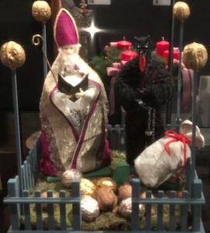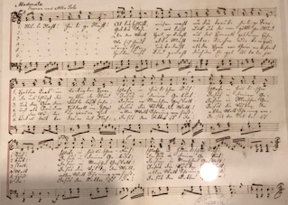
Christmas is coming

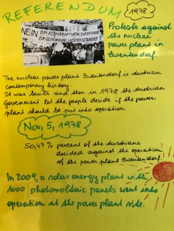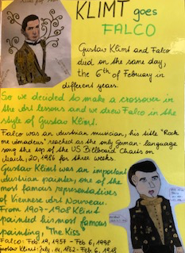
Jubilees of 2018

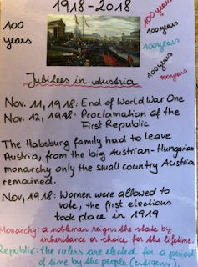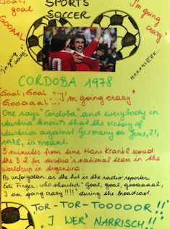
Jubilees in 2018
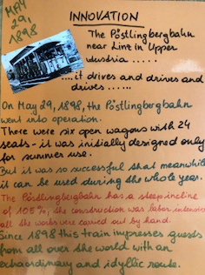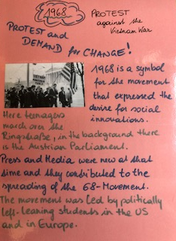
Jubilees in 2018

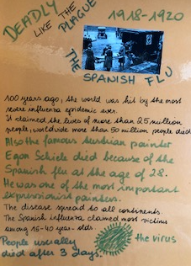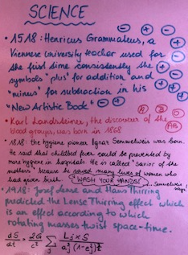
Jubilees in 2018

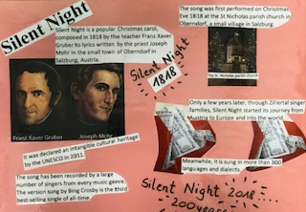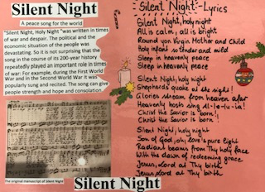
Silent Night also became 200 years in 2018

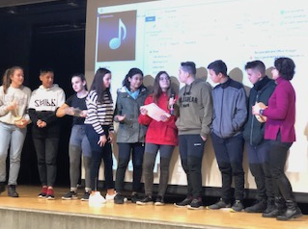 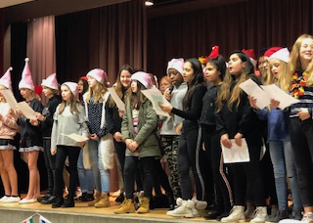
Presentations on stage Singing together

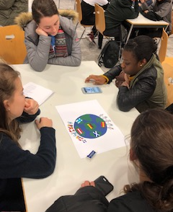 Logo drawing in mixed groups
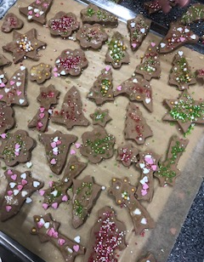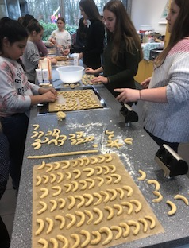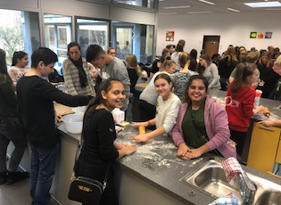
cookie baking

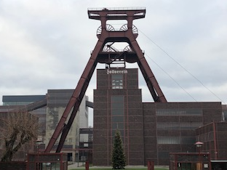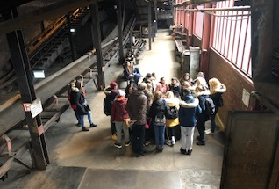
Essen Zeche Zollverein

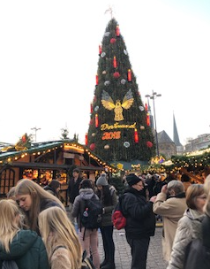Christmasmarket in Düsseldorf

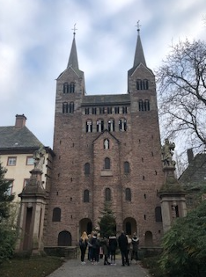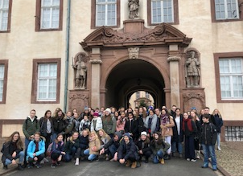
Corvey Abbey

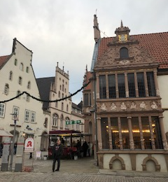 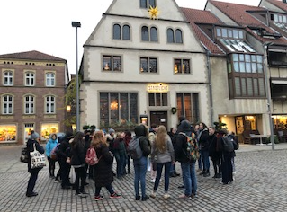
Beautiful Lemgo

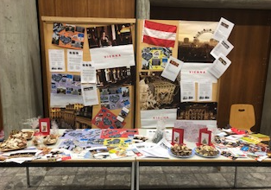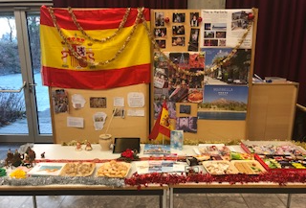

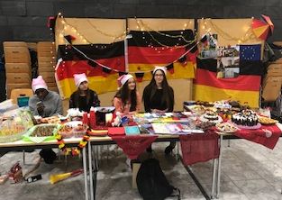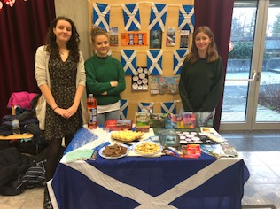

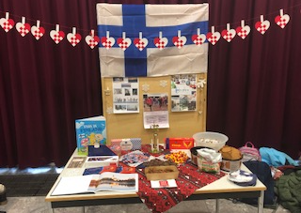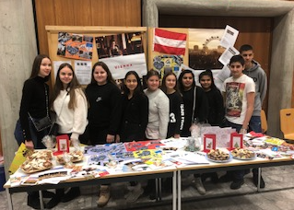
The international stalls

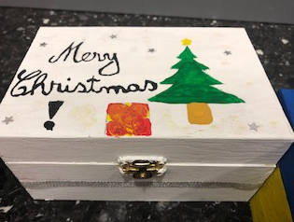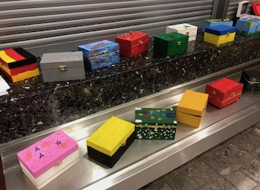
Christmas boxes made in workshops

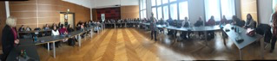

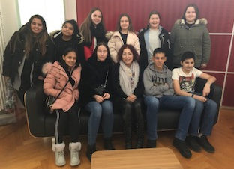 At the Mayor’s office

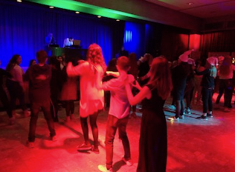 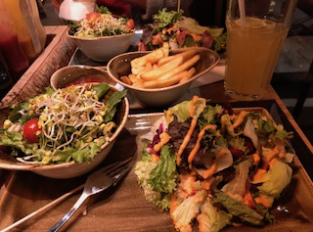
Party time on Friday

One of the activities during the meeting in Germany was singing „Stille Nacht“ in all the project languages.
This popular Christmas song became 200 years old in 2018 coming from a small village in Upper Austria it is sung and known in all partner countries.

Here is the text of the first three stanzas:

German:
Stille Nacht! Heilige Nacht!
Alles schläft, einsam wacht
Nur das traute hochheilige Paar.
Holder Knabe im lockigen Haar,
Schlaf in himmlischer Ruh!
Schlaf in himmlischer Ruh!
Stille Nacht! Heilige Nacht!
Gottes Sohn, o wie lacht
Lieb aus deinem göttlichen Mund,
Da uns schlägt die rettende Stund‘.
Christ, in deiner Geburt!
Christ, in deiner Geburt!
Stille Nacht! Heilige Nacht!
Die der Welt Heil gebracht,
Aus des Himmels goldenen Höh‘n
Uns der Gnaden Fülle lässt seh‘n
Jesus, in Menschengestalt,
Jesus, in Menschengestalt

English:
Silent night, holy night
All is calm, all is bright
Round yon Virgin Mother and Child
Holy Infant so tender and mild
Sleep in heavenly peace
Sleep in heavenly peace

Silent night, holy night!
Shepherds quake at the sight
Glories stream from heaven afar
Heavenly hosts sing Alleluia!
Christ, the Saviour is born
Christ, the Saviour is born

Silent night, holy night
Son of God, love's pure light
Radiant beams from Thy holy face
With the dawn of redeeming grace
Jesus, Lord, at Thy birth
Jesus, Lord, at Thy birth.

Spanish:
Noche de paz, noche de amor,
Todo duerme en derredor.
Entre sus astros que esparcen su luz
Bella anunciando al niñito Jesús
Brilla la estrella de paz
Brilla la estrella de paz.
Noche de paz, noche de amor,
Todo duerme en derredor
Sólo velan en la oscuridad
Los pastores que en el campo están
Y la estrella de Belén
Y la estrella de Belén
Noche de paz, noche de amor,
Todo duerme en derredor;
sobre el santo niño Jesús
Una estrella esparce su luz,
Brilla sobre el Rey
Brilla sobre el Rey.
Noche de paz, noche de amor,
Todo duerme en derredor
Fieles velando allí en Belén
Los pastores, la madre también.
Y la estrella de paz
Y la estrella de paz.

Finnish:
Jouluyö!Juhlayö!
Päättynyt kaikk' on työ,
Kaks vain valveill' on puolisoa
lapsen herttaisennukkuessa,
|:seimikätkyessään.:|
Jouluyö!Juhlayö!
Paimenill' yksin työ,
enkel taivaasta ilmoitti heill':
suuri koittanut riemu on teill'!
|:Kristus syntynyt on!:|
Jouluyö!Juhlayö!
Täytetty nyt on työ.
Olkoon kunnia Jumalalle!
Maassa rauha, myös ihmisille
|:olkoon suosio suur!:|

One of the activities which the students really loved was the Xmas cookie baking workshop and of course afterwards eating the cookies on the next day.
Here are the recipes we used:
Vanilla crescents:
Vanilla biscuits: Ingredients for 40 servings
500g flour
160 g icing sugar
400 g butter
200 g almonds, grated
2 packs of vanilla sugar
Ingredients for turning
1 packet of vanilla sugar
5 tbsp icing sugar
Required kitchen utensils Rollers
Time 90 minutes total time 15 minutes preparation time 75 minutes cooking & resting time
preparation For the vanilla crescents, process the flour, powdered sugar, vanilla sugar, butter cut into small pieces and the grated almonds (or nuts) into a dough and place it in the refrigerator for 1 hour (wrapped in cling film). Then take the dough out of the refrigerator, form a roll on a floured work surface (approx. 3-4 cm in diameter) and cut approx. 1-1.5 cm thick slices from this roll. Shape these slices into croissants and bake on a baking sheet lined with baking paper at 175 ° C for approx. 12-15 minutes (convection) until light brown. Roll the still warm croissants in a mixture of icing sugar & vanilla sugar and then let them cool down completely.

Gingerbread:
Ingredients for 20 servings
300 g of rye flour
180 g of icing sugar
100 g honey
2 pc eggs
1 teaspoon baking soda
3 teaspoons of gingerbread spice
1 pinch of cinnamon
Ingredients for the decoration 1 pinch of sprinkles (colored)
Time 23 minutes total time 15 minutes preparation time 8 minutes cooking & resting time
preparation For the simple gingerbread, the dry ingredients are mixed in a bowl. Then add honey and eggs and knead into a dough. Then roll out the dough, cut out, brush with egg white and decorate with crumble if desired. Then bake in a preheated oven at 180 ° C, top and bottom heat for approx. 8-10 minutes. Let cool and serve. Tips on the recipe. The dough is very, very sticky and can also be prepared with the food processor. The gingerbread can be stored in a cookie jar. If the gingerbread is too hard, put an apple wedge in the cookie jar overnight. If you want the gingerbread darker, add half a tablespoon of baking cocoa. You can also bake the gingerbread biscuits first and then coat them with egg white and sprinkle crumble over them after they have been baked.
Homemade anise donuts
The doughnuts are a traditional sweet popular in all Spain.
The origin of doughnuts is not known with accuracy, it is believed come from the Roman Empire;
Although what's if there is evidence that Arabs produced centuries candy from pan similar to doughnuts.
Ingredients for about 30 units
600 g of all-purpose flour
2 eggs
150 g of sugar
200 g of milk
the zest of half a lemon
100 ml of sunflower oil
100 ml of anise
1 envelope of yeast
a pinch of salt
soft sunflower or olive oil for frying
powdered sugar to decorate

Preparation:
First sieve the flour with the help of a sieve.
In a bowl combine the eggs and sugar, beat them and then add the oil and anise. Again we mix these ingredients and add the zest of half a lemon. We add the flour little by little to the container with the eggs and the milk we mix until obtaining a homogenous mass. Cover the mixture with a cloth and let it rest in the fridge for half an hour.
The recipes that carry yeast tend to be better when there is a rest. After the resting time, we remove the dough and put a little flour on the counter. Knead the dough with a rolling pin until it is soft and manageable. We make about 30 balls of dough, then with the base of a glass or cup we crush them a little and with the handle of a spoon, a spatula or something round we make the hole in the center. Prepare a plate with kitchen paper, where once fried we will leave thedonuts.In a nonstick skillet we add sunflower oil or soft olive oil (the best olive oil does not add more flavor).
We brown the donuts in batches without filling the pan excessively. If you run out of oil add a little more. It is important that they be made in abundant oil. We leave them on a plate with kitchen paper to absorb the excess oil. Prepare the powdered sugar and when they are still warm sprinkle on the donuts. Let them cool before serving, keep well in an airtight container.

Coconut balls:
Ingredients:
125 grs of coconut
125 grs of sugar
2 eggs
Preparation:
Mix the 2 eggs together in a bowl
In another bowl mix the 125 grs of sugar and the 125 grs of coconut
Mix the eggs with the sugar and the coconut and make little balls with the mixture
Pre-heat the oven at 170º
Bake for 10-12 minutes

MARBELLA:

Programme Marbella:

Monday, May 6
8:15 Reception by the headmistress at school
9:00 Departure to Malaga
10:30 The Alcazaba-Arabian Castle
12:00 Lunchtime
13:00 Picassomuseum
14:00 Freetime
14:30 Gymkhana in the old town
17:00 Free time back in Marbella
Tuesday , May 7
8:15 Poetry workshop
9:30 - 12:30 Trip to Juanar mountains.
Time for breakfast there.
13:00 - 13:45 Gifts culture presentations at school.
13.45 - 14:45 Traditional games at school.
14:45 Freetime
Wednesday, May 8
8:15 Trivia „We are Yourope“
9:15 Pasodoble workshop
10:15 Flamenco Workshop
11:15 Mediterranean breakfast for teachers
11:45 Traditional flamenco outfits. Photocall.
12:45 Picasso workshop- Biography and Guernica painting workshop
14:45 Lunch at school’s restaurant for teachers
17:30 Freetime

Thursday, May 9
8:15 Trip to Cordoba
11:00 Mezquita, Arabian Mosque and Christian cathedral protected by Unesco
12:00 Old Town and Jewish district
13:00 Free time for Lunch
15:00-16:30 Medina Azahara, Arabian town protected by Unesco
19:00 Free time back in Marbella
Friday, May 10
8:15 Best poems presentation
9:30 Reception by the city Mayor in the Town Hall.
10:00 Tour in the Old Town
11:00 Trip to the Roman Baths in San Pedro.
Breakfast by the beach.
15:00 End of meeting PARTY
17:00 Free time

5-11 MAY 2019
ERASMUS+ MEETING IN MARBELLA
REPORT

The month of May had just begun when we received our partners in the Erasmus+ project “What's our heritage? We are YOUrope. We had planned lots of activities related to the topic of the project: the cultural heritage.
Visits to important historical places, flamenco and art workshops, a cooking masterclass, etc, but leaving some free time to enjoy the town and everything it has to offer.

On Monday 6th, everyone met at the school's assembly hall where the school's headmistress, Sofía Morales Morales, welcomed the guests. After a fun game to get to know each other and break the ice, the Spanish coordinators explained the plan for the day. The plan for Monday was visiting Málaga. We enjoyed the views of the city and its surroundings from La Alcazaba and visited the Picasso Museum. In order to show our guests some of the most interesting places in the city, we organised a urban gymkhana. By solving riddles, the national teams got to the Picasso statue at La Merced Square, the Cathedral, the Town Hall, or the statue of the “cenachero” (traditional fish seller). Back in Marbella everyone had free time to rest, go to the beach or go shopping.

Tuesday 7th was a very active day. Before the trip, the kids worked in international teams in the Poetry Workshop. They wrote a poem titled “My gift”, which they had previously practised at their schools. After that, we set off for El Juanar mountain, part of Sierra de las Nieves, Biosphere Reserve. There is a lookout at the top from which we could see a big area of the Costa del Sol. Back in the school, the kids took part in a Traditional Games workshop, in which they learnt about different Spanish games that are part of our culture and collective memory. After school, from 14:45, the Erasmus+ team had free time with their host families.

Wednesday 8th, Flamenco and Picasso. This might have been the most intense day. Flamenco was declared World Intagible Heritage in 2010. This is the reason why it is an essential part of this proyect. A successful Pasodoble workshop, with live singing and dancing by teachers from our school, was the big event of the day. Everyone had fun dancing to this traditional music. Next, we had a Flamenco workshop, also with live guitar playing and dancing by a teacher and some students from our school, in which the main elements of flamenco were explained. This was followed by a brief hand clapping workshop in which we practised the rhythmic pattern of two easy and popular flamenco types: sevillanas and rumba. During breakfast time, kids and teachers had the opportunity to wear flamenco traditional dresses, and take pictures at our photocall. After breakfast, teachers and pupils attended a Picasso workshop. The kids, in international teams, made two murals of El Guernica, the famous Picasso work, using the grattage technique, after hearing a brief explanation about the artist, his work and style.

Two of the best examples of the influence of different cultures in Andalusia are the Mosque-Cathedral and Medina Azahara in Córdoba. Our scheduled activity for Thursday 9th was a trip to Córdoba. Before visiting the Mosque-Cathedral, the group had time to walk about Córdoba's old town.

At the end of the week, the Erasmus+ team visited Marbella's Town Hall where they were received by Carmen Díaz, the Culture and Education Councillor, who welcomed us and talked about the importance of European consciousness and culture. After that, we visited the Roman Baths in San Pedro Alcántara, and we had a guided tour about the most interesting historical places in Marbella's old town. Back at the school, we attended a masterclass on Spanish traditional dishes (gazpacho -tomatoe soup- and the famous potatoes omelette) by one of the shool's Catering and Cooking teachers. Finally, the long-awaited end-of-week party at the school's gym. The whole Erasmus+ team, and the host families enjoyed the music show by Eugenia Sánchez (ICT teacher as well as professional flamenco and copla singer) and flamenco dancing by two groups from a local dancing school. We tasted the two paellas made by school's teachers and the delicious dishes brought by the host families.

In addition to all these activities, we found time to develop an important part of the project content as the differences regarding the culture of gift-giving. Firstly, we organised the poetry workshop arranged in the application, titled My gift. In international teams, the kids put into practice what they had already prepared in their schools. Afterwards they made posters with the new poems and some illustrations. Also, the students had the opportunity to show the work they had done at their schools about the gift-giving culture in their countries. The conclusion of this workshop was that, except certain specific occasions, there are not big differences among European countries regarding gift-giving culture.

Our shool's Erasmus+ corner has the shape of a Trivial game board, in which each partner country is represented by a colour. The Spanish kids had made a set of questions about each country covering topics such as traditional food, natural areas, history and culture, to play a game with their guest mates. We had this activity on Wednesday 8th first thing in the morning.

The intensity of the week, as well as the previous months of organisation, are worth it when we see the results and the experience that both our students and the guests have had. We have seen how new friendships are shaped and how we all understand better other cultures and lifestyles which are, somehow, our own. This definitely contributes to the development of a common European consciousness.

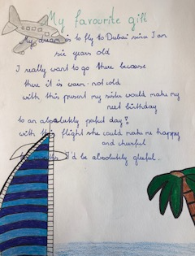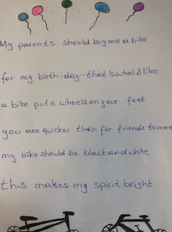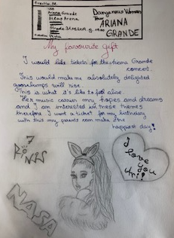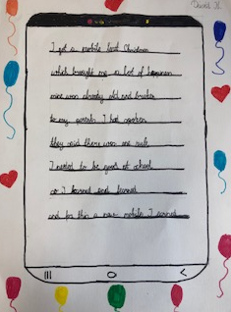

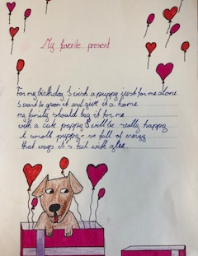 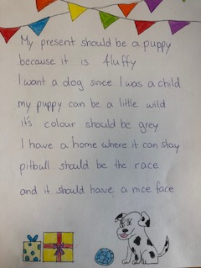
Some poems about presents

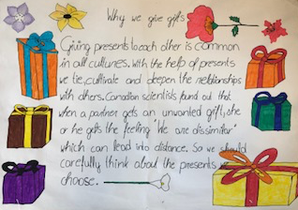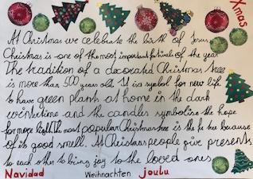

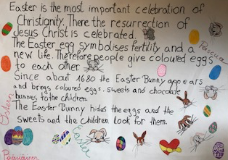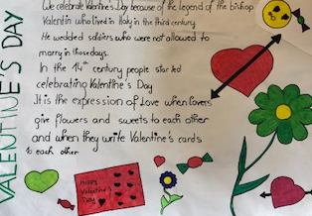
Why we give gifts to each other and exaples for some occasions

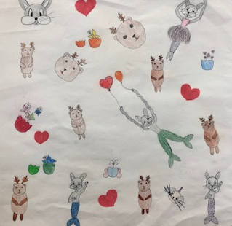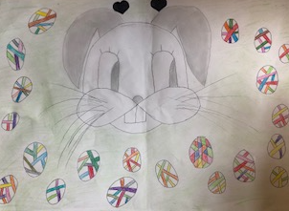

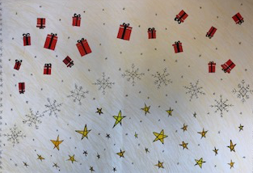 Examples of self-made giftwrappings
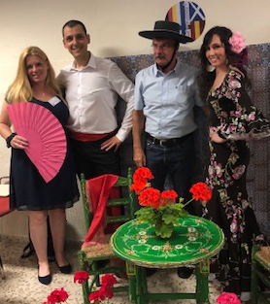 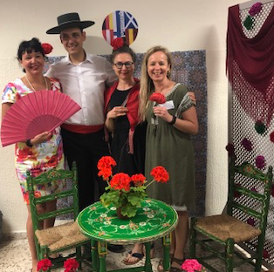
Photocall- Flamenco and Pasodoble workshop

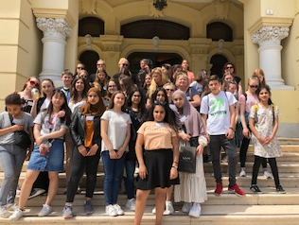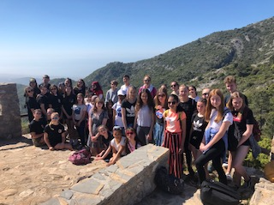
The group in Malaga-no pics allowed in the In the Juanar Mountains
Picasso Museum

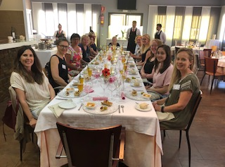 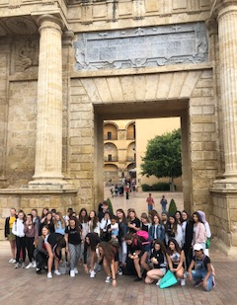
Lunch at the partner school, they have an own restaurant Beautiful Cordoba
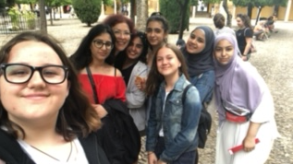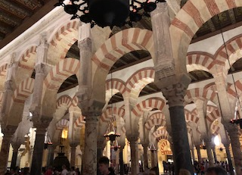
Cordoba

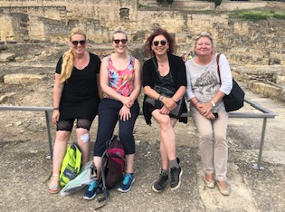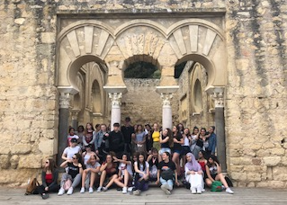
Medina Azahara

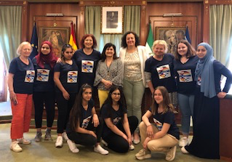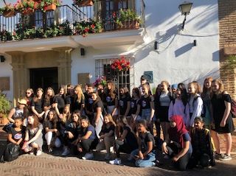
Marbella townhall

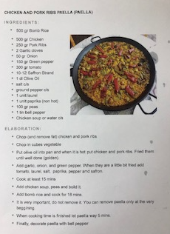 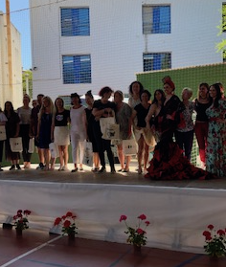 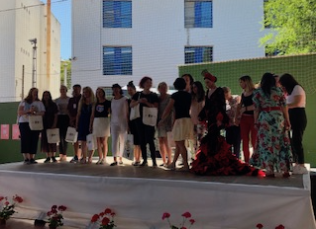 Party with delicious Paella

STIRLING:

STIRLING 23.9.-29.9.2019
Programme:

Monday
9-9:10am – Staff coffee in Conference room, short meeting of days activities.

9:10-10am – Welcome by Mr Pennock & Miss MacRae. Context of where Stirling is etc. – Horrible Histories

10 – 10:45am – Game of touch rugby to get to know each other– rugby was invented in Scotland

10:45-11:05am – Break time (staff to meet in staff room)

11:05-11:45am – Tour of school with pupil guides

11:45-12:30pm – Gaelic lesson for all. Lead by Miss MacRae & Gaelic pupils.

12:30-1:15pm – Lunch (Teachers to meet in conference room for lunch of haggis, neeps & tatties and soup – please let me know of dietary requirements)

1:15 – 3:30pm –Wallace Monument, walk up to monument from school, tour up to top of monument

3:55pm – Home time with pupils

Evening: Meal for teachers, TBC

Tuesday

9-9:10am – Staff coffee in Conference room.

9:10-10:15am – Craft workshop, making tartan [Staff meeting regarding next trip]

10:15am – make way to Stirling (local bus)

10:30 – Engine Shed, Stirling, workshop

12 noon – free time for lunch in Stirling

1pm - Stirling Castle tour

(free time in Stirling / pupils to make own way home from town, unless they wish to go up Dumyat)

Afterschool – opt in walk up Dumyat (weather permitting)

Wednesday

9:15am – All meet at train station

9:30am – Depart for Edinburgh on train

10:30am – Arrive Edinburgh. Guided tour with Harry Potter theme. Taking in sites eg: Castle, Royal Mile (UNESCO site), Greyfrairs Bobby, Grassmarket, Tartan making.

12noon – free time for lunch/shopping

2pm - Edinburgh Dungeons tour

3:30pm – Train back to Stirling

Thursday

9am – All meet at train station

9:30am – Depart for Glasgow.

10:30am – Arrive Glasgow, underground to West End. Visit to Glasgow uni & Kelvingrove museum

12noon – back into Glasgow city centre. Free time for lunch/shops

3pm – Train back to Stirling

Evening – meal for teachers

Friday

9-9:10am – Staff coffee in Conference room, short meeting of days activities

9:10 – Travel into town to meet with Lord Provost (local bus)

10 – 11am – Lord Provost

11am – Return to school

11:10 – 11:40am - Presentations

11:40 - 12:45pm – Social Dancing [Teachers can visit subject specific classrooms if they wish, please let me know beforehand if you wish to do this]

12:45pm – 1:25pm – Lunch

1:25pm – Social Dancing [Teachers can visit subject specific classrooms if they wish, please let me know beforehand if you wish to do this]

2:30pm – Quick quiz of the week (optional, time permitting)

3pm – Home time

7pm – Cèilidh in school. Stovies & Soup. Home baking. Irn Bru.
Report on our Erasmus + Meeting in Scotland 22nd-28th September 2019

Visiting countries were met at the train station by host families and everyone was very excited to meet their visiting students.

Monday

This was the first full day that our international students were here. We started the morning with some ice breakers, which were very fun and beneficial for bringing the nationalities together. After that we did a tour around the school where we showed them our facilities. They especially loved the swimming pool and the girls bathroom. We spent break time getting to know our students and sharing our cafeteria food with them. A new experience of cuisine for some of the countries! After break, we were taken through a Scottish lesson by Miss MacRae who taught us about Gaelic and the Scottish Clans. There was a competition where we made our own tartans, which everyone enjoyed. We also made wee tartan rosettes which we wore…. Although a lot of them broke quite quickly.
We ate lunch and discussed the previous activities. After lunch we went on a trip to the Wallace monument, where we learned about William Wallace, a deep rooted part of Scottish history. The international students loved the birds eye view of Stirling and the surrounding areas that could be seen from the top of the monument. Many selfies were taken.
When that was done, students took their international friends home, and they all split off and did separate social activities.

Tuesday

Tuesday began with some ice breaker activities that got everybody excited for the day and the trip. It was fantastic to see people from all over Europe come together and bond, fantastic and sensational!!!

We then moved onto the Engine Shed, a major attraction in the middle of Stirling. It was there we learned all about Stirling’s architectural history that captivated the foreign students in an indescribable way.

The third thing the group did on Tuesday was head up to Stirling Castle, a mighty fort that towers proud over the city. The students enjoyed walking around the castle and getting a feel of what it was like to live thousands of years ago as a knight, king, queen, servant, maid or jester. It was truly mind blowing, and the students are still blown by the experience that is Stirling Castle.

Tuesday evening took the group to a sushi restaurant within Stirling at 7.30pm. When making their way back towards the Castle, the Austrains took an unknown detour to the local McDonalds but were fortunately found quickly. Perhaps sushi was not to the taste of all the nations.

Wednesday

Wednesday was the day that we took a day trip to Edinburgh with our students. We met at the train station in Stirling at 9:15 in the morning for a train to Edinburgh. Once we arrived in Edinburgh we walked the royal mile showing the foregin students the sights. They all enjoyed seeing the historic Scottish architecture and the differences of it to the architecture from home. We then had some free time with our students allowing them to properly get a feel for what Edinburgh and Scotland was like, including the famous Scottish weather! Dreich! We finally met at Waverley Station at 1:45pm in preparation for a trip to Edinburgh Dungeons which gave the student an idea of Edinburgh’s chilling past. The first tour started at 2pm and the second at 2:15pm. After these tours we got a train home arriving back in Stirling for roughly 5pm where the students returned home with their hosts for the rest of the night. The students all enjoyed a fantastic trip out to a famous and traditional city.

Thursday

On Thursday everybody was so upset that it was nearly time to leave this wonderful place named Scotland.
At the break of dawn, everyone met at the train station to go on an awesome train journey over to the magical city of Glasgow where they walked through the city to the museum at Kelvingrove. We learnt more in a couple hours than we had in our whole lives, it felt. Then they went to do some more cultural activities on the subway, learn how it works and why it’s such an incredible invention, known in Glasgow as the ‘Clockwork Orange’.
Then we all went to visit one of the prestigious Universities of Glasgow, which is the place where people study everything from Accounting and Finance to Ancient History and Anatomy. I'm sure everyone learnt even more about how we teach things in Scotland and how school works over here, maybe even considering coming over to study here in the future.
Then we went shopping in the big city and enjoyed the typical Scottish weather, aka the magical rain that tends to show up at the most perfect moments and make everything seem like a movie scene.
We all enjoyed browsing in the big shops with the city lights all around us, everyone got some fun touristy things and most importantly made memories together, which is even more valuable than any knick knack you could find in a souvenir shop.

Friday

On Friday we took our students to Stirling Council to meet Stirlings Lord Provost, Christine Simpson. During this meet both the Scottish and foregin students alike got a feel for what it is like to work in the Scottish governmental system. This took several hours, allowing a real in depth look at her job. We then took some rest time to prepare ourselves for the ceilidh at night. This was a great set off for the end of the week showing the foreign students a view into Scottish traditional dancing and ceilidh culture, a very new and exciting experience for all of our visitors. It was a great end to the week!

Thank you to all for making this such a fantastic trip and a chance to learn so much about others. We look forward to the next time we can share these experiences together.

Enjoy the Impressions from the great meeting in Stirling!

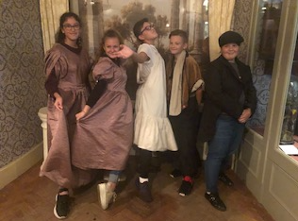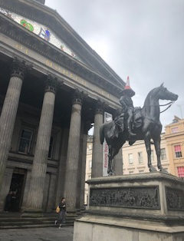
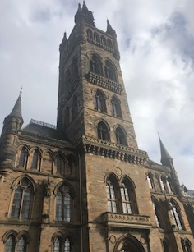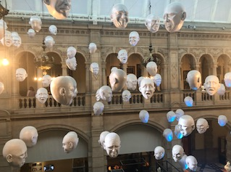
Impressions from Glasgow and the Kelvingrove Museum

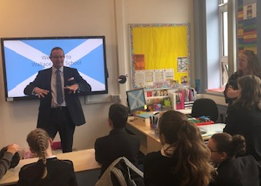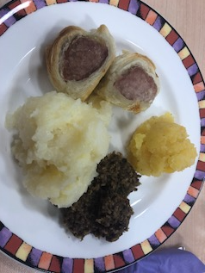
Reception at school and traditional Haggis to taste –we loved it!

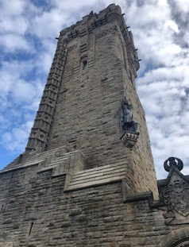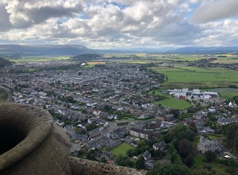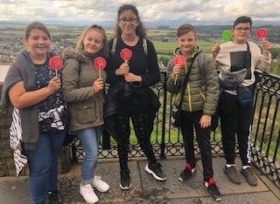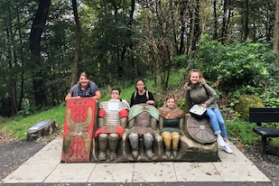
The great William Wallace Monument
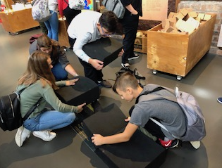The Stirling Engine Shed

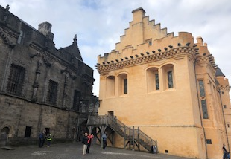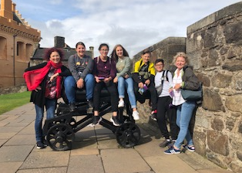
Amazing Stirling Castle

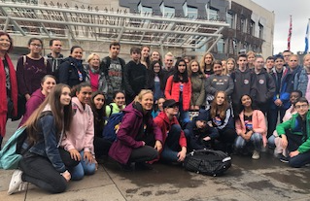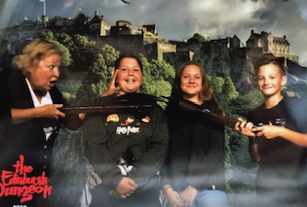
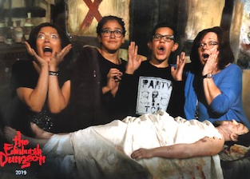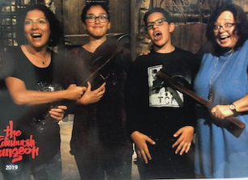 Edinburgh and the frightening Edinburgh Dungeon-we are haapy that we survived this experience!

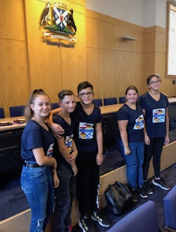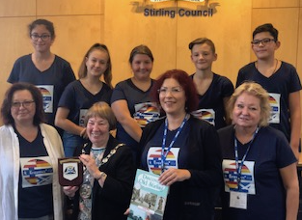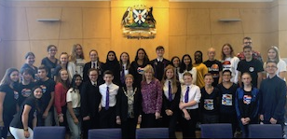Reception at the Lord Provost

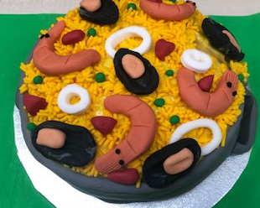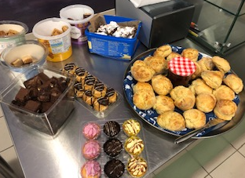
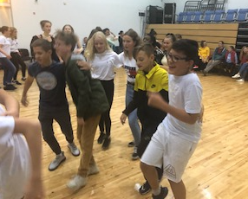 Farewell Party on Friday

OULU:

Oulu FINLAND 20.1 – 24.1.2020 Planning for Erasmus Guests
Monday 20.1.

9:00am – Welcome to Oulu Finland
Opening words by Principal
Split teachers/students
- Raija to hold presentation about OIS for teachers only in staff room
- Samantha: ice breaker for students

10:15 – student-lead tour of school in small colour-coded groups

11:00 Finnish language/drama workshop

12:00: Students’ lunch in the School dining hall – The Big Bite

12:30 – 14:15
Tour of Oulu city centre in groups

- joining in with last lessons/going home with host

Evening for students: FREE TIME WITH HOST FAMILIES

Evening for teachers: 18:00 Sokeri Jussi Finnish restaurant

Tuesday 21.1.

Arrive at school with host according to their timetable and follow their lessons

10:15 Whole school assembly: each country does presentation max 5 mins each

11:15 student’s Lunch at school (teachers: lunch with the principal at Tuba)

11:45 – 13:45 Music workshop in the music class

14:00 – 16:00
Art museum workshop , then going home with host

Evening for students: FREE TIME WITH HOST FAMILIES

Evening for teachers: 18:30 Robert Burns evening – English club of Oulu (takes place in a beautifully maintained cultural heritage building)

Wednesday 22.1

Arrive at school with host according to their timetable and follow their lessons

8:30 Erasmus teacher’s meeting in staffroom

10:15 Outdoor trip to do winter activities: and grilling sausages at Ainola Park

12:00 Lunch at school for students (teachers’ lunch across the road at Tuba)

12:30 Tietomaa interactive Science museum

17:30 Potluck dinner with OIS students, parents and teachers arranged by OIS Parents’ Association

Evening for students: FREE TIME WITH HOST FAMILIES

Evening for teachers: free time after potluck

Thursday 23.1.

7:30 AM departure from school by bus toward Rovaniemi

11:00 – 13:30 - Arktikum museum: guided tour

Lunch at Arktikum Café

14.00 - 15.30 Husky Park

15.30 - 17.00: Santa’s Village
Look at Xmas exhibition; Santa photos and shopping/free time/Arctic circle

8:00 pm – Arrive back in Oulu

Evening: FREE TIME WITH HOST FAMILIES
Friday 24.1

Arrive at school with host according to their timetable and follow their lessons

9:30 – 11:00 Trip to Pikisaari Seamen’s home museum.

11.30 – lunch at school for students

12:00 – 12:30 Oulu mayor visits OIS

12:30 - 14:00
Finnish workshops: 2 crafts workshops and 1 cooking workshop

14:00 – 16:00 – Ending Party: Finnish folk dancing; eating Finnish goodies made in cooking workshop; trivia Kahoot about Oulu/Finland

Farewell for students

Evening for students: FREE TIME WITH HOST FAMILIES

17:00 - 19:00
Evening for teachers: “saunalautta” sauna and jacuzzi evening – own cost for food and entry; snacks/drinks can be bought there. The ferry is docked during winter and we are booking the venue for ourselves. (Everyone wears their swimming costumes – also a warm beanie for outside in the jacuzzi)
https://koivurannansaunalautta.fi/en/

Report of Finland Mobility Monday 20.1.2020 – Friday 24.1.2020
Our guests from Austria, Germany, Spain and Scotland arrived during the weekend at various times.
Monday 20.1.
At 9:00 am on Monday morning, the Oulu International School (OIS) principal, Raija Perttunen, welcomed our guests hoping they would spend a lovely week at our school learning about our school and Finnish culture. After this, the students went with OIS teacher, Samantha Harjula, to take part in an ice-breaker activity to get to know each other better and feel more relaxed being with new friends in a strange school. Meanwhile the accompanying teachers attended an informative presentation about our school and then a staff meeting with the OIS teachers.

Before attending a Finnish language/drama workshop the students and teachers were introduced to the school premises through a guided tour of our facilities by OIS students. In the Finnish language workshop, one of our Finnish teachers, Tanja Salo, lead the visiting students and teachers in fun and games that taught them some basic Finnish words and phrases which might come in handy during the week in Finland like thank you – kiitos, and how to say Finland in Finnish – Suomi.

Midday was lunchtime. Our visiting students got to experience their first typical Finnish school lunch in our school’s lunch hall called The Big Bite. There is always a warm food, salad, and bread as well as either water or milk to drink. Once a week we have a dessert.

The afternoon was spent doing a tour of Oulu city centre in groups. We mixed the groups so that each group had students and teachers from different countries. A sheet of instructions was given to each group which had photos of 6 famous landmarks in the city centre such as Oulu Castle, the Toripoliisi statue and Oulu Cathedral among others. The idea of the tour was an interactive one. Each group had to take a fun selfie with the whole group next to each landmark. There was also a question asked about some detail at each location. Selfies and answers to the questions had to be uploaded to an internet site called Padlet. The locals in each group recognised each landmark and knew how to navigate their group to each location. The group which had all of the tasks done and questions answered correctly was awarded a prize and was announced at Friday’s assembly.
Students went home for the evening to enjoy activities and dinner with their host families while teachers went out to Sokeri Jussi which is a restaurant that provides traditional Finnish food. We ate reindeer and other Finnish specialties.
Tuesday 21.1.

On Tuesday morning when students arrived at school, they joined in with host’s lessons according to their timetable to experience normal classes in Finland. At 10:15 it was time for everyone to go to the gym for a whole school assembly. Each country had a short presentation to show which they had prepared in advance about cultural heritage monuments and buildings in their own city and how they are maintained and restored.

After lunch, our music teacher Maarit Haataja held a workshop about traditional Finnish music. Students learned a Finnish song and how to play simple chords on a traditional Finnish instrument called a kantele. The music was truly beautiful and it was amazing how everyone caught on so quickly.

Then, there was one more creative workshop for the day, and it was off to the nearby art museum. Students viewed the current exhibition of contemporary art called Shared Dreams and then created some of their own art consisting of short video clips in a Green Screen workshop lead by experts at the art museum.

Students had free time again with their host families after the day, while teachers participated in an annual Scottish event held in Oulu each year: a Robert Burns evening hosted by the English club of Oulu which took place in a beautifully maintained cultural heritage building called Weckman House. Amongst all the other programme for the evening, one of our talented teachers from Scotland, Alison MacRae, who is also a singer, sang some traditional Scottish songs for all to enjoy. This evening was very profound and special, also because it was a meeting of Finnish and Scottish cultures within our project.

Wednesday 22.1.

Being in the city centre of Oulu, OIS has many nearby places to visit. Across the road from the school, there is a beautiful large park called Ainola Park where we spent the morning. Wednesday was the day to experience Finnish some traditional Finnish winter activities. Unfortunately, this year there is not as much snow as there usually is, but we managed to do some sledding down an icy hill and grilling sausages on the open fire. We had hoped to ski as well but it was not possible. Grilling sausages is very typical for anyone on a day outdoors in Finnish nature.

Another attraction just 5 minute’s walk from our school is Tietomaa which is an interactive science museum and this is where we spent the afternoon. There are several floors to roam and many interesting exhibits to participate in through hands-on activities.

The OIS Parents’ Association arranged a potluck dinner for the evening. It was held at the school in the Big Bite dining hall. The host families brought along some food and desserts to share with the guests and to eat together. It is special to have OIS parents share their foods as we are an international school and so there were many tasty foods from many different countries including traditional Finnish dishes of course. The evening was fun with lots of feasting and socialising.

Thursday 23.1.

The bus departed from the school at 7:30 am on Thursday morning. It was an early start to an exciting day trip on the bus to Rovaniemi to see Santa. The bus trip takes 3 hours and the first stop in Rovaniemi was the Arktikum Museum with a guided tour. The Arktikum Museum helps people understand the history of the Arctic, what it is like for people and animals to live in the Artic regions. It also teaches about the climate and changing seasons that are unique to the area. Lunch was eaten at the Arktikum Café instead of the school lunch – which was a nice change and upgrade.

After the museum, it was time to see some huskies at the Husky Park. The guests all had a short husky ride. They also had fun patting and hugging the beautiful dogs and having photos taken with them.

Finally, it was time to see Santa. The best part of the trip was left until last. Santa’s Village had many interesting things to do. Students and teachers roamed freely, going to see the Christmas exhibition which shows many different Christmas traditions from Finland and around the world; shopping in specialty Arctic shops; taking photos of stepping over the Arctic Circle line; and of course meeting Santa Claus and having a photo taken with him. It was late – after 8:00pm when the bus arrived back in Oulu.

Friday 24.1.

The first item in today’s programme was to walk 1 ½ km to Pikisaari Sailor’s home museum. The walk is a pretty and scenic one through parks and gardens, across bridges and the Oulu River. The museum was quite small so two groups were made. While one group was in the museum, the other went for a tour of nearby landmarks like the city library. The museum tour was guided, and the hosts were dressed in costume and told and showed what it was like to live a few 100 years ago in Oulu. Since Oulu is a coastal city, sailors played a large part in its history.

Back at school in the afternoon, the mayor of Oulu, Päivi Laajala, came to visit. The mayor gave a presentation about Oulu – it’s past, present and future plans, and she responded to questions afterwards. A group photo with the mayor was also taken. The original idea was to visit the City Hall to meet the mayor, but it was under renovation, so the mayor was kind enough to come and visit the school instead.

One last set of Finnish cultural workshops were held after the mayor’s visit. Students were divided into 3 groups: 2 crafts workshops with craft teachers Anne Linna and Jussi Heikkilä, and 1 cooking workshop with our home economics teacher Sanna Åman.

After the workshops a final “Ending Party” was held. Firstly, there was a trivia Kahoot competition about Oulu and each of the activities that was experienced throughout the week. Hosts teamed up with their guests to compete as a team. Questions included things like: “What does the Finnish word, kiitos mean?”; “Where was our pee break on the way to Rovaniemi and back?”; and “What was the name of the snowmobile simulator at Tietomaa Science Centre?” This was a nice way to review all the activities done during the week. The winning pair received bags of goodies from Oulu. The winning group of Monday morning’s Oulu City tour was announced and the Padlet pictures were shown. To end the celebration, everyone danced the Finnish letkajenkka - a Finnish folk dance and ate Finnish goodies made in the cooking workshop.

Students spent their final evening with their hosts. Many had teamed up during evenings to go bowling together as a group or do other activities. Good memories were made and lasting friendships were sealed.

The teachers had a final Finnish cultural evening. They went to a sauna ferry or “saunalautta” to have a traditional Finnish sauna on a boat which was docked on the Oulu River. The boat also had a warm bubbling jacuzzi outside in the freezing cold. Teachers went in and out of the sauna and jacuzzi as well as taking a few dips into the icy water of Oulu River. Everybody survived the ordeal and even felt refreshed afterwards.

Saturday saw the departure of our dear guests. OIS Finland loved hosting our guests, learning together, and seeing our guests experiencing our Finnish culture with us.

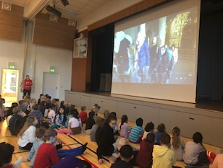 Reception at school

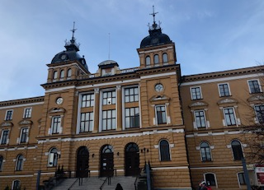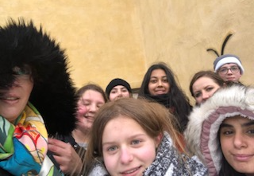
Getting to know Oulu in mixed groups

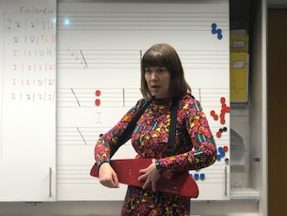 One of the great workshops at school
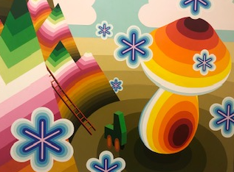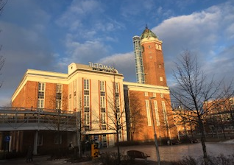
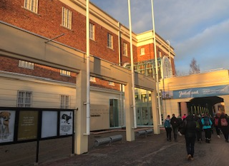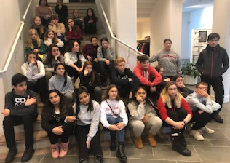
At the Oulu Art Museum

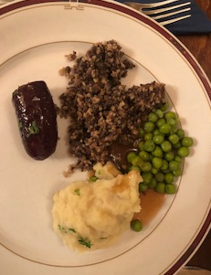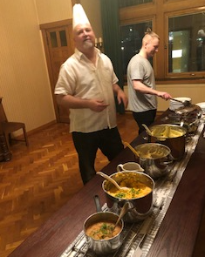
The Robert Burns evening with traditional Haggis

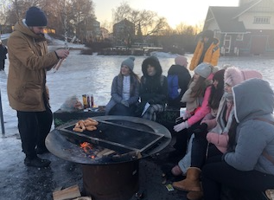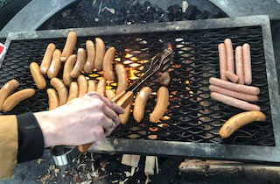
A winter barbecue
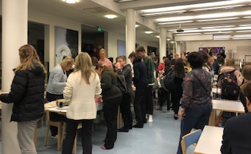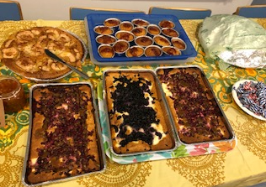
Buffet at school where we met the host families

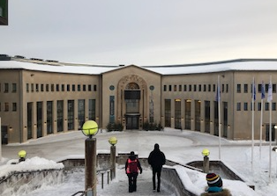The Arktikum Museum

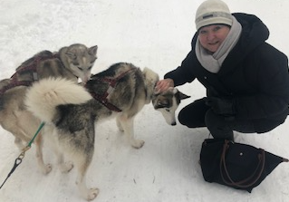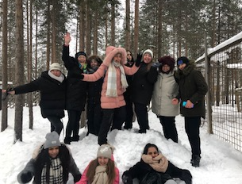
We met lovely Huskies and had a short sleigh ride

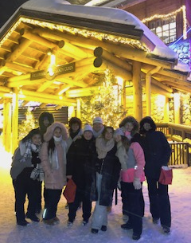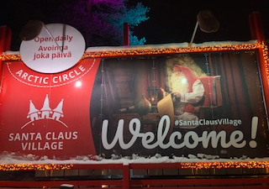
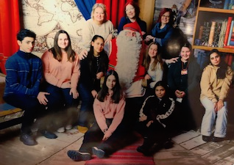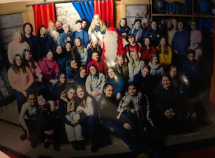
We met Santa in Rovaniemi

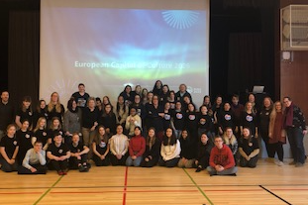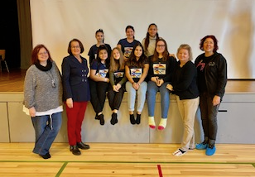
After the presentations we met the Mayor

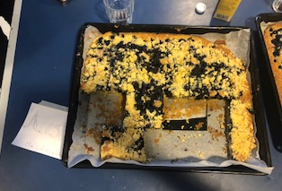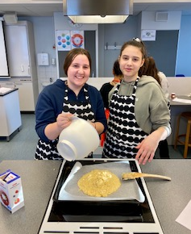
Baking workshop-who had the best recipe?

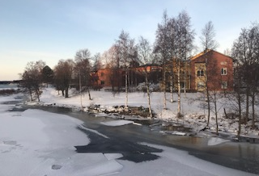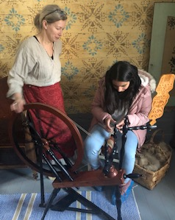
Oulu and inside the Pikisaari Museum

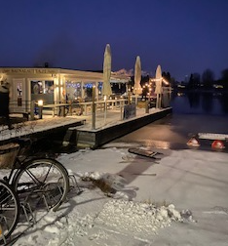Not to be missed- Sauna on a boat

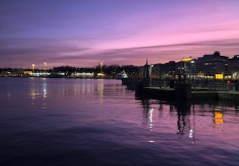 Helsinki