Preserving A Culture With Traditional Games
Traditional Games and Sports were recognised by UNESCO as world intangible cultural heritage.
In the purest sense, they are the games and movements that are traditional to our cultures, from dances to ball games and water sports. But they are more than that. TSG form a significant part of our history and help make us, and our variety of cultures, what we, and they, are today. TSG tell the story of our past, and span genders, generations and individual differences like little else can. By their very nature, TSG are localised and regional, and should be recognised as the necessary counterparts to the globalised mass sports and culture of today, right alongside language, music, literature and architecture. TSG are a chance to enjoy diversity and community in an increasingly globalised world.
Traditional Sports and Games provide unique opportunities that mainstream sports may not. They are often based on fun and participation, not competition, and provide a link to something bigger than sports and physical activity alone.
There are so many traditional Spanish games that you can find. Below are some of the most popular traditional games that you can find these days.
An opportunity to renew connections to history and culture.

Think about these questions in your group and express your opinión.

- What games do you play?
- What games did your parents play?
- What gamesd did your grandparents use to play?
- Who plays or played more? Do you think that today children and teenagers play less or different?
- Do you think that traditional games reflect ant trasmit cultural values?

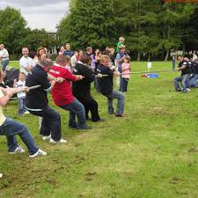

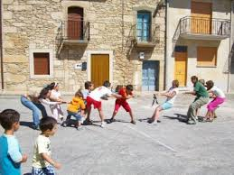

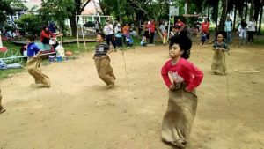

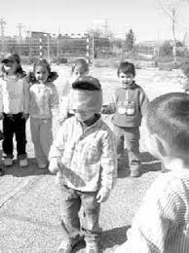
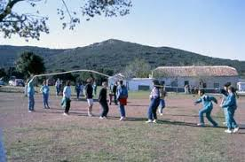

TRADITIONAL GAMES

IF YOU ARE SUCEED TRYING A TRADITIONAL GAME, YOU WILL HAVE TO FILL THIS TABLE WITH DIFFERENT STAMPS.
TEAM NAME:
COMPONENTS:
1.
2.
3.
4.
5.
6.
7.
8.

SACK RACE | JUMPING ROPE | THE HOOP | PRISON BALL
THE HANDKERCHIEF | BLIND MAN BLUFF | LAS CHAPAS  THE BOTTLE CAP GAME | EL CHITO
ROPE WAR

