PROYECT ERASMUS+ 2018 DIARY
By Kajsa Urtecho
Before even starting I want to say that this has been a beautiful experience and that I’m so grateful to have been given the chance to travel with my friends and wonderful teachers, it is something I will never forget.
Sunday, december 9th
We got up early and finished packing our stuff to get on time to the airport and fly from Malaga to Dusseldorf. It was a nice fly, in which we chatted, read, played…
Once in Dusseldorf we had to take a train to Bielefeld, or to another city and then Bielefeld, I don’t remember pretty well because we were in a rush and had to run because a train was delayed. Finally we got in a train which took us directly to Bielefeld.
When we got there we saw all the families waiting for us and the teacher named us one by one and introduced us to our hosts. My host was called Julina, and she came to pick me up with her mom. They were really nice and they recieved me warmly.

Monday, december 10th
On Monday we saw the whole school in a lovely guided tour that some German pupils gave us, it was really different compared to our school, it was 5 times bigger than ours, and really well organised. We had lunch there and we did some other activities like singing christmas songs or playing board games with our new friends. Then at15:30 we went home and spent the evening with our hosts.

Tuesday , december 11th
We started the day by singing christmas songs again, then made christmas ornaments in some workshop they had prepared for us.Later we had lots of fun baking typical spanish sweets for the christmas stalls, and playing outside when we were done.
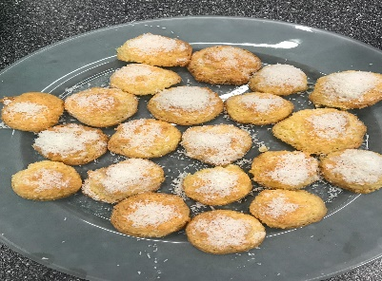
we made some coconut balls that turned out surprisingly good, and some “donuts”, but they didn’t turn out that great.

Later that day we visited Dr.Oetcker’s Factory. And had great fun seeing the museums and cool stuff that they had there. Like a giant pudin or the interactive room. They also gave us cereal, and later pizza, it was all delicious.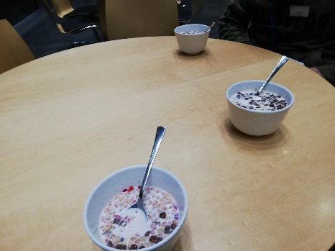
Wednesday, december 12th
This day we got up eraly becausewe had to be at the train station really son, so once thair we got in several crowded trains to Zolverein, where we visted the Zeche und Zolverein mines.
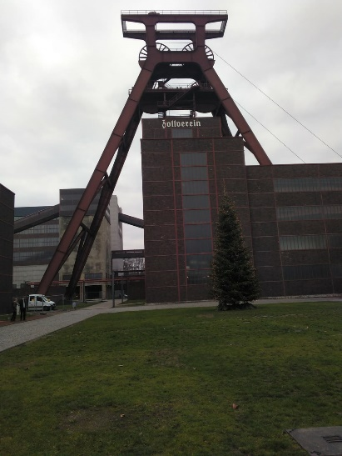
This is the entrance to the mines.
Later that day we took some more trains to get to Dortmund. And there we had free time for shopping, eating and walk around, we also saw Europe’s biggest christmas tree, and took a lot of pictures.
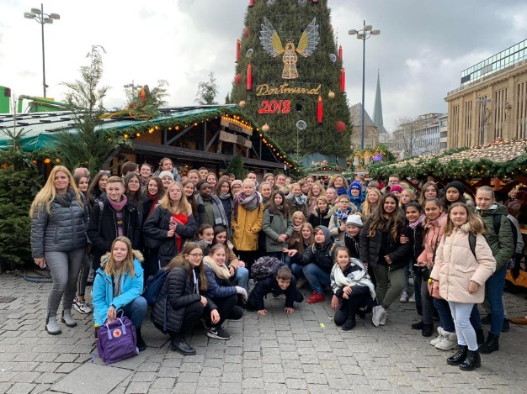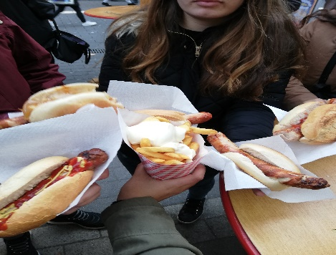this is what we had for lunch in Dortmund
Thursday, december 13th
In the morning we got in our bus headed to a Corvey’s castle where we had a guided tour.
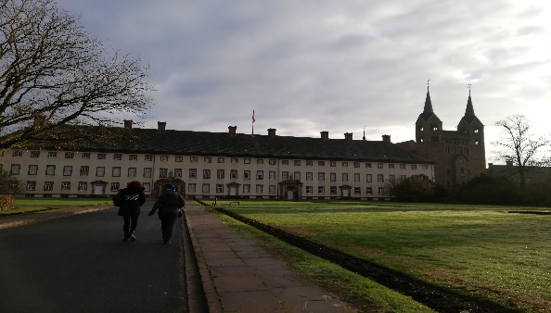
In the evening we went to a Little towncalled Lemgo, where we had some free time to walk and see the town. Me and my friend Shemsi went shopping for souvenirs and gifts,and had coffe and some sweets. And later we visited a witchcraft museum where we had another guided tour.
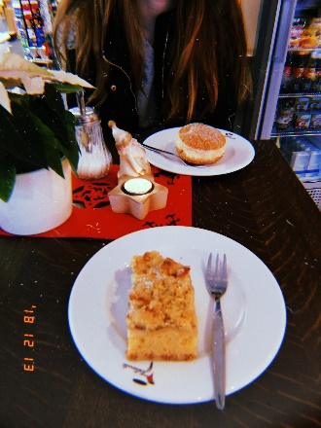
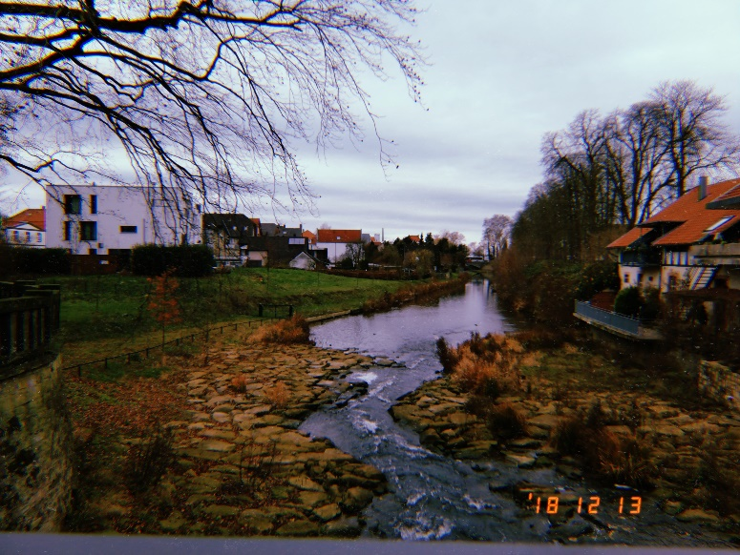
Friday,december 14th
This adventure was coming to its end and we were only getting closer togheteher with all our new friends. In the mornig we made our christmas stall, which turnedout great, in my opinion.
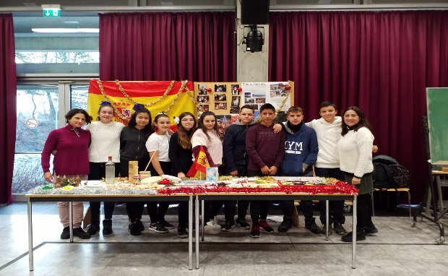
An hour later we saw all the performances that the pupils had prepared, and we also sang our popular song which everybody had been singing for the whole week “la marimorena”. And some others like “feliz navidad” and “holy night”.
After that we went to the town hall to mett the town’s council, where we had a Little chat with her and got to ask her a lot of questions.
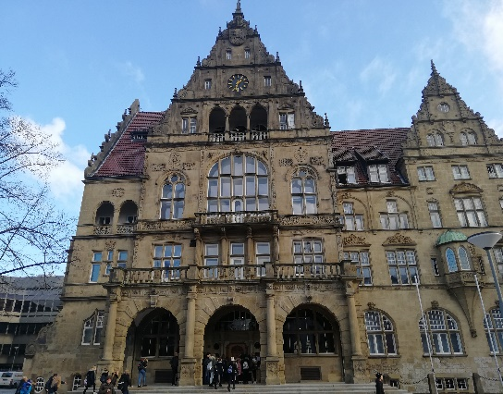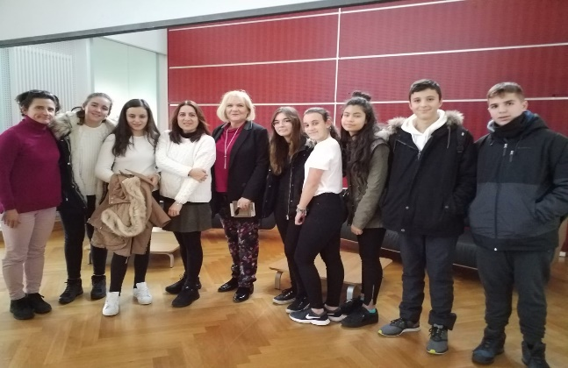
And finally that day we had to say good-bye to all our ew Friends and had a party that was really fun.

Saturday,december 15th
We got up really really early because our train left at 5:58 and the said good-bye again to our hosts and Friends, then left and took a plain to malaga.

