5-11 MAY 2019
ERASMUS+ MEETING IN MARBELLA
REPORT

The month of May had just begun when we received our partners in the Erasmus+ project “What's our heritage? We are YOUrope. We had planned lots of activities related to the topic of the project: the cultural heritage. Visits to important historical places, flamenco and art workshops, a cooking masterclass, etc, but leaving some free time to enjoy the town and everything it has to offer.

On Monday 6th, everyone met at the school's assembly hall where the school's headmistress, Sofía, welcomed the guests. After a fun game to get to know each other and break the ice, the Spanish coordinators explained the plan for the day. The plan for Monday was visiting Málaga. We enjoyed the views of the city and its surroundings from La Alcazaba and visited the Picasso Museum. In order to show our guests some of the most interesting places in the city, we organised a urban gymkhana. By solving riddles, the national teams got to the Picasso statue at La Merced Square, the Cathedral, the Town Hall, or the statue of the “cenachero” (traditional fish seller). Back in Marbella everyone had free time to rest, go to the beach or go shopping.

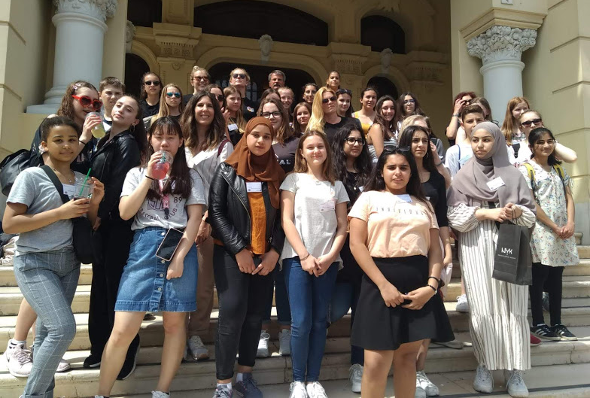
Tuesday 7th was a very active day. Before the trip, the kids worked in international teams in the Poetry Workshop. They wrote a poem titled “My gift”, which they had previously practised at their schools. After that, we set off for El Juanar mountain, part of Sierra de las Nieves, Biosphere Reserve. There is a lookout at the top from which we could see a big area of the Costa del Sol. Back in the school, the kids took part in a Traditional Games workshop, in which they learnt about different Spanish games that are part of our culture and collective memory. After school, from 14:45, the Erasmus+ team had free time with their host families.

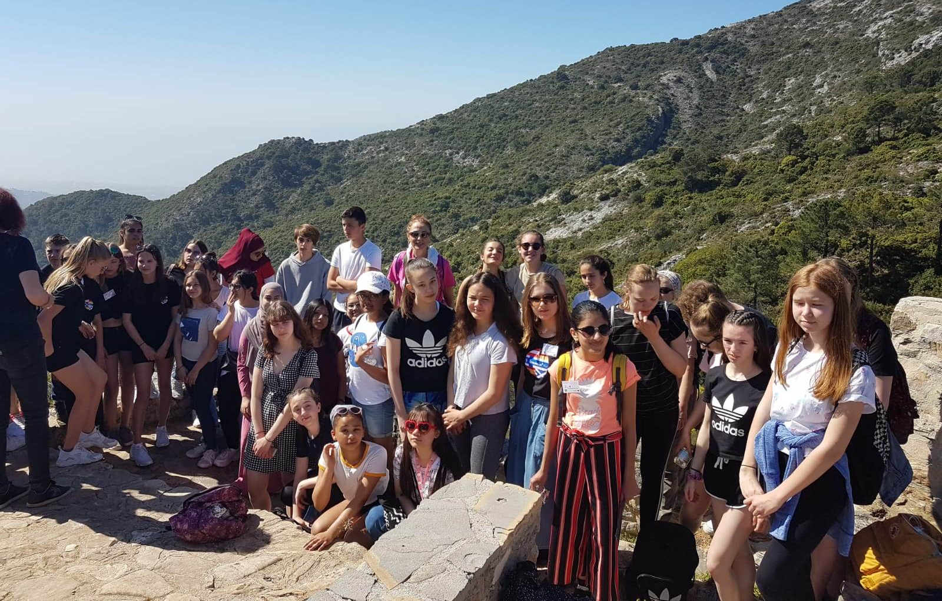
Wednesday 8th, Flamenco and Picasso. This might have been the most intense day. Flamenco was declared World Intagible Heritage in 2010. This is the reason why it is an essential part of this proyect. A successful Pasodoble workshop, with live singing and dancing by teachers from our school, was the big event of the day. Everyone had fun dancing to this traditional music. Next, we had a Flamenco workshop, also with live guitar playing and dancing by a teacher and some students from our school, in which the main elements of flamenco were explained. This was followed by a brief hand clapping workshop in which we practised the rhythmic pattern of two easy and popular flamenco types: sevillanas and rumba. During breakfast time, kids and teachers had the opportunity to wear flamenco traditional dresses, and take pictures at our photocall. After breakfast, teachers and pupils attended a Picasso workshop. The kids, in international teams, made two murals of El Guernica, the famous Picasso work, using the grattage technique, after hearing a brief explanation about the artist, his work and style.
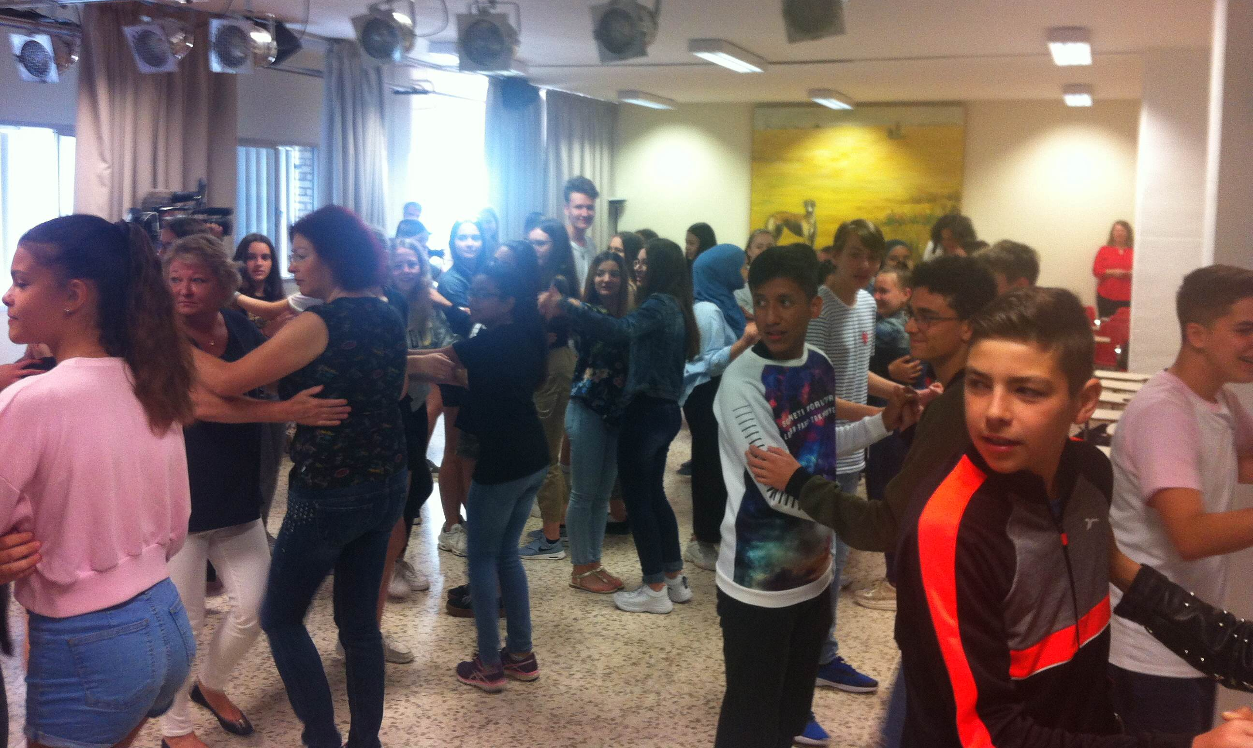
Two of the best examples of the influence of different cultures in Andalusia are the Mosque-Cathedral and Medina Azahara in Córdoba. Our scheduled activity for Thursday 9th was a trip to Córdoba. Before visiting the Mosque-Cathedral, the group had time to walk about Córdoba's old town.

At the end of the week, the Erasmus+ team visited Marbella's Town Hall where they were received by Carmen Díaz, the Culture and Education Councillor, who welcomed us and talked about the importance of European consciousness and culture. After that, we visited the Roman Baths in San Pedro Alcántara, and we had a guided tour about the most interesting historical places in Marbella's old town. Back at the school, we attended a masterclass on Spanish traditional dishes (gazpacho -tomatoe soup- and the famous potatoes omelette) by one of the shool's Catering and Cooking teachers. Finally, the long-awaited end-of-week party at the school's gym. The whole Erasmus+ team, and the host families enjoyed the music show by Eugenia Sánchez (ICT teacher as well as professional flamenco and copla singer) and flamenco dancing by two groups from a local dancing school. We tasted the two paellas made by school's teachers and the delicious dishes brought by the host families.
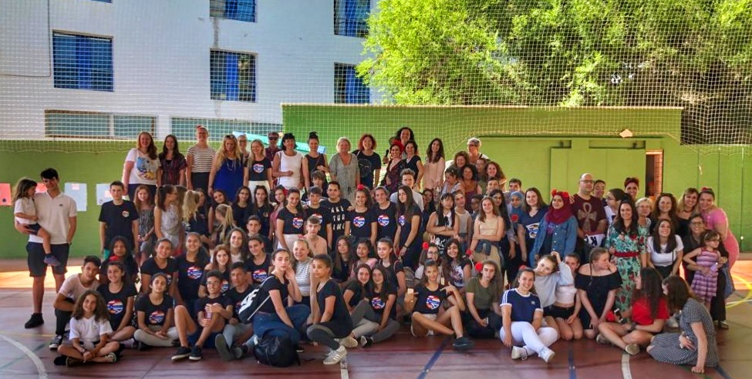
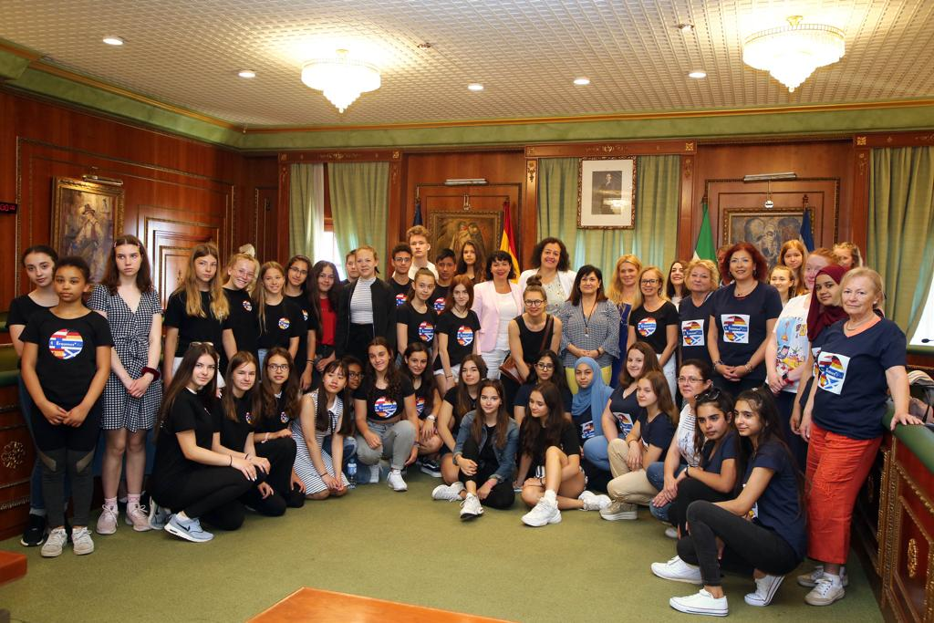
In addition to all these activities, we found time to develop an important part of the project content as the differences regarding the culture of gift-giving. Firstly, we organised the poetry workshop arranged in the application, titled My gift. In international teams, the kids put into practice what they had already prepared in their schools. Afterwards they made posters with the new poems and some illustrations. Also, the students had the opportunity to show the work they had done at their schools about the gift-giving culture in their countries. The conclusion of this workshop was that, except certain specific occasions, there are not big differences among European countries regarding gift-giving culture.
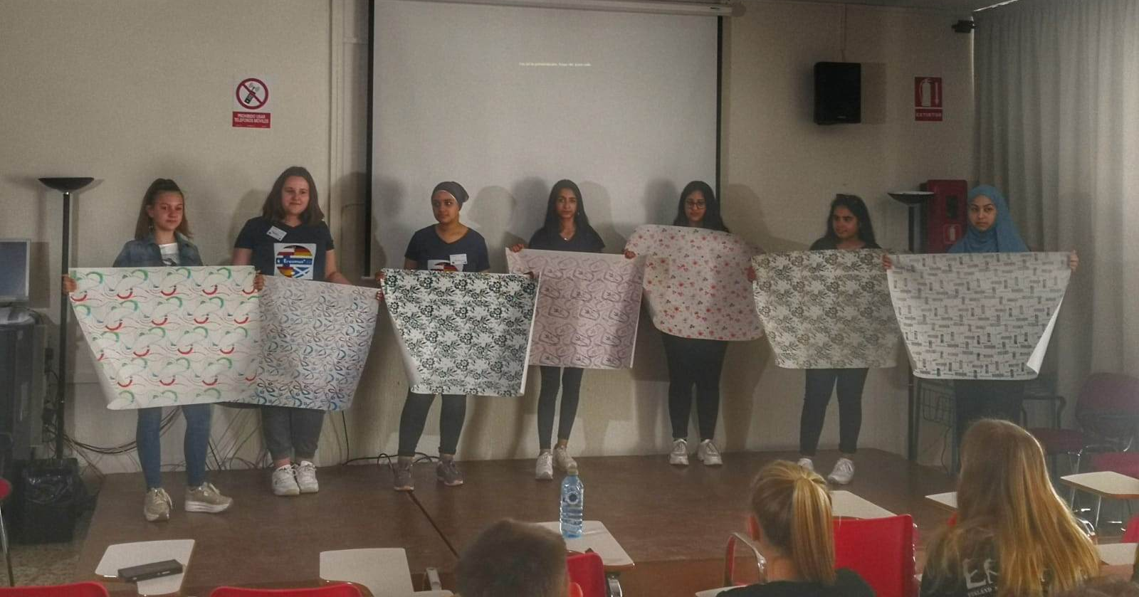
Our shool's Erasmus+ corner has the shape of a Trivial game board, in which each partner country is represented by a colour. The Spanish kids had made a set of questions about each country covering topics such as traditional food, natural areas, history and culture, to play a game with their guest mates. We had this activity on Wednesday 8th first thing in the morning.

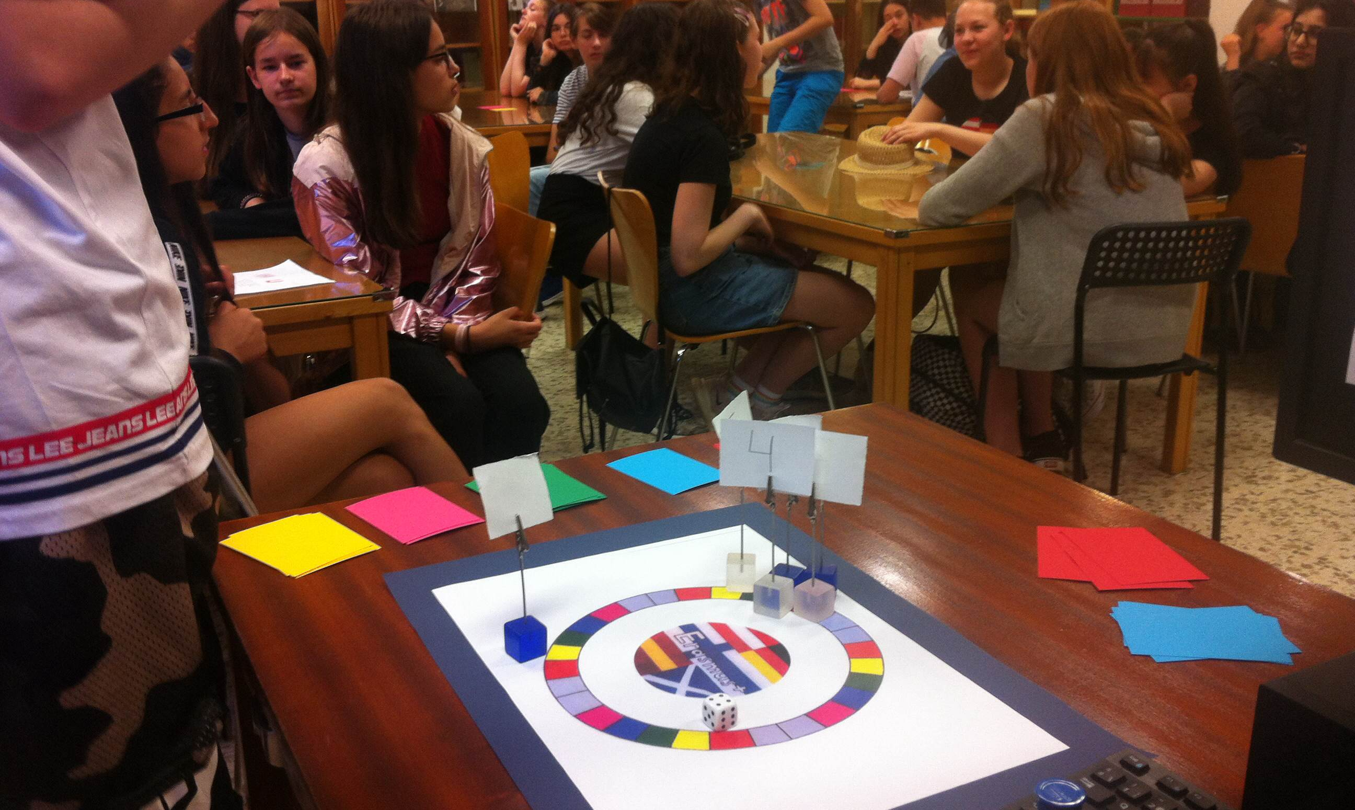

The intensity of the week, as well as the previous months of organisation, are worth it when we see the results and the experience that both our students and the guests have had. We have seen how new friendships are shaped and how we all understand better other cultures and lifestyles which are, somehow, our own. This definately contributes to the development of a common European consciousness.



