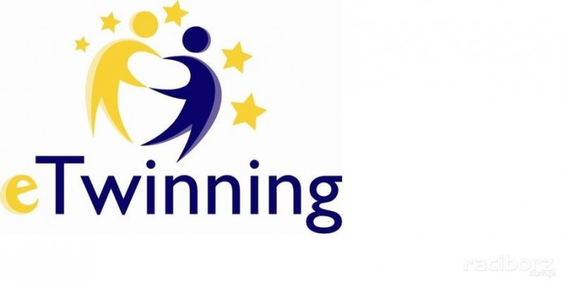

This Certificate is proudly presented to

………………………

for winning the Karaoke Competition *“Don’t be shy, Give it a try!’’* e-Twinning Project

14.01.2019  
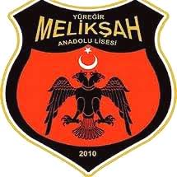

**MELİKŞAH anatolıan hıgh school**

Englısh teacher

SCHOOL Prıncıpal

Firdes KOC SAGILIR

Cebrail AKBAYIR