
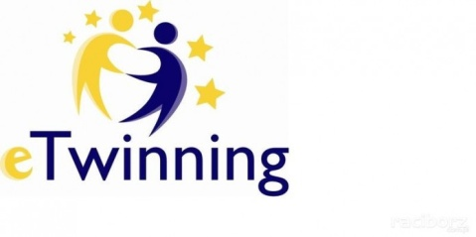
BATMAN SASON anatolıan hıgh school
This Certificate is proudly presented to
...............................
for the participation of Karaoke Competition “Don’t be shy, Give it a try eTwinning Project
24.04.2019
Englısh teacher
Prıncıpal
Perizan Feriha GÜNGÖR
Veysel GÖKTAŞ

