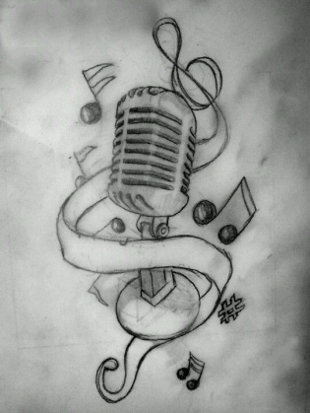
Sıra | Ad Soyad | Sınıf | Numara | TELAFUZ  (PRONOUNCIATION) | RAHATLIK  (IMPRESSION OF THE SONG) | ŞARKIYI DOĞRU TONDA OKUMA  (SINGING WITH THE RIGHT TONE) | SÖZLERİ TAKİP EDEBİLME  FOLLOWING THE LYRICS OF THE SONG) | SAHNE PERFORMANSI  (STAGE PERFORMANCE) | TOPLAM  TOTAL
1
2
3
4
5
6
7

