Life cycle of rocket (Rauke)

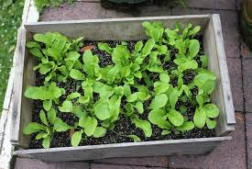
This plant is small but it has to be threaten well (has to be kept wet)
It has to be kept by a temperature of 10 to 20 degrees. Rocket has to be planted with 10 to 20 centimeters distance. You can eat it within 4 to 6 weeks. This plant is often confused with Rucola. You can eat it as a salad.
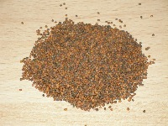
This are the seeds of the rocket. They are a little brown

This are rocket rungs they are little.

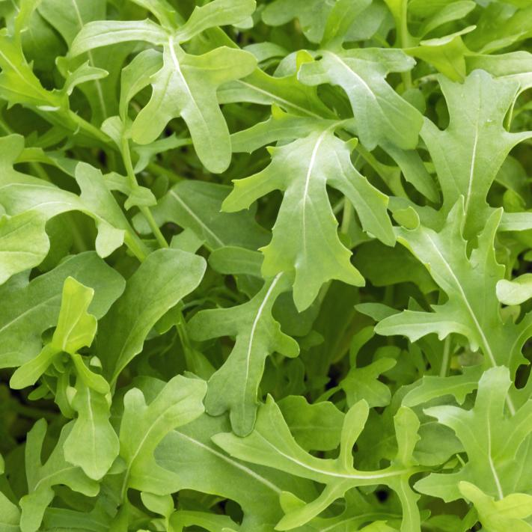

At the end it will be looking like this, then you can eat it as a salad.

Enjoy.

