Method: Convey a Message Using Film
Material:
You need a camera and a program for editing. An iPad with iMovie is sufficient.
Age group:
10-adult
Aim:
- Convey a message to others
- Expressing an idea using images, sound and words
How to:
- Create a storyboard.

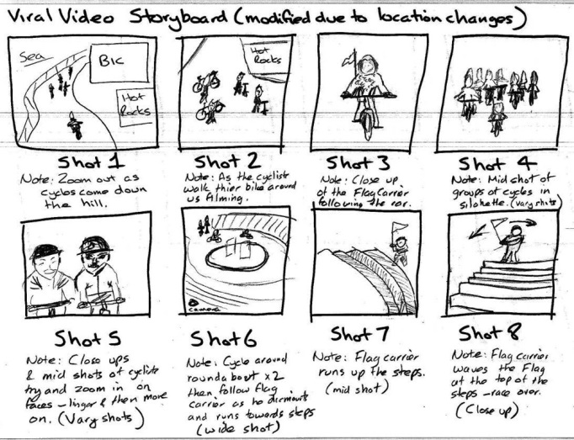
Decide what the message of your film is.
What is it that you want to convey to the viewers?
- Decide who is going to take on each role in your group: camera man, director, actors, script etc.
- Write a script.
- Start to film. Take lighting, sound and different angles into consideration.
- Edit your film. The final product should be 1-3 minutes, but you need a lot more material to work with.
- Give your film a suitable title.
- Show your film to a test audience. Ask them what message they get. If they don’t get it, go back editing.

Example:
- A Girl’s Story - a film created to start a discussion regarding freedom of expression
https://youtu.be/T4GiTFnbUH8
- Buddies’ Earphone holder – a film created to sell a student company’s product
https://youtu.be/8GwCHre9_88

