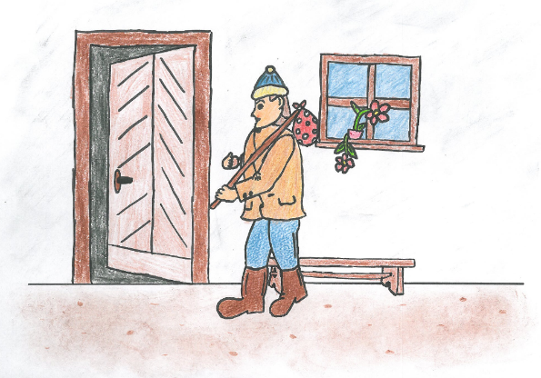
HONZOVY BUCHTY (= JACK´S BUNS)

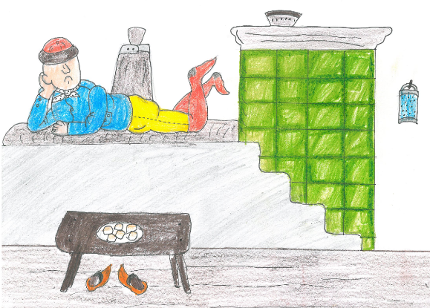
The word buchty is the plural form of the word buchta, which is Czech for “small bun” or “small cake”. If buchteln is the common word used by many countries to call these little buns, they have a different name depending on each region or country. In Slovenia they are called buhteljni, in Serbia, it is buhtle, in Hungary, they are called bukta, in Croatia, buhtle, in Poland, buchta, In Bavaria, they are called rohrnudeln, in the Czech Republic buchty, buchtičky or buchtička…

Many Czech fairy tales start with a similar scene: in a small village, there is a family which has a son named Honza, who appears to be very lazy and dumb. He sleeps a lot, eats a lot and is no help to his aging parents. One day, his parents either send him to see the world and learn some skills, or he decides himself that it is time for him to get up and save the princess. He leaves the village while his mom is crying, and to make sure that her boy won’t suffer too much or starve to death, she packs for him some sweet buns with farmer cheese filling. The young man eats the buns on his way, or sometimes also shares them with some creatures in the forest, and they give him enough strength and smarts to kill a dragon, beat a devil, or outsmart an old witch. Besides our hero, the delicious treat from his mother is definitely the winner here.
That is no surprise – the sweet buns have centuries-long tradition in Central Europe, since the 1600s to be exact. The buns are soft, slightly sweet, sprinkled with icing sugar, and they make a perfect breakfast or snack with a cup of coffee, hot tea, or hot chocolate.
Flour, butter, milk, salt, yeast, eggs, and a little sugar, these are the ingredients of these traditional buchty. Of course, you can prepare plain buchty but, the most traditional recipe includes a „povidla“ filling. The povidla is a confit of fruits, and most often of damson plums. In Central Europe or Eastern Europe, every year at the end of August, the women gather to patiently make this confit of plums. Unlike jams, the sweetness of this fruit confit does not come from any added sugar but from the concentration of the sugars of the ripe fruits obtained by cooking them for a long time at low temperature. In its most authentic form, a povidla never contains sugar. The second traditional filling for the buchty is poppy seeds. The ground poppy seeds are cooked with milk and sugar for a few minutes. The cooled mixture is then blended with sugar and vanilla. And finally the tvaroh-based filling (quark cheese), that is mixed with lemon zest, vanilla, and raisins that are rehydrated with rum and sugar.

During the 18th and 19th centuries, buchty was not only a treat on Sunday mornings for both rural and urban families, but they also used to be a traditional meal on Christmas Eve. In the earlier days, the dough was cooked in boiling water and dipped in melted butter, but later, people started to form buns, bake them in the oven and added different sweet fillings as well. Many families have their own recipes they keep for generations.

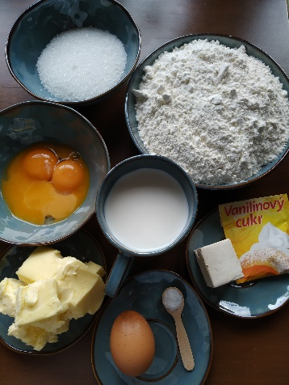

For the filling
- 1 jar of povidla (plum jam)
- 120 grams ground poppy seeds
- 100 ml lukewarm milk
- 2 tablespoons vanila sugar
- 2 tablespoons caster sugar
- 250 grams cottage cheese
- 1 egg yolk

For the decor
- icing sugar
- 5 tablespoons of melted butter

INGREDIENTS
- 500 grams (of) all-purpose sifted flour
- 200 ml (of) lukewarm whole milk
- 60 grams yeast
- 130 grams caster sugar
- 170 grams butter
- 4 egg yolks
- 1 egg
- 1 teaspoon vanilla sugar
- pinch of salt

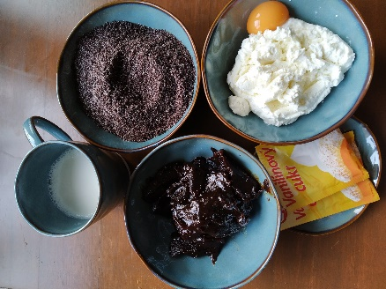

Instructions
- In a large bowl, mix the yeast with a lukewarm milk and one tablespoon of caster sugar.
- In a small saucepan, melt the butter and let it cool down.
- In a large bowl, pour the egg and egg yolks and beat them lightly.
- Add the vanilla sugar, melted butter, and mix everything together very thoroughly.
- Add the yeast and 1 cup of flour. Start kneading and gradually add the remaining sugar and flour.
- Knead for at least 3 minutes, then add a pinch of salt.
- Knead again for another 3 minutes until the dough is nice and smooth.
- Cover the bowl with a kitchen cloth and let the dough rise for at least 30 minutes, away from draft.
- While the dough is resting, prepare the filling. Mix following ingredients together: For the first filling you need ground poppy seeds, 1 tablespoon of vanila sugar and 1 tablespoons of caster sugar. For the second filling you need cottage cheese, 1 tablespoon of vanila sugar, 1 egg yolk, 1 tablespoon of caster sugar. And for the third filling you need a plum jam.
- Preheat the oven to 180 degrees Celzius.
- Once the dough is ready, place it on a lightly floured work surface.
- Divide the dough into 20 equal pieces, flatten each piece in your hand.
- Put a teaspoon of plum jam in the center of each piece and fold the sides to enclose the jam. Form small balls, buns. Make sure you have all the filling inside.
- Turn each bun over and place them next to each other in row in a greased, rectangular pan.
- Brush all buns generously with melted butter.
- Let the buns rise again for 20 minutes at room temperature, away from draft.
- Place a pan with buns into the oven and let them bake for 25 to 30 minutes in a preheated oven, until golden brown.
- As soon as they are baked and out of the oven, brush the buns with melted butter again.
- Let the buns cool down slightly and at the end, sprinkle buns with icing sugar.
Enjoy these deliciously soft and airy „buchty“!
