CASE STUDY
OF PUPIL/S WITH LEARNING DIFFICULTIES

Pupil/s Age: | Different students and difficulties, regarding literacy, have been taken into practice.
Academic Year: | 2016/2017
Area of curriculum and difficulties: | Literacy
Summary of difficulties including specific needs, barriers to learning and adaptations to curriculum:

- Slow reading aloud
- Slow pace of work
- Low self-confident
- Low reading comprehension
- Low speaking (poor vocabulary, strucutres…)

TEACHING AND LEARNING STRATEGIES USED
- PEER MENTORING READING:
The teacher groups the students in twos. Every pair consists of a high reader (HRS) and a lower reader (LRS).
A great variety of texts has to be selected.
The teacher gives a text and reading comprehension questions to the HRS, who has to read it thoroughly in order to become an “expert” on that text.
The ARS and the LRS sits together. The LRS reads the text aloud. Once the LRS has read the text, the HRS has to assist the LRS with vocabulary.
While the LRS is reading, the HRS puts his hand on the LRS shoulder so that he can feel body contact. When he reads too fast, skips full stops… the HRS moves his hand from the LRS shoulder so that the LRS realizes he has something to correct. Finally, the LRS has to answer the questions and the HRS has to correct/guide if there’s any mistake. It is important that the HRS uses encouragement vocabulary so that the LRS feels confident.
Different readings have to be practiced systematically. The couples of students don´t change.
Finally, the HRS has to invent different questions to understand the text. The teacher assists the ARS to make sure s/he can deal with the reading.
Finally, the HRS makes the questions to the LRS.

- BUILD UP SENTENCES 1 (see pic.)
Different examples of grammar categories are written on lollipops sticks (subject, grammar…). Each category has got a different colour. The student has to make up sentences using the code of colours: 1st pink (subject), 2nd red (verb), 3rd blue (complements).

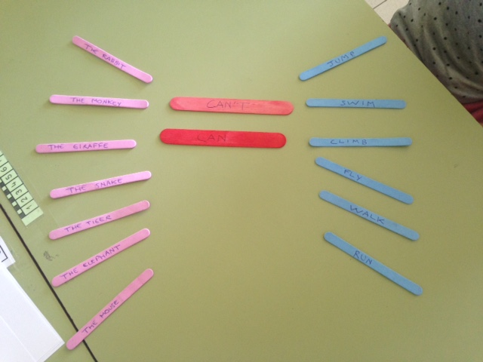
- BUILD UP SENTENCES 2
Different stripes of grammar categories are written on stripes on a book. The child can choose different words, organized into categories, to build up a sentence. It can also be used using different parts of a story (character, place, actions…) in order to build up a story.
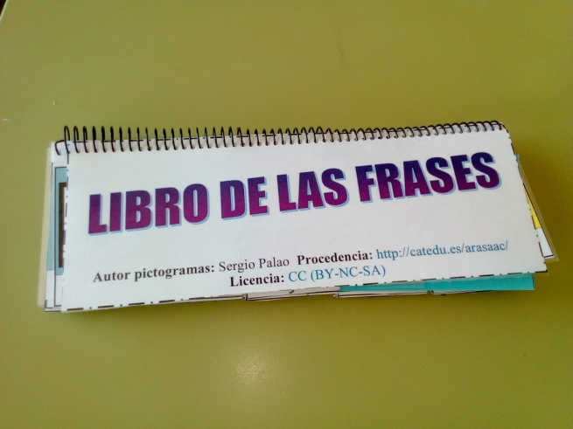

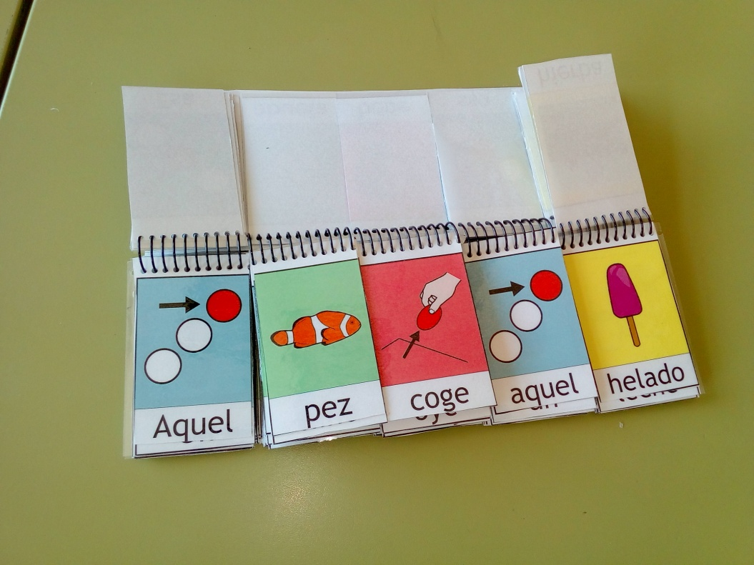

- VISUAL DIARY
The student uses a visual diary so that he can improve his speaking, structures sentences and organize time schedules. It is also an input for the student so that he can tell his parents what he has done at school every day.

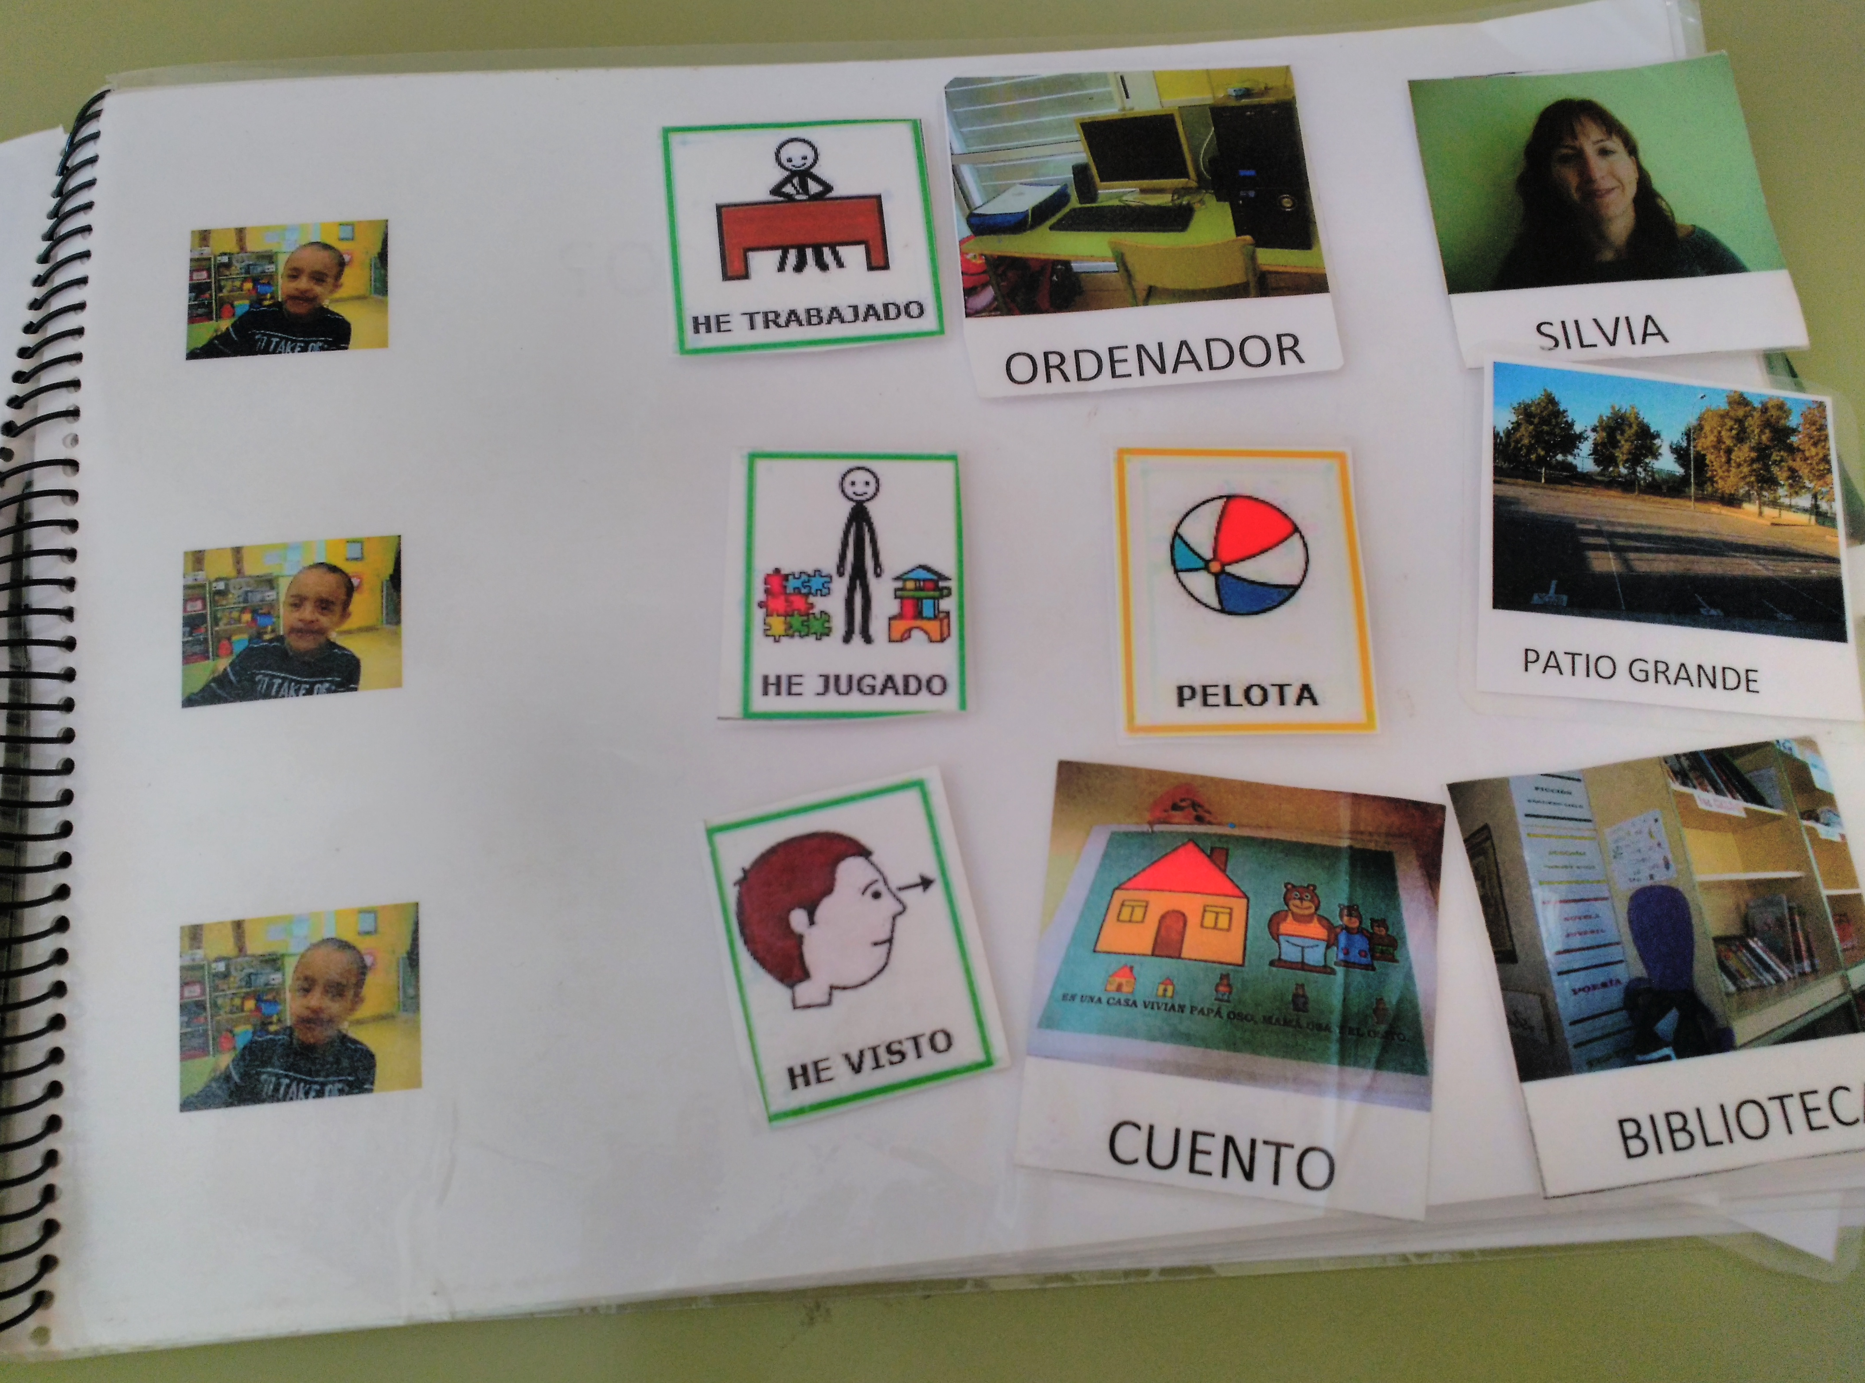

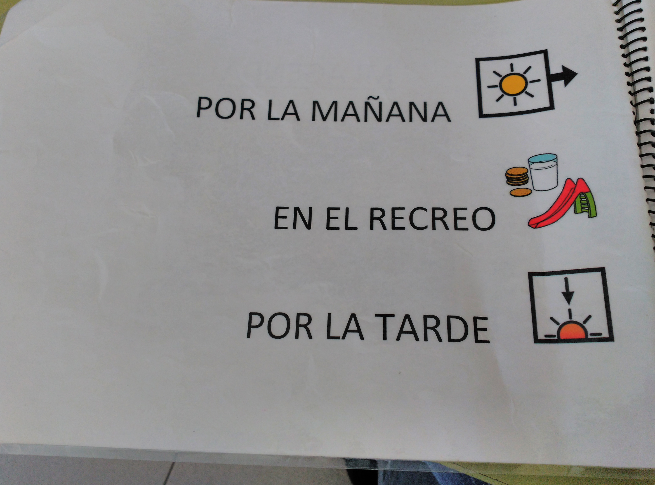

- WRITING WITHOUT GRABBING A PENCIL
The AP XODO is used to help students (movement disorder) writing without grabbing a pencil using a tablet.
The student can practice writing using his forefinger touching the screen of a tablet. It allows the student to practice the same activities as his classmates.
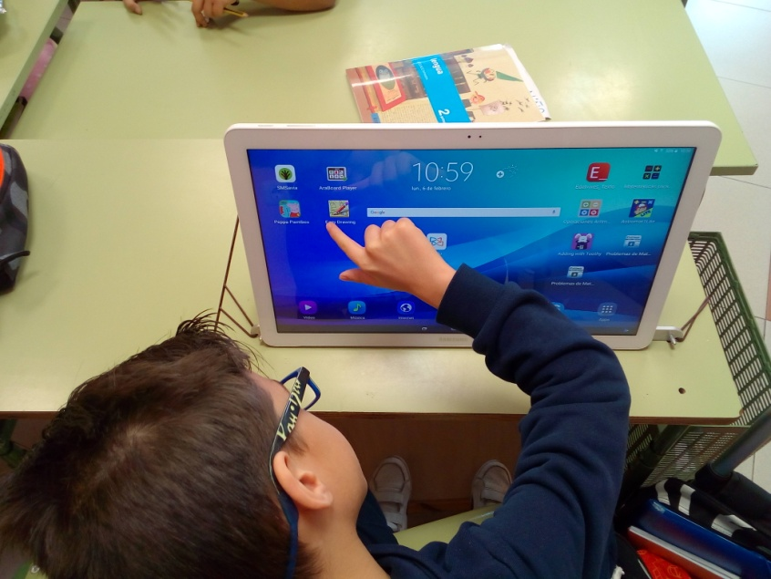

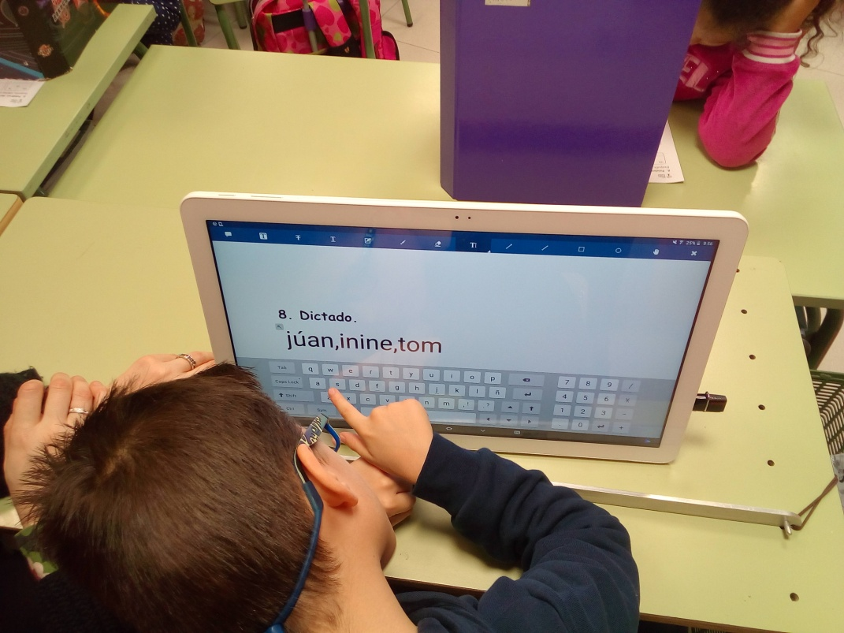

Resources (web links, apparatus...)
Ice cream sticks
Texts
Tablet
Pictures: http://www.arasaac.org/index.php
Programme: https://www.xodo.com/

IMPACT AND EVALUATION
Impact on pupil´s learning/school:

- Higher self-confident
- Better understanding of a text
- Empathy
- Better organisations of ideas
- Autonomy in learning
- Better sequence of stories
- Higher motivation

Next step to improve:

