Alessandra Anna Maria MEI - IC Confalonieri, Milano (Italia)

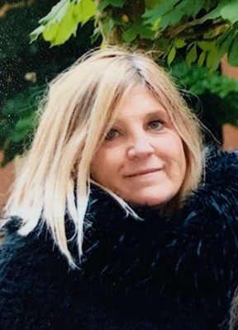

Hi! I teach in primary school maths, science, geography, music and art.
I have some digital competences: editing images, cloud storage,
sharing documents in google drive and padlet,
planning of activity of robotica and coding.

