MY DESCRIPTION:

Hi my name is Lucía Carrero López; I am thirteen years old and my birthday is on the 22 of October. I live in Valdepeñas that is a town that is situated in (Ciudad Real, Spain). I live with my mother, my father and my twin brother that is the same age as me and is called Esteban (he goes to the same class as me so we probably have another description that says that he has a twin sister that is called Lucía). I speak three languages that are Spanish, English and a little French because I am learning at high school. (English and Biology are my favourites subjects at high school).

From Monday to Friday I go to classes at high school but in my free time I hang out with my friends, I spend time with my family etc..

My passion is music, I play the guitar and ukulele and sing all songs that I hear. I also like many more things like reading books (like   
Harry potter or the Hunger the games) or watching series like (Stranger things or Riverdale) . My favourite songs are Castle on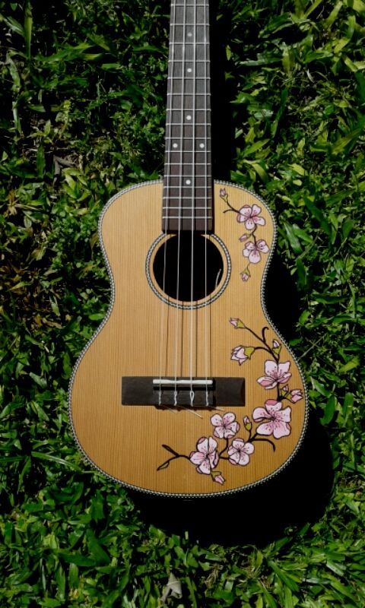 the hill by Ed sheeran and False coincidence by Noah Kahan.

