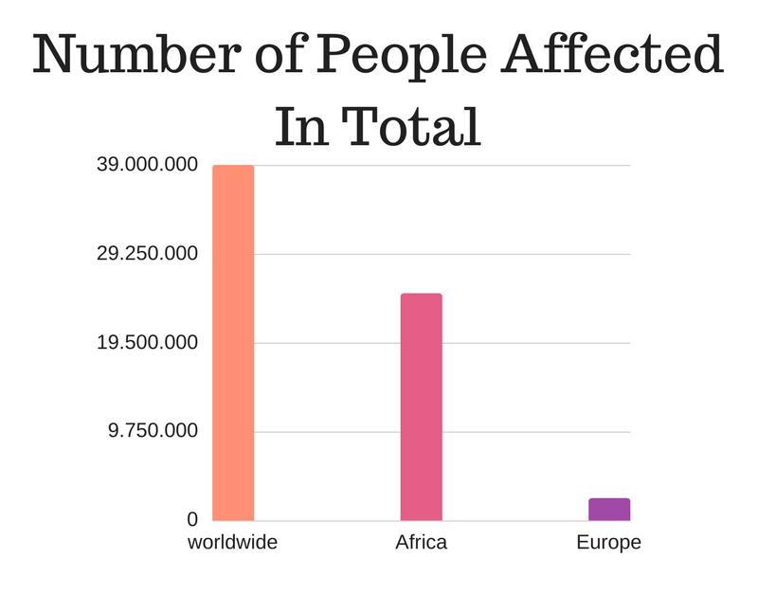
(Source: http://www.avert.org/global-hiv-and-aids-statistics, 26.01.17)
- Describe all three bars with data from 2013.
- Compare the amount of people affected in Africa and Europe.
- Give reasons for the distribution of the disease.

