Learn with fun
By Josephine Ficola and Ilenia Pastorelli LSP, Assisi/Italy
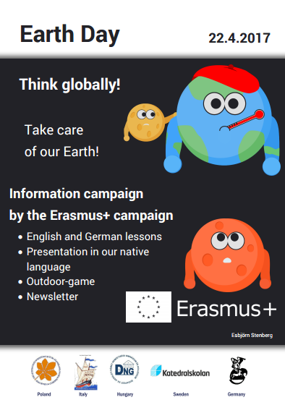

On the 5th May our class organized the third Erasmus plus info-campaign “International Mother Earth Day” in order to share with the other students of our school the themes analysed during the meeting in Växjö.
This time the three language lessons and the five-station game were focused on environmental issues and what we can do to solve them.

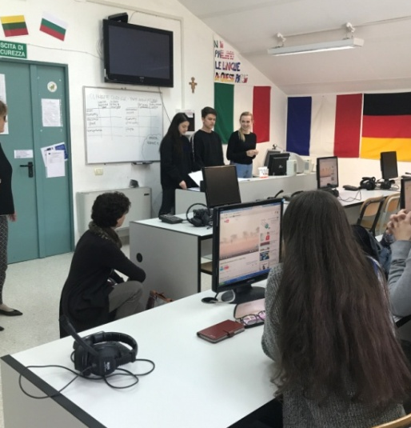

In this photo we can see the English lesson, held by Francesca Acori, Iris Subashi and Lucrezia Fioretti in 5 Classico. It dealt with global warming and climate changes and the students were very responsive.

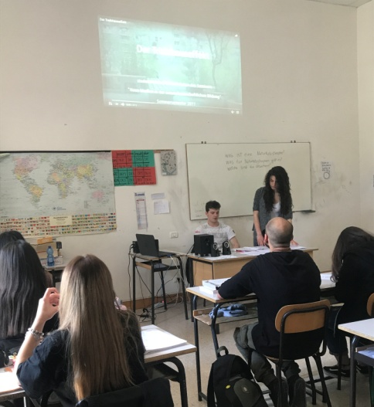

Here there are Annalisa Genovese and David Del Bianco during their German lesson in 5BL. It was focused on natural disasters and the class seemed to appreciate it!
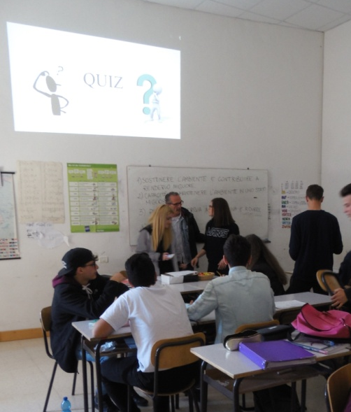
On the right we can see our “teachers for one day” Martina Merone, Giulia Violini and Diego Luna while they are correcting the quiz answers of the Italian lesson, which concerned ecological sustainability and the different environmental issues of the Erasmus countries.
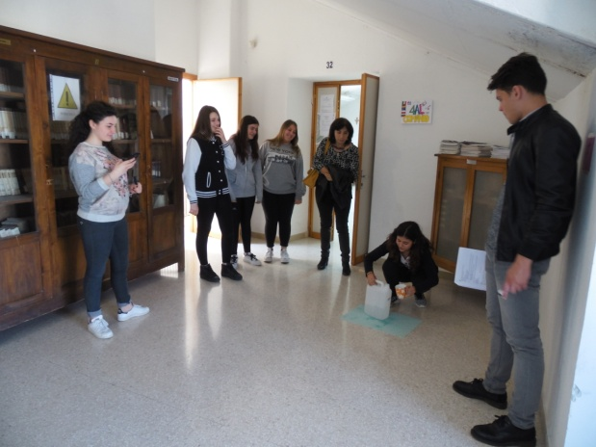
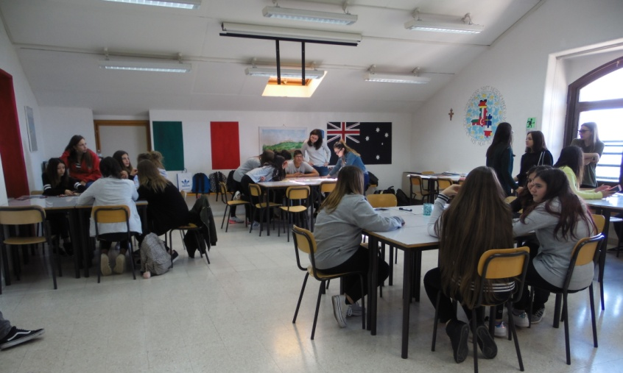
In these last two pictures you can see the five-station game which involved 1AL. The class enjoyed the game a lot and showed a real interest in the themes we proposed.
In general the info-campaign was well conducted and well organized. Unlike the previous one, the students seemed to be much more interested because even if we live in a region defined as "The Green Heart of Italy", nothing can be taken for granted. Our school tries to make us ‘eco-friendly’ promoting correct behaviours, starting from recycling . The classes involved proved to be very interested and active, in fact the students didn’t back out at all, on the contrary they took the challenge without any difficulty. Moreover, everything turned out to be very educational as almost everyone seemed to grasp the educational aspect of the project, enriching their cultural baggage and we felt proud of ourselves!
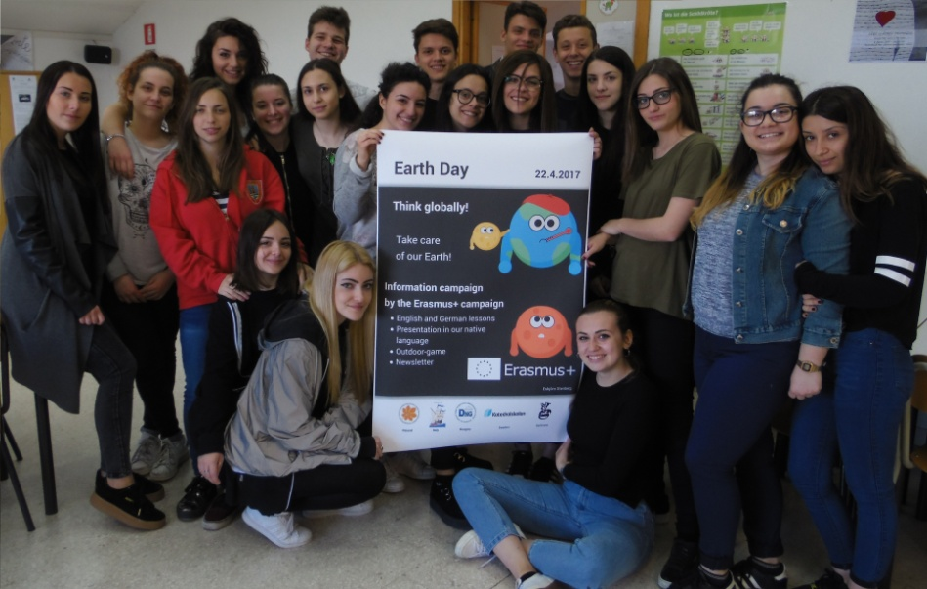
7th May 2017

