English lesson

1. Topic: "Migrant crisis – Voyage to safety".

2. Age and level of the students: 16-19 – B2

3. Duration of the lesson: 60 minutes
a. warm-up, presentation of the topic – 10 minutes
b. teamwork + vocabulary + crossword puzzle - 30 minutes
c. videos + discussion - 20 minutes.

4. Goal of the lesson: the students are expected to learn words referring to the refugee crisis and become more aware of the problems that the refugees have to face.

5. Teaching materials and teaching aids: instructions for teamwork, vocabulary sheet, crossword puzzle, PPT, videos

6. Structure of the lesson:
a. Introduction
b. Development
c. Closing phase

STRUCTURE OF THE LESSON

a. Introduction of main countries and age of migrants with possible routes of voyage (see PPT – slides from 1 to 7)

b. Teamwork showing difficulties and dangers of the voyage (see PPT – slides from 8 to 21)

b.1 - The beginning of the voyage:

Millions of people chose to leave their native land to reach Europe.
You are one of them and you come from Libya. Because of wars, death and hunger you are forced to sell your house in Tripoli for a fraction of its value and dreaming of safety in Europe you are ready to begin the journey. To make it you must risk being smuggled across the sea.
You leave your family in the house and go out to look for supplies. You manage to get small bottles of water, some snacks and some inflatable rings. Two days later you meet a guy called Amhad who says to you:
"I found a truck to take you to the harbour. Let's go." You board the truck with your family.
During the trip the driver says you now have to make a choice. "You can keep going to Benghazi for $4,000 each, or go to Zuwara for $3,000 each?"
You have to choose:

1) The trip to Zuwara by road is longer, which means a higher risk of being caught but the boat journey is shorter.

2) The trip to Benghazi is shorter by road but involves a longer onward boat journey with a higher risk of drowning.

1) ZUWARA:
After a long, dangerous drive, you and your family reach Zuwara. You're all exhausted and very scared.
The truck driver introduces you to another smuggler who takes you to a flat for the night. You are taken to the boat for Italy the following evening.
The boat is 10 metres long. Twenty people are already on board when you and your family get in and it casts off into the night. Fifteen minutes later another boat approaches; you're unsure if it's Libyan coastguards or a militia group.
They fire shots at your boat. You think they want to steal the smugglers' money. Some people jump out in a panic and swim to the shore. Do you jump?
You have to choose:

- JUMP
You are stranded

You decide to dive into the darkness.
You and your family swim to the shore. Now you are back in Libya with very little money left. You might have to stay here and make a new life for yourself.
Now you have another problem: you lost all your money.
- DON’T JUMP
You are rescued at sea
The other boat approaches and demands money. The smuggler pays them off. You and the others who stayed on board hope you can reach Italy.
When your boat reaches international waters, the boat has been damaged in the shooting. The boat capsizes.
Luckily, you have the inflatable rings. You hope you can survive a few hours in the cold water. There are already dead bodies around you, floating in the water. You huddle together for warmth and keep swimming. An Italian ship looms out of the dark. You all scream and shout to get attention.
The crew sees you, and takes you to Italy. You have arrived in Europe.

2) BENGHAZI

You leave with your family in the truck.
A group of Libyan soldiers stops you at a checkpoint. They ask for money from all the passengers. They point guns at your family and threaten you. You need that money. It's all you have to start a new life.
Is it worth trying to negotiate or should you give them the money?
You have to choose
a. GIVE MONEY
The men could kill you and your family if you do not give them your money.

b. NEGOTIATE
Losing your life savings will be a problem as you won't be able to pay for the onward journey.

A) YOU GIVE THEM THE MONEY
They take your money and let you go. You have no money left, but at least you are all still alive.
The smugglers agree to take you to the next stage. At the shoreline you see a boat. It is too small for all the people who have to leave. You get on. The smugglers tell you "there is another boat, bigger than this one waiting in international waters".
After a few hours you see the other, bigger boat. It's also completely full. You go alongside. You're told you have to jump on to the other boat.
The boats are rocking and waves are hitting against the boats dangerously. Some people are refusing to jump. More and more people are starting to protest and asking for your support. You need to decide. Do you protest or jump boats?
You have to chose:

- PROTEST
You refuse to go to the other boat and you join the protest against the smugglers.
They start hitting you with sticks and attacking the other passengers. They hit you over the head and throw you into the water.
You drown and your family is left to make the journey alone.

- JUMP BOATS
After sailing for three days. Food and water is scarce. You think you can see the Italian shore ahead. The boat suddenly capsizes. You are all in the water. Luckily you have your inflatable rings. You all hold on and they keep you afloat until an Italian coastguard ship sees you.

You and your family are taken to Italy. You have arrived in Europe

b. 2 - Glossary followed by a crossword puzzle
Glossary:
-refugee: a person who has been forced to leave their country in order to escape war, persecution, or natural disaster.
- migrant: a person who moves from one place to another in order to find work or better living conditions
-isis: stands for Islamic State in Iraq and Syria and is an extremist militant group that rules by Wahhabi/Salafi law.
-route: a particular way or direction between places
-smuggler: someone who moves goods or people illegally into or out of a country
-supply: an amount of something that is available for use
-integration:an act or instance of integrating a racial, religious, or ethnic group.
-refugee camp: a place where people who have escaped their own country can live, usually in bad conditions and only expecting to stay for a limited time
-asylum: protection or safety, especially that given by a government to people who have been forced to leave their own countries for their safety or because of war:
-Zuwarah: is a port city in northwestern Libya near to the Tunisian border
-Benghazi: A city of northeast Libya on the Gulf of Sidra. It is a major port and was a capital of Libya from 1951 to 1972.

b.3 - Crossword puzzle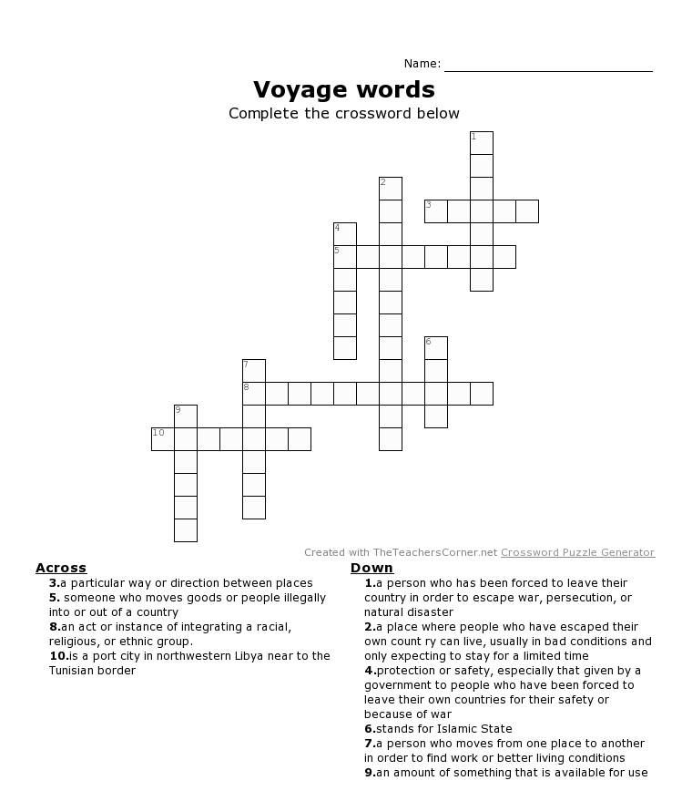

c. Videos on migrant crisis followed by discussion (see PPT – slide 22)

https://www.youtube.com/watch?v=cMkHS_r81YQ
https://www.youtube.com/watch?v=RvOnXh3NN9w

