Curriculum
of intercultural competences

- Intercultural competences at school
- Catalogue of intercultural competences
- Questionnaire “My intercultural competences”
- Certificate of intercultural competences
- Guidebook for teachers

developed in the Erasmus + project "Think globally!" 2018
1. Intercultural competences at school

What are intercultural competences?
The term "intercultural competence" should be understood both as specific knowledge (1) and specific skills (2) as well as an appropriate approach to other cultures and an appropriate attitude (3) which is based on intercultural awareness and tolerance towards other systems of values and ways of thinking, experience in work and communication in an international team acquired through practical actions (4), and finally also motivation and readiness to act in the international arena (5).
Intercultural competences allow to "move safely/securely among different cultures", i.e. to work successfully in an international team and live peacefully in a multicultural society.

Why should intercultural competences be "taught" at school?
International corporations dominate the world, and their needs within the intercultural competences of their employees are becoming more and more visible. As a result of the internationalization of the labour market, the structure of societies, which are becoming more and more multicultural, is changing. School should face the challenges of globalization and prepare its students not only for their high school diploma and university studies, but also for living in a globalized world.
Working in an international team and living among representatives of different cultures are not easy, and getting intercultural skills at a high level is a long process. Therefore, you should start it in the early years of life. Young people should be made aware of it, and communication and cooperation with representatives of other cultures should be available to them already at school.
Multicultural education, usually carried out in the form of a "dry" transmission of information within the framework of Social studies, Cultural studies, Geography, History, foreign languages or as a part of the curriculum, is insufficient today and should be complemented by practical activities aimed at developing intercultural competences.

2. Catalogue of intercultural competences

The catalogue aims at defining what competences are necessary to be able to work successfully in an international team and at the same time to achieve a good level of cooperation.
The student acquired intercultural competence because he / she ...
1) Knowledge and understanding
* has basic knowledge of Europe and the world
* learns about other cultures to recognize prejudices and to avoid them
* is interested in current affairs, challenges and changes in the world
* knows and understands intercultural differences and their possible influence on international communication and team work
* knows and understands different types of communication
* learns about the working conditions of the partners and takes this accordingly
2) Skills
Communication:
* communicates with people from other cultures in different situations
* uses different communication strategies
* takes initiatives to improve his/her language skills
* is able to listen to others carefully and lead a difficult dialogue
* can understand, respect and accept the views and perspectives of people from other cultures
* can successfully and diplomatically come to a common conclusion with negotiating partners
Teamwork
* performs tasks in a multicultural context
* can adapt well to a new international team
* can realize his/her own ideas in an international group to which he/she belongs
* has the skills necessary to organize and coordinate international teamwork successfully
* evaluates international cooperation and draws necessary conclusions from it (regarding good examples and avoidable errors)
* can share his/her knowledge, experiences and intercultural competences with other team members
except that:
* is also open to various forms of work on the project and is able to adapt to individual situations and new circumstances
* maintains good relations with other team members
* feels responsible for the group and is able to commit himself fully to the common goal
* performs tasks in a timely, conscientious, accurate, complete and reliable manner
* is able to apply his/her own skills constructively, but also accept criticism and accept support
* can solve any kind of controversy through discussion and compromise
3) Attitude and conduct
Awareness
* is aware of the common European culture and has the ability to disseminate it
* is aware of national and European identity and builds his/her own identity on this
* is aware of cultural diversity and perceives it not as an obstacle but as enrichment
* recognizes the differences dominating in different cultures and in their thinking and actions takes into account the way of thinking and behaviour of others, also determined by the political, economic and social situation,
Values
* is open to other cultures
* respects other cultures and values and makes a positive use of it
* sees diversity as an opportunity for development
* relies on common European values such as democracy, tolerance and equality
4) Experience
* was involved in all project activities (online work, international project meetings, school campaigns) of his/her school project team
* was constantly active in the project’s TwinSpace using different tools, thanks to which he/she can work with representatives of other cultures on the Internet (e.g. on the eTwinning platform)
* participated in building intercultural dialogue in the project's TwinSpace, publishing articles, comments, video clips, photos and other materials
* was a student in at least one weeklong intercultural class and got involved in all of its activities (workshops, lectures, project work, group work, competitions, etc.)
* cooperated in at least one international project meeting at his/her own school
* participated in at least one international project meeting at a partner school abroad
5) Motivation
* recognizes both the need for international cooperation and the benefits of it
* is ready to follow new international routes
* is open to cooperation with representatives of other cultures
* regards working in an international team as appropriate for the present times and necessary but also enriching
* is able to motivate himself/herself again after defeats and failures in an international team
* plans to remain active in the international arena

3. My intercultural competence

Erasmus + 2016-18 Denke global! - Think globally!
Name: _______________________________ Date I: _______________
School: ______________________________ Date II: _______________

Subprojects: T1 = Education and the labour market -♦- T2 = Medical care -♦- T3 = Climate change and environmental protection -♦- T4 = Refugee crisis in Europe -♦- T5 = Cultural diversity

Please answer the following questionnaire to the best of your knowledge. Try to judge yourself as objectively as possible! The questionnaire must be returned to the teacher.

I. What have I done to develop my intercultural competence?
What is in my portfolio?

1) Subprojects in which I took part:
Subproject | International project meeting in … | TwinSpace | Info campaign
T1
T2
T3
T4
T5

2) International project meeting at my own school: Yes in ________________________ / No

3) International project meeting at a partner school: Yes in ________________________ / No

4) My articles:
Subproject | Forum (Nr.) | Subject | Title of article | number of comments
T1
T2
T3
T4
T5

5) My comments:
Subproject | Forum (Nr.) | Subject | Title of articles | Title of the comment (if there is one)
T1
T2
T3
T4
T5

6) Other blog entries
Memories from …  (City with Subproject) | Report on campaign / survey | In the section forum | In the school team forum | Others
(If there isn’t enough space, please add another sheet)

Survey I | Survey II
7) My own photos:
8) My own films:
9) All my presentations:

10) I have worked on / developed / translated the following teaching scenarios:
Subproject | English lesson | German lesson | Outdoor game | Lecture in the mother tongue
T1
T2
T3
T4
T5

11) I have guided / taught the following info campaigns:
Subproject | English lessen | German lesson | Outdoor game | Lecture in the mother tongue
T1
T2
T3
T4
T5

Survey I | Survey II
12) In which section have I worked? What have I done?
Info □ ‖ Monitoring □ ‖ Evaluation □ ‖  Imprint □ ‖ Dissemination □ | Info □ ‖ Monitoring □ ‖ Evaluation □ ‖  Imprint □ ‖ Dissemination □
13) Have I viewed photos, films or presentations which were uploaded on TwinSpace?
Yes □ - No □ | Yes □ - No □
14) Have I read project blog entries?
Yes □ - No □ | Yes □ - No □
15) Do I know the pages of your TwinSpace?
Yes □ - No □ | Yes □ - No □
16) How many TwinMails have I read / sent?
17) How often have I been on TwinSpace (average number)?

II. What was my cooperation with the international partners (students and teachers) like?

5– absolutely true 4 – true 3 – partly true 2– not really 1 - not at all

 | 5 | 4 | 3 | 2 | 1
1. I have actively used TwinSpace.
2. I have succeeded in making clear my point of view within the international group (group works, presentations etc.).
3. I have been able to put into practice my ideas within the international group of teachers and students.
4. I was open and willing to do different types of project work.
5. I was open to consider new ideas and different opinions of other group members (group work during visits etc.).
6. I have become aware of existing national prejudices during my cooperation with people from other countries.
7. I have developed an understanding that knowing about other cultures can help to judge fairly and to avoid prejudices.
8. I have been able to deal with and/or solve conflicts within my international work group.
9. I have a good relationship with the other Erasmus+-participants.
10. I felt responsible for my group and tasks we had to deal with.

III. What have I learned/achieved?

5– absolutely true 4 – true 3 – partly true 2– not really 1 - not at all

 | 5 | 4 | 3 | 2 | 1
1. I can work online together with the other Erasmus+-participants.
2. I can communicate with the other students and teachers in different situations in English or German.
3. I have extended my knowledge about Europe, a common European culture and the cooperation in the EU.
4. My interest in current events and changes in the world has increased.
5. I have learned to respect other cultures and values and to profit from them.
6. Cultural diversity enriches my point of view.
7. I am able to present my home country and my culture to the other Erasmus+-participants.
8. Now I understand intercultural differences and their possible influence on international communication and teamwork better than before.
9. I have developed skills to organise and coordinate international teamwork successfully.
10. I plan / I am willing to remain active on the international level.

4. Certificate of intercultural competence
At the end of the project, after two years of project activities, each participant (student/teacher) receives a certificate confirming the acquisition of intercultural competences at a certain level.
This level will depend on the involvement level of this student or teacher, namely:
- his/her participation in international project meetings in his/her own school (especially cooperation in the preparation and implementation of the meeting) and in partner institutions (self-presentation of the team, work on the project, workshops, etc.),
- his/her participation in the campaigns conducted (development of lesson plans, conducting lessons, analysis of evaluation surveys, publications in the TwinSpace),
- his/her work on the eTwinning platform and his/her contribution to intercultural dialogue,
- the quality of material products of the project created by him/her.
The following three levels of acquisition of intercultural competences are planned:
- participated
- participated actively
- participated with great commitment

Assessment of the level of participant's development and intercultural competences acquired by him/her will be based on the questionnaire "My intercultural competences" completed by the student / teacher, and in the case of the student - also based on the portfolio, prepared by him/her throughout the project duration, documenting his/her work and his/her involvement in the project (articles, comments, photos, certificates, lesson plans).
The level of development achieved by an individual student and teacher will ultimately be determined by the school coordinator together with his team of teachers.

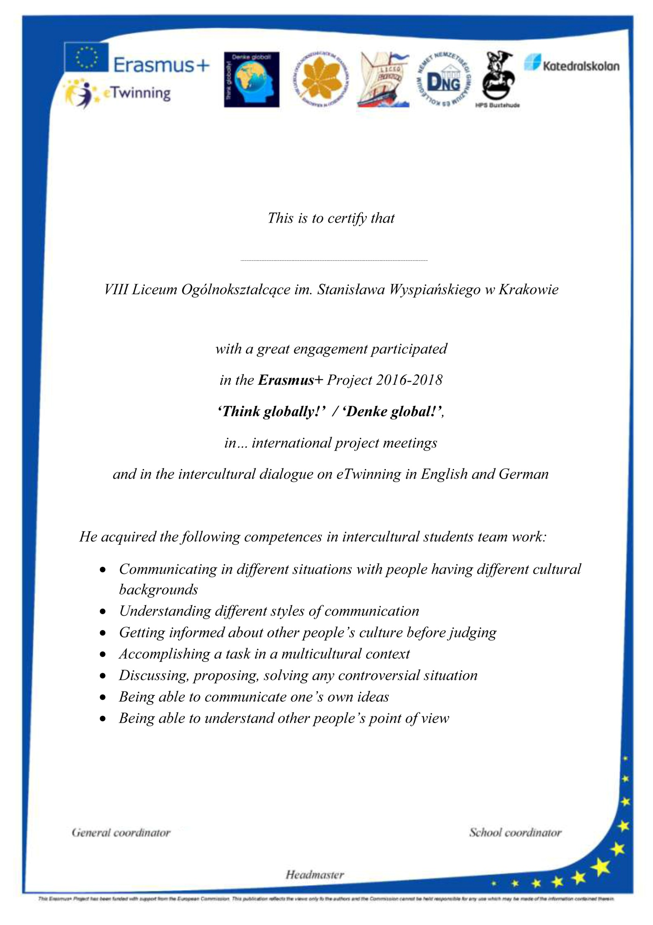
5. Guidebook for teachers
Our guidebook contains the hints and tips (formulated on the basis of the two-year collaboration on the Erasmus + project "Think global!") for teachers who want to develop intercultural competence by their students.
Tips for teachers:
- Personal encounters should be encouraged, since fully understanding a foreign culture is only possible through personal contact.
- Real-life encounters enable a more profound understanding of foreign cultures than for example online communication.
- Teachers should be open and try to engage students and colleagues in international projects.
- It is important to inform and engage the principal(s) in order to ensure that the school provides the resources needed to carry out the project (extra time and substitute teachers, for example).
- Organize information meetings where students tell teachers and their fellow students about positive experiences with working in an international project. This will hopefully make more colleagues interested in working with international exchanges.
- Try to apply an intercultural/comparative perspective when teaching (in as many subjects as possible and regardless of whether the school is currently involved in an international project or not).
- Select students based on interest and not according to who is friends with whom.
Try to think from the perspective of the other participants when planning and carrying out activities within the project.
- Prepare the students: What are they to expect? What will be expected of them?
- Involve international contacts in and outside of the school in the courses you teach.
- Be flexible.
Monika Farkas, Timea Szép und Emese Eszenyei (DNG Budapest), Nina Karlström (KS Växjö)

Wegweiser für LehrerInnen, für die das Thema „Interkulturelle Kompetenz” neu ist
- Eine direkte Begegnung auf Schüler- und Lehrerebene ist unerlässlich, um durch Empathie und das persönliche Kennenlernen
- mögliche Vorurteile zu erkennen und sie abzulegen,
- die Bereitschaft zu fördern, anderen Kulturen gegenüber offen und tolerant zu sein,
- mögliche Meinungsverschiedenheiten in der direkten Gegenüberstellung zu lösen,
- andere Werte stärker zu respektieren und auch von ihnen zu profitieren,
- den eigenen Horizont zu erweitern,
- den europäischen Gedanken hinsichtlich Kultur und Politik mit Leben zu füllen,
*Eine reine Online-Kommunikation kann die o.g. Punkte nicht erfüllen.
- Themenfindung:
  - Direkt oder indirekt schildern persönlich betroffene Menschen ihre Situation (z.B. schwarzafrikanische Flüchtlinge in Italien oder eine Ärztin, die für „Ärzte ohne Grenzen“ im Jemen gearbeitet hat), um über Empathie die interkulturelle Kompetenz der Schüler und Lehrer zu stärken.
*Es besteht die Gefahr, dass eine nur theoretische orientierte Arbeit die Schüler nicht erreicht.
- Arbeitsformen:
  - Theoretische Einleitung in das Thema, um die Schüler und Lehrer zu sensibilisieren
  - Festigung der interkulturellen Kompetenz durch praktische Arbeit am Thema (z.B. Unterrichtseinheiten entwickeln und vor allem halten, Mitarbeit in unterschiedlichen Projekten, Entwicklung eigener Ideen, wie die Einrichtung einer Kinderspielgruppe für Flüchtlinge, Ausrichtung eines „Festes der Kulturen“)
Dagmar Wiegand und Anja Merhof (HPS Buxtehude)

Our main tips
1. Teachers and students need to have a clear understanding of the entire project from the beginning.
2. Students and teachers working within an international project need clear instructions in order for the work to run smoothly.
3. Everyone needs to prepare for each project meeting.
4. The most important thing is to respect differences, since you have to work with students and teachers from very different countries.
5. The teacher is responsible for strengthening the self-confidence of each student so that he or she will have the courage to use a foreign language to communicate with people he or she has never met before.
6. Moreover, the teacher should encourage the students to actively participate in the project work.
7. The success of the project is also connected to the topics chosen: They should be interesting to the students and not offensive to anyone.
8. The students need to show understanding, patience and respect - especially in cases where there are differences of opinion.
9. Teachers should make the students understand that they are also responsible for the results of the project.
10. Conflicts will inevitably arise, but it is important that you try to find a solution together and in a peaceful manner.
11. Before, during and after the project meeting it is important to work towards reducing prejudice.
12. The ability to work together as a team should be developed, since experience when it comes to international collaboration will be an advantage for the students on the labor market.
13. Teachers within an international project are responsible for conveying the ideas of European intellectual tradition and the common values of our cultures.
Orsolya John und Erzsébet Laczkó (DNG Budapest), Barbara Marten und Fredrik Kjällbring (KS Växjö)

Guide for teachers
++
During the project, the teachers were able to determine how international bilingual communication is developing. Subproject after Subprojekt, the interaction became more and more efficient and successful.
The intercultural dialogue at the meetings worked well and we had no problems caused by intercultural differences. It was an enrichment for all participants.
International teamwork has not been difficult and everyone has been able to adapt relatively easily to new methods / forms of work.
The team leaders made it possible for the students to express their ideas.
+
The topics of the info-campaigns were of interest for teachers and students who were not directly involved in the project, but they did not lead to any further development.
-
Pupils did not always meet deadlines, and the teachers always had to exercise strong control. Articles / comments were often published in the wrong forum, because the platform was too complicated. Sometimes files were accidentally deleted, and that, too, had to be controlled by the teachers.
The reactions to the articles were sometimes not so spontaneous and deep. For the students, it was difficult to comment articles, to refer to the opinions of other students. It would have been useful to guide the students to write a commentary in an appropriate way.
Ágnes Kóbor (DNG Budapest), Elisabeth Plaz und Rosella Baldelli (LSP Assisi)

Tips for teaching intercultural competences
* students need to have the opportunity to meet each other because the personal contact is more important than learning about the different cultures based on schoolbooks (e.g. exchange programmes or international school projects like Erasmus+)
* students should live in host families to profit from the hospitality of their exchange partners
* students explain cultural habits and differences, they can compare and contrast their lifestyles as well as school activities
* they explore different cities and places together to share their impressions
* talking to people in real life situations improves their language skills more than anything else, e.g. they have to mediate in different contexts to understand their cultural background
* teachers should encourage their students to be ready to cooperate with international students and be tolerant and open-minded
* create realistic scenarios so that students can practice how to take responsibility for their own and each other’s actions
* If students are supposed to prepare and give lessons, teachers should think about the classes that they should teach in beforehand to guarantee a certain quality relevant to the students’ level
* “student-teachers” should think about their target groups
Agnieszka Grochowska (VIII LO Kraków), Mariann Dézsi (DNG Budapest) und Steffi Techau (HPS Buxtehude)

The Way to Intercultural Competences

How can we successfully help our students to develop intercultural competences?
We know what the aim of our teaching is:
- Being able to understand points of view of people from other countries;
- Having the skills needed to organize international teamwork and to coordinate its work successfully;
- Being able to realize ideas in an international group to which the students belong;
- Being interested in current affairs and changes appearing in the world.
These are the points that we consider fundamental. But how to get there?
Curiosity, openness, motivation, this is the beginning. And then you try to create a good atmosphere within the group of students you are working with. This will encourage them to be more self-confident and share their ideas giving a contribution to their group. As teachers we should ensure them that they are part of the group and their active participation will help to perform their task.
At the same time the teacher should motivate the students to contribute to the promotion of their local culture while working in an international team as well as becoming more aware of being part of the European culture.
Taking part in this intercultural communication the students will get some insights of the countries participating in the project and of the changes in the world. All these experiences will make them worldly and this will eventually lead to the realization of the European idea.
Evelina Bertok (DNG Budapest) and Leonella Pippi (LSP Assisi)

On the way to intercultural competence
Based on our knowledge, we can give the following tips and advice:
1. Intercultural competence at school can only be achieved and developed by international educational projects (e.g. Erasmus+, eTwinning).
2. The adjustment of the international school project to the curriculum and its integration into the educational programme of the class or the group of students make it possible to realize the project, at the same time realizing the curriculum and facilitating the work of the teacher with his students.
3. Long-lasting and regular online work (e.g. on the educational platform eTwinning) is as important and necessary as one-week long direct international project meetings. Both aspects should be considered during the planning of an international school project.
4. Foreign languages are a good tool for international school projects and the development of intercultural competence. But this does not mean that such international projects can only be realized in foreign language classes. They should be interdisciplinary and implemented in many different subjects. This depends of course widely on the topic of the project.
5. Topics of projects dealing with relevant and important questions in the lives of young people arouse their interest to a bigger extent and stimulate them to act themenselves.
6. Practical knowledge and actions are the basis of good projects.
a) Meetings with specialists in certain fields and visits in specialised institutions as well as workshops and project work in international student groups are more successful than merely theoretical speeches in a school auditorium based on information from the internet.
b) Lessons given by students serve as the best way of disseminating project results among their school-friends. Campaigns focused on certain classes are more effective than those focused on the whole school community.
7. For teachers it is advantageous to get accustomed to the project description and project contract before starting work with their students.
8. Exactly defined rules of communication and cooperation and their carrying out by all participants enable an undisturbed project progress.
9. It is advisable, at the beginning of the project, to talk about and clarify in detail all the things connected with the project among the participating teachers: conditions and aims, methods of working, deadlines and expected results. In the course of the project they should also be constantly and punctually informed about all rules, decisions and changes.
10. For all agreements the points of view of all teachers and coordinators and the regulatory framework of each partner school should be taken into consideration.
11. The deliberate acquisition of intercultural competence guarantees better results; that is why students should be made aware of its meaning and usefulness at the beginning of the project.
12. The level of the acquired intercultural competence depends on the commitment of each participating team, because it is highly motivating for the others and thus determines their possibilities of action and their chances to acquire intercultural competence themselves.
13. It is recommended to distribute the project tasks among/with your students in such a way that each of them has got the opportunity to experience all aspects of intercultural competence and achieve all its levels.
14. To achieve good project results it is necessary that the teacher controls and leads the work of his team but he should give his students enough freedom by always supporting them.
15. Marks for written articles and comments or other works produced by the students could be motivating.
16. Students and teachers should be prepared for each international project meeting by precisely formulating their tasks, the recommended behaviour and the expected benefits.
17. An international buffet, national costumes, folk songs and folk dances as well as other concrete forms of self-presentation make it possible to get to know other cultures and better understand the value of cultural variety.
18. The lesson in the native language at international project meetings enjoys great popularity among the participants and encourages them to learn new foreign languages.
19. When dividing the teams in the international class being formed at each international project meeting the linguistic competences of each student and teacher should be taken into consideration. The groups should be put together in the best way possible.
20. It is also recommended to pay regular attention to private contacts, which also reinforce the cooperation and team spirit in the project.
Bożena Cudak (VIII LO Kraków), Hermann Hausmann (HPS Buxtehude)

