STATION 1: Folk Music
INTRODUCTION: RECOGNIZE A PIECE OF FOLK MUSIC ! Here are some information.
Folk music is a kind of music, transmitted orally, it’s got an unknown composer, it is performed by customs of a long period of time. It is different for different regions and ethnic groups.
The music in the mountains is quite characteristic but recognizable by every Polish person (sometimes it sounds a bit like the Hungarian one). Violin, accordion and double bass are typical musical instruments.
The oldest Swedish musical instrument is the so called „nyckelharpa”; the emphasis is on the violin; lockrop is typical: it’s a style of singing, only women take part in it and it sounds a bit like talking.
Tarantella is typical, it comes from the South of Italy; it got its name after Taronto in Apulien (a town); it is accompanied by tambourine; Italian music is passionate.
Germany: the folk music is sunny and optimistic; it includes lots of „so-called” work songs; a rhythm and brass bands are typical.
Hungary: musical instruments are violin, double bass, viola, dulcimer, citera; the Hungarian music can be either sorrowful (slow, has a bad-mood) or impetuous (has a tempo giusto rythm, rapid).
Technical aspects:
- 2 students at the „station”
- A loudspeaker (connected with Bluetooth if it’s possible)
- A cell or a laptop with the downloaded music.
- A sheet o paper with a table-grid to fill in for the team- see example below
- All the five downloaded folk music pieces ar played to the participating teams. The team has to say which country (Poland, Sweden, Italy, Germany, Hungary) the piece of music is from.
So for example, as number 1 music from Sweden is played, the teams have to write the word SWEDEN in the table next to number 1, as number 2 music from Italy is played, so the students write the word ITALY next to number 2 in the table, etc.
- good answer= 1 point
INSTRUCTION:
You hear a part of folk songs twice and you have to guess from which country they come.

MUSIC:

Team 1 | Scores: | Team 4 | Scores:
1 |  | 1
2 |  | 2
3 |  | 3
4 |  | 4
5 |  | 5

Team 2 | Scores: | Team 5 | Scores:
1 |  | 1
2 |  | 2
3 |  | 3
4 |  | 4
5 |  | 5

Team 3 | Scores: | Team 6 | Scores:
1 |  | 1
2 |  | 2
3 |  | 3
4 |  | 4
5 |  | 5

STATION 2: Folk Dance

Tarantella comes from the south of Italy, her first appearance dates back to the first XVII century. The name is a mix of popular dances and music.

Mazurek is a couple and group dance, it is appearance dates back to the 16. century. It is the symbol of union and strength for the members of the community.

Polka is the typical dance in Smoland (southern Sweden). In it are intricate pattern of holds and underarm turns involved.

Csárdás is a popular couple dance, it was danced in taverns.

Quadrille is a square dance with popular songs.

INSTRUCTION: Every group gets a dance. They can watch it twice, then they have to try to dance it.

CUTTED DANCE VIDEOS: They are in Twinespace.

STATION 3: A Quiz About The Buildings

INSTRUCTION: At this station the students are supposed to form one of the typical buildings from each country with their own bodies. Those are the Hungarian Parliament, the Brandenburger Tor, the leaning tower of Pisa , the Wawel- Cathedral and Dalahäst from Sweden.
After portraing the buildings you will get three questions with three possible answers, of wich you are supposed to pick the right one.

The Brandenburger Tor
• Why was it build?
1. It was build for political purposes
2. It is the memorial of the divison of Germany
3. It was the former border of the country

•Which king demanded to build it?
1.Friedrich Wilhelm 2nd
2. Joseph 2nd
3. Karl 6th

•When was it build?
1. 540 years ago
2.168 years ago
3. 225 years ago

The Leaning Tower of Pisa
• How long did it take to build the Tower?
1. 245 years
2. 176 years
3. 39 years

•How tall is the tower?
1. 233m
2. 145m
3. 55m

• Why does the tower have a leaned position?
1. It stands on a soft ground
2. There was an earthquake and it tilted a little bit
3. A mistake was made while construction

The Hungarian Parliament

•Where is the parlaiment located?
1. on the Vigadó place
2. on the shore of the Danube
3. on the Széll Kálmánplace

•What is in the parlaiment?
1. the holy crown
2. the Festy- Panorama
3. the coronation coat

•Who was the architect?
1. Mihály Pollack
2. Miklós Ybl
3. Imre Steindl

The Wawel- Cathedral
•Who ist the most important saint in Poland?
1. Wladyslaw I.
2. Heilige Stanislaus
3. St. Leonhard

•Who was the first Polish- Hunagrian queen to be seputed in the cathedral?
1. Anna Cillei
2. Elisabeth Habsburg
3. Hedwig I.

•How many times did the cathedral burn down?
1. two times
2. one time
3. five times

Dalahäst
What is the Dalahäst?
1. a living horse
2. a wooden symbol
3. a food

•How tall ist the biggest Dalahäst?
1. 13 m
2. 1 m
3. 5 m

•Which are the dominant colours on this horse?
1. yellow, red, brown
2.gold, silver, blue
3.red, blue, white

PICTURES:
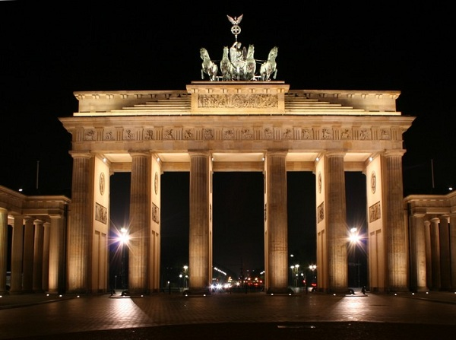
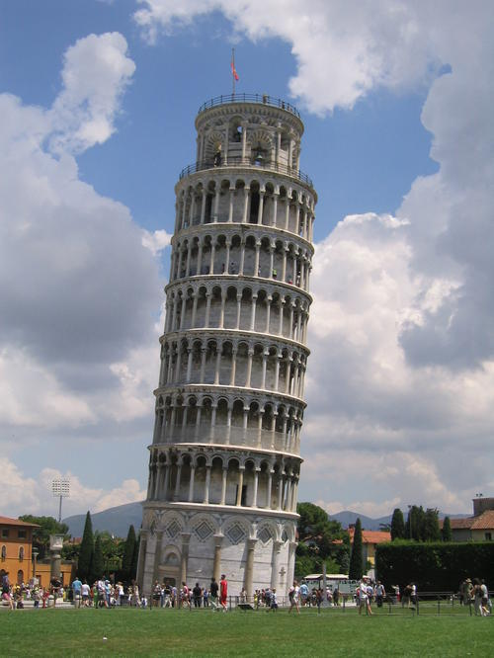

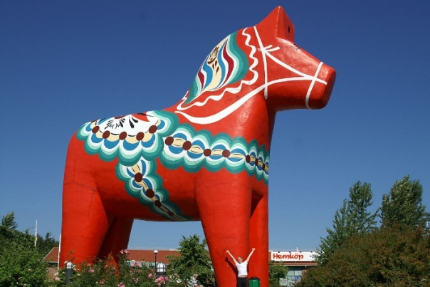
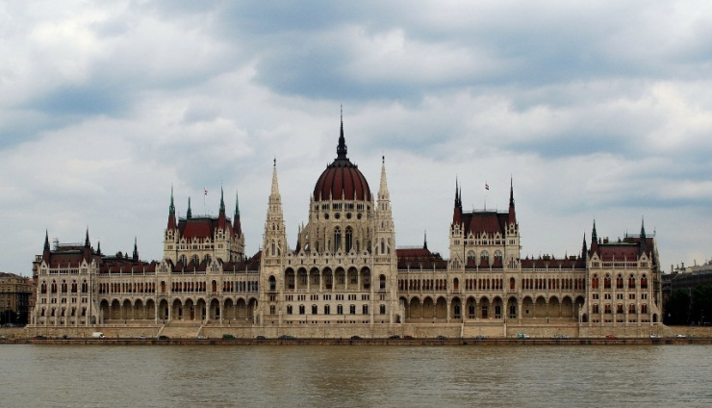

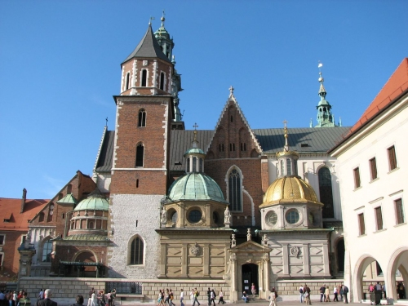

STATION 4: Craft

In every culturs are different liked crafts. In this game you can try them. In Sweden yuo can create trolls with stones. In Italy they work with leam. Polnish people cut out different motives for example snowflakes from paper. In Germany they press potatoes on a paper. Hungarian people like to work with hungarian flowermotives.

INSTRUCTION:
Every group have to choose blind a craft and they get a box with the materials they need and the picture will help them. They have 10 minutes.

The boxes include:
Sweden: stones, felt pens, yarn, glue
Italy: plasticine
Hungary: white paper, colored pencils
Poland: scissor, paper
Germany: potatoes, knife, color, paper, painbrush, little water in a pail

Pictures:
