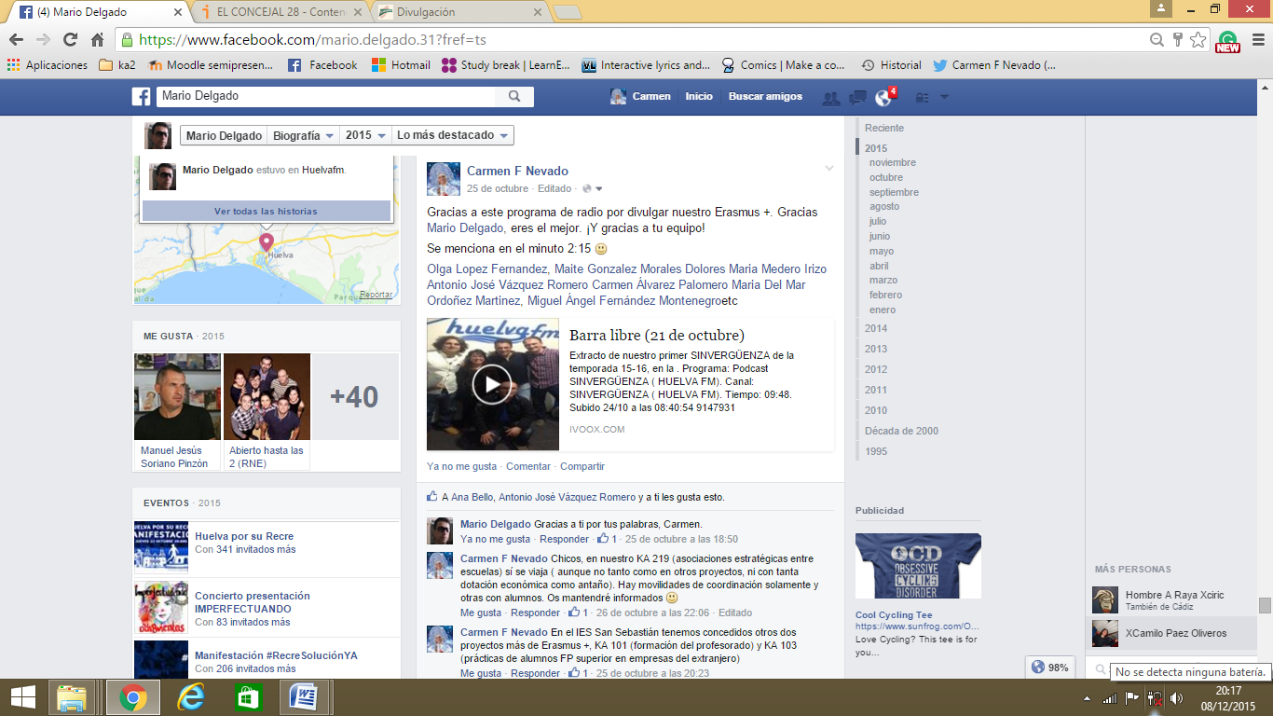

http://www.ivoox.com/9147931

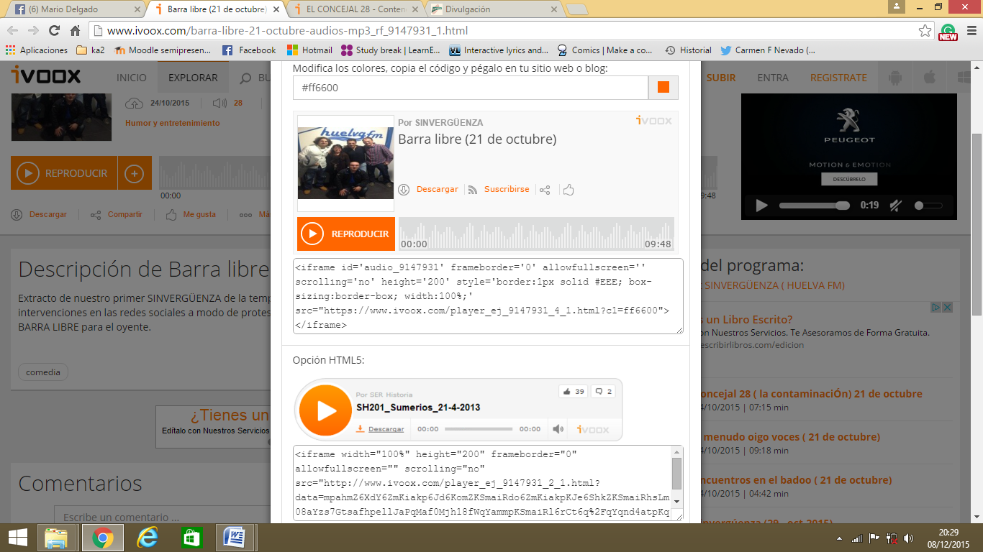
<iframe id='audio_9147931' frameborder='0' allowfullscreen='' scrolling='no' height='200' style='border:1px solid #EEE; box-sizing:border-box; width:100%;' src="https://www.ivoox.com/player_ej_9147931_4_1.html?c1=ff6600"></iframe>
