

IN THE PAST:
- Waste was thrown into landfills or dispersed in the environment.
- In 2011 in Italy there were 200 landfills containing more than 13 million tons of garbage.
- The worst performance was Molise’s with 400 kg capita and the best were Friuli’s and Lombardy’s with less than 50 kg per capita
- In 2013 there were still 218 illegal landfills, of which more than 10% in Sicily.

LANDFILLS AREN'T FOREVER:
- Landfills can’t contain garbage indefinitely.
- Through bacterial fermentation landfill waste produces biogas, which is mainly composed of methane and carbon dioxide.

BIOGAS:
- Methane can be burnt to produce energy to share through the national electricity grid.
- It is a sustainable energy form
- Landfills can be seen as deposits of methane which are not exploited

LANDFILL MINING:
- Landfills contain many recyclable materials such as plastics, glass and metals.
- In landfills iron, aluminium and copper are present in higher concentrations than in the minerals where they are naturally contained.
- Landfills also contain materials that are not found in nature (steel).

FUTURE PERSPECTIVES:
- Less use and waste of paper
- More electronic waste ("WEEE") which is more difficult to dispose of
- Eco-design, i.e. production of goods easy to dispose of
- Landfill mining will become a common practice
- People will become more responsible with respect to the waste they produce
- There will not be landfills any more and waste will not be dispersed in the environment

Sources
- Grosso-Montani, “Dove vanno a finire i nostri rifiuti?”, Zanichelli
- www.ecoem.it
- www.cdcraee.it
- http://www.beppegrillo.it/movimento/parlamentoeuropeo/2016/02/esclusivo-la-lista-d.html
- http://waste-management-world.com/a/landfill-mining-goldmine-or-minefield
- http://www.yeslife.it/1878-eco-design-definizione
- http://www.tekneco.it/ambiente/eco-design-tra-arte-e-sostenibilita/
- http://www.theguardian.com/sustainable-business/2015/feb/23/future-of-waste-five-things-look-2025

Carlotta Civiero
WASTE PRODUCTION IN EUROPE AND ITALY

- The production and the destruction of waste are a real problem for our society
- This production is linked with the economy of the country
- Europe and the USA produce more than 10% of rubbish in the world, 450 billion of tons. They have 8% of the World population. Americans and Europeans have the highest rate of household waste.
- Europe produces 253 billion of tons but this amount of rubbish is decreasing (2.4% between 2011-2014). Europeans produce 499 kg per capita per year
- 34% is put into landfills, 27% recycled, 24% is burnt and 15% is used as fertilizer
- There are obvious differences among the EU countries, especially between Eastern and Western Europe

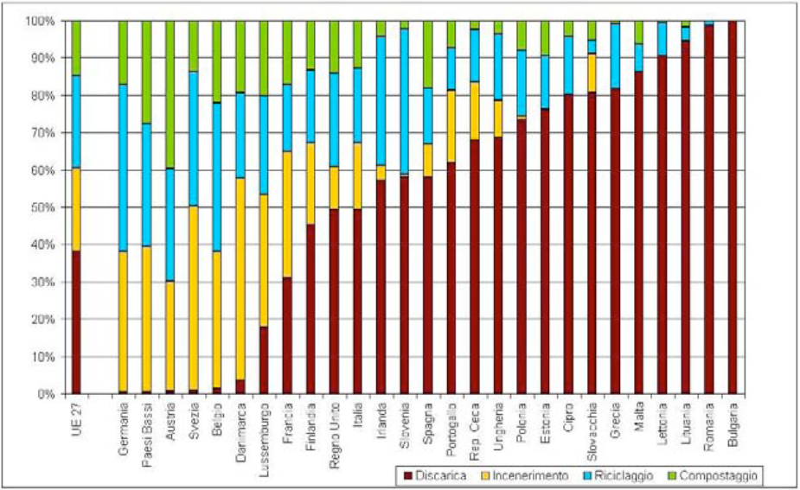

- Italy reflects the European trend: from 2001 to 2008 there was an increase in waste production. Then, due to the crisis, a decrease
- Every region has different situation of separate collection and per capita production
- In the Veneto we produce 455 kg per capita (2.2 million of tons): 1.5 is recycled, 0.3 undergoes organic treatments, 0.2 is burnt, 0.2 is put into landfills.

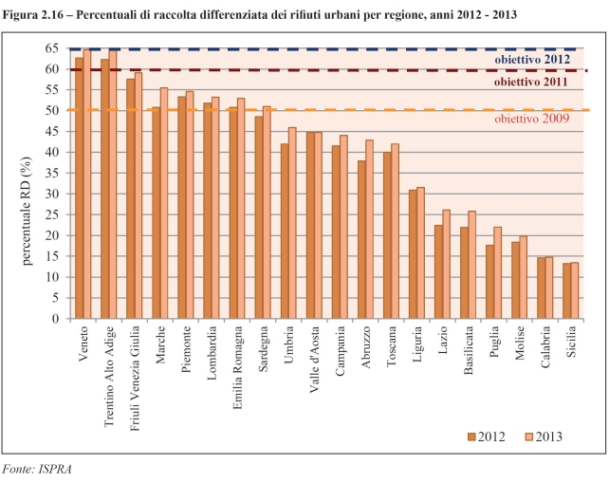 Filippo Gajo
Sources
http://www.legambiente.it/temi/rifiuti
http://www.arpa.veneto.it/temi-ambientali/rifiuti
http://www.isprambiente.gov.it/it
http://ec.europa.eu/eurostat/statistics-explained/index.php/Waste_statistics/it
WEEEs

Weee (Waste from Electric and Electronic Equipment) includes all the technological devices that nowadays we are accustomed to use, like cellphones, computers, refrigerators and so on.
ReMedia is an Italian consortium which has the aim to dispose of WEEEs.
In order to achieve its aim in the best way, ReMedia has involved as many countries and associations it could.
ReMedia is carrying out several projects for the proper disposal of WEEE:

EWIT is a project based on the collaboration between Europe and Africa. Indeed Africa needs help in managing its waste which is constantly increasing and in 2020 will be double the amount in 2010. In 2010 each African inhabitant produced 2 kg of WEEE and in 2020 is calculated that everyone will produce 4 kg.

PREMANUS' aim is to help recycling companies to process WEEE. Recycling an object can indeed have such a strong environmental impact that it may not be the best way of disposing of it. In order to work out the most profitable way of disposing of a WEEE item, Premanus also calculates how much a company would pay to reuse it and how much it would earn.

SMART CITIES is a project that supports scientists in finding new ways and technologies to recover more metals from WEEE.

WEEELABEX provides inspectors for each Italian company to supervise their activities and ensure they follow European standards.

GLASS PLUS is a futuristic project that promotes the idea of recycling the glass of old television sets (a particular glass called cathode ray tube, CRT) in order to produce a pottery dough containing the 20% of CRT glass.

FLAT SCREEN, connected to the previous project, wants to find a way to recover metals from the new devices, like plasma and LCD screens.

Source:

http://www.consorzioremedia.it/it/le-iniziative/progetti-rd/

Piero Bergamo

Mines in the World

-The areas in the world with the highest concentration of mines containing metals used in the production of electronic devices, like gold, silver, copper, iron ore, aluminium and coltan are China, Indonesia, Australia, South America and Africa.
-In China you can find gold and aluminium, in Indonesia mostly gold mines, in Australia copper, aluminium and a lot of iron ore, in South America all the above metals, especially in Chile and Brazil, while in in Africa there's a lot of coltan.
-The 20% of the gold mined in Peru comes from illegal mines which give work to over 40 thousand people.
Since 2015 a lot of policeman squads started missions to drive the miners and their families away from the illegal mines, destroying their houses, the work machinery and all the devices that they use.
-Very often these workers oppose the police actions with the result of violent fights which just make things worse.
-These illegal companies are owned by the biggest drug cartels of the country so it's not easy for the families to run away from those places, also because they are often threatened and treated violently.
-The biggest problem associated with the illegal extraction of gold is mercury pollution. Since the systems are not very sophisticated, they use mercury instead of the modern fuels which pollute much less but are more expensive.
Sitography: www.ilpost.it

Riccardo Fallani
Materials used in electronic devices

- Rapid technological development has resulted in a big increase in demand for raw materials
- 58% of each electronic product is made of plastic, 21% is made of metals and 21% is made of other materials
- Special metals which come mainly from foreign countries, are essential components of electronic devices
- Among the traditional metals are copper, tin and magnesium
- Among the precious metals are silver, gold, palladium and platinum
- Special metals are cobalt, nickel, niobium and coltan
- In Italy alone 35 million mobile phones a year are sold and there are two methods of recovering the metals they contain: pyrometallurgy and hydrometallurgy
- The recovery of the metals contained in the phones is a profitable business

Sources
http://www.focus.it/ambiente/ecologia/un-tesoro-di-telefono-tra-rame-oro-e-argento-nel-cellulare-c-e-una-miniera
http://scienzamateria.blog.tiscali.it/2013/06/16/rottamazione-cellulari-e-metalli-rari/
http://www.enea.it/it/pubblicazioni/EAI/anno-2013/n-5-settembre-ottobre-2013/tecnologie-innovative-per-il-recupero-riciclo-di-materie-prime-da-raee-il-progetto-eco-innovazione-sicilia

Raffaele Paron
COLTAN

- What is Coltan?
  - Coltan is a rock containing both columbite (used to obtain niobium) and tantalite (used to obtain tantalum)
  - Tantalum is used in electronic chips because it allows to save energy

- How is Coltan mined?
  - Coltan is obtained by digging holes in the ground and then filtering the water found inside them
  - Coltan miners are exposed to lung diseases (because of the dust they inhale) and to cancer and infertility (because of Coltan’s radioactivity)
  - There are so many Coltan miners since their wages are up to 20 times higher than the ones earned by average Congolese workers

- War in the Congo
  - Coltan is so precious (its price has reached several hundreds of dollars per kilogram) that warlords from the Congo, Uganda and Rwanda are waging war against each other trying to control as many mines as possible
  - These paramilitary groups often attack villages and mines killing every civilian they find

- Coltan Trade
  - Major companies claim they are not using Coltan coming from war zones
  - However, the intermediaries (the ones who sell Coltan from Africa to America, Europe and Asia) often lie about the origin of the minerals they are selling
  - For each electronic device that is sold, a part of the money goes to the warlords who use it to buy weapons and upgrade their armies

Sources
•http://www.disinformazione.it/coltan.htm
•http://www.ilpost.it/2010/06/29/minerali-insanguinati-congo- africa-guerra/
•https://it.wikipedia.org/wiki/Columbite-tantalite

Jacopo Salvalaggio

RECYCLING METALS FROM ELECTRONIC DEVICES
The strategic materials contained in hi-tech waste are identified in 14 different raw materials (silver, zinc, nickel, iron, copper, gold are the most important) partially recoverable from the waste from electrical and electronic equipment. The risks associated with their supply make it necessary to look for alternative sources through the development of technologies for their recovery from waste. Recovering and recycling these materials can be decisive particularly with respect to the need to reduce the amount of waste and preserve natural resources.
The technologies for the recovery of high added value metals from WEEE and waste in general are basically of two types: pyrometallurgy and hydrometallurgy.
- Pyrometallurgy → Fusion/Oxidation in a converting oven, metal slagging
- Hydrometallurgy→ Liquid treatment through chemical-physical techniques
- Advantages of hydrometallurgy: high selectivity, low energetic cost and low emissions
- Importance of recovery and recycling using these two technologies for: saving natural resources, reduction of amount of waste.

Source
www.enea.it
Miriam Scarpa Tagliapietra

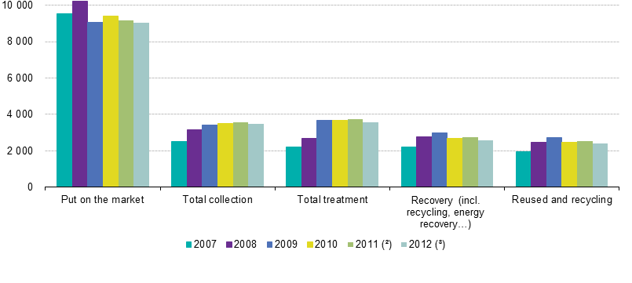
Disposing of WASTE from ELECTRIC and ELECTRONIC EQUIPMENT

How much E-waste is produced every year?

E-waste is a topical issue: every year 20-25 million tonnes are produced worldwide, of which most comes from Europe, the United States and Australasia.
E-waste collected and recycled is by far less than Electric and Electronic Equipment put on the market (source: Eurostat)

Is E-waste perceived as an important issue by EU governments?

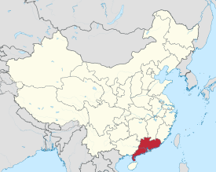
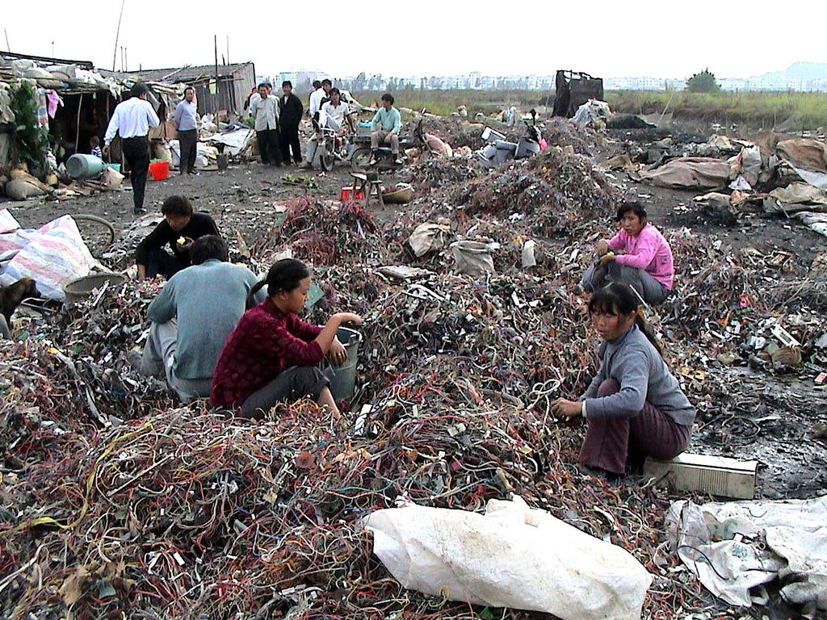
E-waste it is not perceived as an important issue: almost all EU governments did not keep to schedule. Legislation on E-waste was not laid down on time and/or not respected
Guodang province, in China

A common Guiyu landscape: safety and health of workers are not respected

Where does E-waste end up?
WEEE is commonly disposed of in landfills; however effective reprocessing technology is expensive. Thus developed countries export an unknown quantity (cf. above graph) of E-waste to poor countries, where recycling techniques include burning and dissolution in strong acids.
The most affected place in the world is Guangdong province, in China.

What are the working conditions of Guangdong people employed in E-waste disposal?

Few measures are taken to protect human health and the environment. E-waste workers suffer negative health effects through skin contact and inhalation, while the wider community is exposed to the contaminants through smoke, dust, drinking water and food.
The highest concentration of E-waste is in Guiyu, a town 5 hours away from Hong Kong. A scientific study has proved that children born there have elevated blood lead levels.
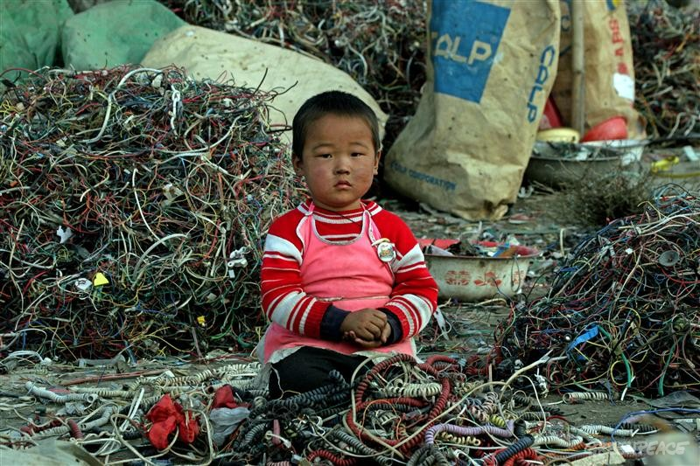

Elevated blood lead levels were found in Guiyu children.

Eventually, there is evidence that E-waste associated contaminants may be present in some agricultural or manufactured products for export.

Sources

http://www.sciencedirect.com/science/article/pii/S0048969709009073

https://www.researchgate.net/profile/Xia_Huo/publication/6200471_Elevated_Blood_Lead_Levels_of_Children_in_Guiyu_an_Electronic_Waste_Recycling_Town_in_China/links/0f31752e91a9fa54fe000000.pdf

http://ec.europa.eu/eurostat/statistics-explained/index.php/Waste_statistics_-_electrical_and_electronic_equipment

https://en.wikipedia.org/wiki/Waste_Electrical_and_Electronic_Equipment_Directive

Ferruccio Busetto
Exportation of e-waste and the Basel Convention
- E-waste is routinely exported from developed countries to developing ones
- About 47% of these exportations are illegal
- The countries most suffering from this problem are China, India, African and Far Eastern ones
- The problem is that recycling waste in these countries is incredibly less expensive than in developed countries where governments need to follow rules meant to protect workers’ health and the environment
- In New Delhi only, 10-20,000 tons of e-waste is handled each year and 25,000 workers are employed in this sector
- Developing countries are trying to ban these exportations but laws are actually not working
- The solution to this terrible problem is partly offered by the Basel Convention
- The Basel Convention was drawn up by Plenipotentiaries, elected by their own countries, from all parts of the world on March 22nd 1989 in a Conference held in Basel, Switzerland
- The main purpose of the Basel C. is the protection of human health and environment against the adverse effects of toxic or hazardous waste
- The Basel C. consists of three main points
- reduction of hazardous waste generation and promotion of environmentally sound management of this
- restriction of transboundary movements of hazardous waste
- creation of a regulatory system applying to cases where transboundary movements are permitted by the law
- Unluckily the Basel C. is not the “final solution” because the governments are not obligated to ratify it
- Currently the USA is legally exporting 50-80 % of its waste to developing countries because it didn’t ratify the Basel C.

Sources:
• http://www.greenpeace.org/international/en/campaigns/detox/electronics/the-e-waste-problem/where-does-e-waste-end-up/
• http://www.basel.int/

Jacopo Barbini
Where does e-waste end up?

Landfills
Dumping e-waste in landfills should be the last resort, but unfortunately, poor countries (like Romania) send their waste to landfills, without reusing it or recovering its components, because it is more economical.
Landfills should be created on an impervious ground, because e-waste has hazardous content that can leak into the ground and then into aquifers.

Incineration
There are two incineration ways:
-one environmentally dangerous, because it releases heavy metals such as lead, cadmium and mercury, into the air. This method is illegal but still practised also in Italy in “Terra dei fuochi” in Campania.
-one eco-friendly, that filters the toxic gas produced by the burning of waste. This method can also generate electric power.

Reuse
Many old products are exported to developing countries, to increase their lifespan. But then they are dumped in areas that have hazardous waste facilities.

Recycling
Recycling can be a good way to reuse the raw materials in a product. WEEE components, however, can harm workers, so there have to be controls.
In developing countries, there are no such controls, so many people and also children are exposed to these dangerous elements.

Source
www.greenpeace.com
Giacomo Rizzo

OIL SPILLS AND THE EFFECTS ON THE MARINE ENVIRONMENT
Introduction
Oil is one of the main pollutants of our planet. It affects particularly the marine environment, oceans and coastal waters.
Oil is found in the subsoil. It is extracted as crude oil and it is used to obtain a great variety of products through refinement processes (fuels, fertilizers, plastics, lubricants, grease, etc.)
Oil has become essential for human activities and, consequently, one of the main pollutants.
It is composed mainly of a category of molecules known as hydrocarbons, which are toxic for all forms of life.

1- Oil is dispersed in the marine environment in different ways:
- very often oil can be released into the sea or into the ocean through accidents involving oil rigs, pipelines, refineries , tankers and barges;
- rarely is oil dispersion caused by natural catastrophes, like earthquakes , hurricanes, etc.;
- illegal oil dumping is a phenomenon by which oil is voluntarily dumped into the marine environment by dumpers.

2- Effects of oil spills on marine wildlife
Animals and plants that live in the water and near the shore are the ones most affected. The effects are many, the main ones are:
- growth reduction
- change of heart and respiration rates
- erosion of fins
- damage of organs
- egg contamination
- incapacity to self-regulate body temperature.

3- The effects on coral reefs and on their habitat
Spilled oil can also damage coral reefs, affecting the whole reef ecosystem. There are different ways in which coral reefs can come in contact with oil spills. It depends mainly on:

- Oil composition: There are many different types of oil dispersed into the oceans and seas. Depending on their composition, their impact on the environment is different;
- atmospheric agents ( currents , winds, …) can mix the oil with water and make it drift down to the coral reefs.
The direct contact with oil can kill corals or prevent them to develop, endangering the lives of all the reef animals.
Once damaged, it takes a very long time for coral reefs to grow again, so the risks are very serious.

4- Prevention measures and clean up methods taken by the main world companies
In recent years new protocols and procedures have been set up to test regularly both processes and equipment used in the oil industry. Moreover, new technologies have been introduced to minimize risks and to protect people's health and safety.
Spilled oil is difficult to clean up because it floats on the water surface and spreads in very thin layers (slicks) called sheens.
The basic clean up method involves:
- floating booms to keep oil from spreading:
- skimmers , boats that skim oil from water’s surface;
- sorbents to adsorb or to absorb the oil;
- dispersants to speed up the oil’s natural biodegradation.

Sources
http://www.shipwrecklog.com/log/history/haven-explosion/
http://response.restoration.noaa.gov/about/media/how-do-oil-spills-affect-coral-reefs.html
http://www.pollutionissues.com/Na-Ph/Petroleum.html
http://www.oilspillprevention.org/oil-spill-prevention/oil-spill-prevention-procedures

Filippo Carraro
Effects of ocean pollution on marine animals

There are three different types of Ocean pollution:
1^ oil spills (from tankers and oil rigs)
2^ solid waste: all the materials that aren’t biodegradable and fishing rubbish
3^ chemicals and heavy metals: introduced into the sea by factories
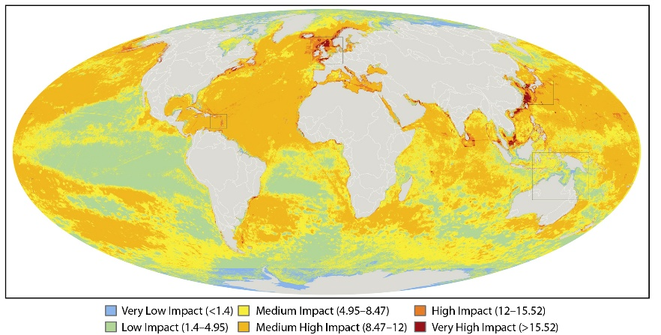

Human impact on marine pollution
The very high impact zones are next to northern Europe, western and eastern coasts of America, Japan and China
How ocean pollution affects the health of marine animals
Animals like turtles and seals get stuck in nets or lines. Sometimes they can even exchange plastic bottles or bags for food and in this situations animals can even die.
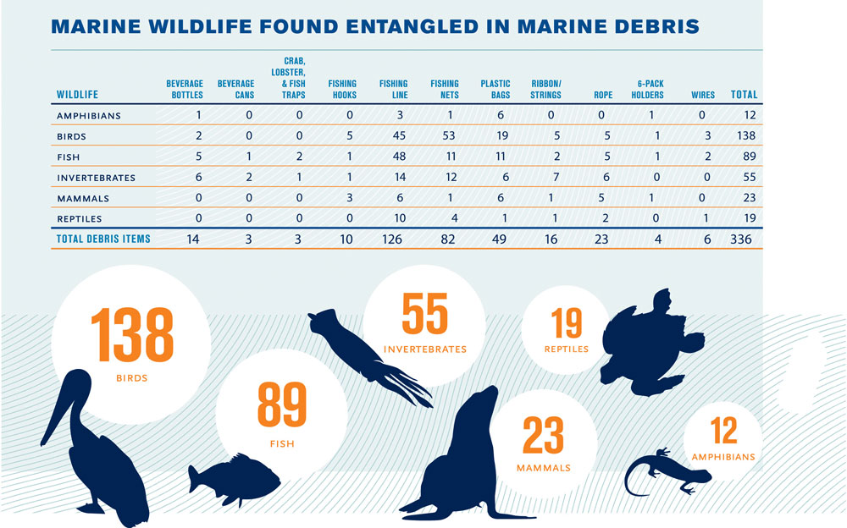
The worst debris for marine animals are fishing lines, fishing nets and plastic bags because they can easily get entangled in them. As a result they become unable to swim and die.
Sources:

https://it.wikipedia.org/wiki/Inquinamento_dalla_plastica
http://www.legambiente.it/contrnuti/comunicati/
http://www.greenme.it/informarsi/ambiente/
http://www.greenstyle.it/
http://scienze.fanpage.it/pacific-trash-vortex/

Nicolò Zennaro

Ocean pollution and marine animals: ingestion

We have seen that there are two main causes of oceans’ pollution:
-chemicals' dumping
-solid waste (plastic, glass, cans…)

Chemicals are used in:
-industries
-agriculture (pesticides)
Then they are washed into rivers and from there are carried into the oceans.

Marine animals can eat them and the effect of ingestion can be:
- obstruction of the digestive or respiratory tract that impairs foraging efficiency or breathing efficiency
- poisoning that often leads to failure of sea animals' reproductive system or illness

Effects on food chain: small animals that ingest chemicals and are later eaten by larger animals like humans.

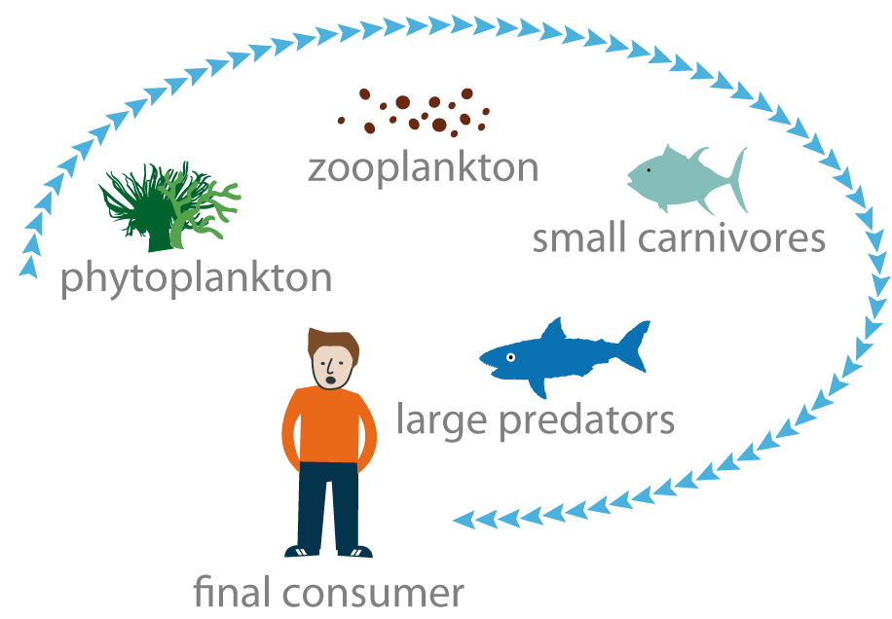

Recently there have been several campaigns to make people aware of these problems, especially of the effects of ocean pollution on humans’ health. Here is an example:

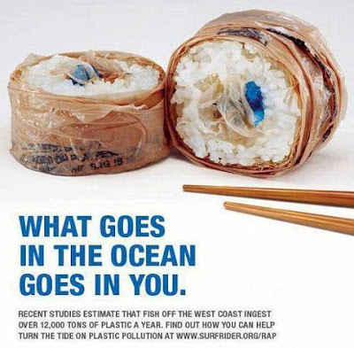
Sources:
http://www.conserve-energy-future.com/causes-and-effects-of-ocean-pollution.php
http://swfsc.noaa.gov/publications/TM/SWFSC/NOAA-TM-NMFS-SWFSC-154_P623.PDF
www.chemical-pollution.com

Giulia Agoni

The Great Pacific Garbage Patch

-The GPGP is a collection of marine debris in the North Pacific Ocean.
-It’s also called “The Pacific trash vortex”; it spans waters from the West Coast of North America to Japan.
-It’s divided into two parts: the Western Garbage Patch, located near Japan, and the Eastern Garbage Patch, located between Hawaii and California.
-These areas of spinning debris are linked together by the North Pacific Subtropical Convergence Zone, it’s where warm water from the South Pacific meets up with cooler water from the Arctic.
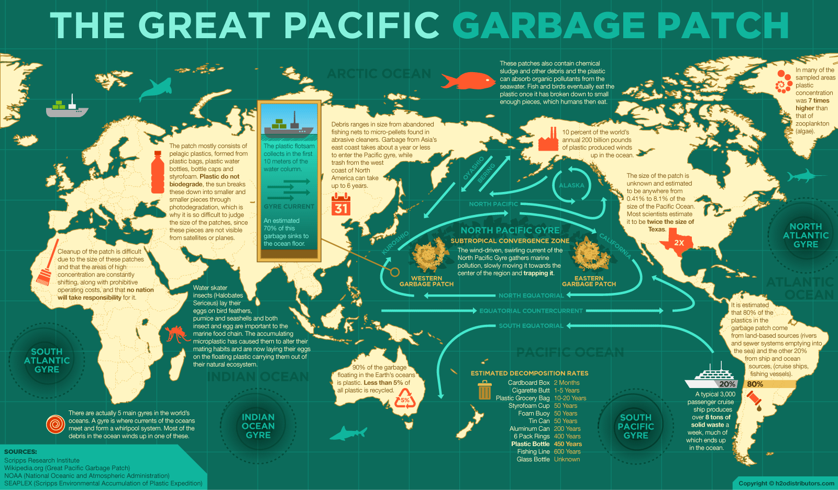
-The entire Great Pacific Garbage Patch is bound by the North Pacific Subtropical Gyre - an ocean gyre is a system of circular ocean currents formed by the force created by the rotation of the planet and by the Earth’s wind patterns.
-All the debris is not biodegradable.
-Plastics don’t wear down, they simply break into minute pieces called microplastics.
-Big pieces of garbage are mixed with microplastics.
-Microplastics make the water look like a cloudy soup.
-The trash vortex was firstly discovered by Charles Moore while he was sailing from Hawaii to California.

Sources
http://education.nationalgeographic.org/encyclopedia/great-pacific-garbage-patch/#
https://en.wikipedia.org/wiki/Great_Pacific_garbage_patch
Elena Cazzanti
The Great Pacific Garbage Patch impact on marine life.

- Estimating how much debris makes up the patch is hard, because it's huge and difficult to measure.

- It's mainly made of plastic pellets and fishing nets; the 80% coming from land based activities, the rest from oil rigs and ships.

- Plastic doesn’t biodegrade, but gets broken into little pieces by the sun in a phenomenon called photo-degradation.

- Plastic hurts sea life, it can make mammals drown in a phenomenon called Ghost Fishing, or be eaten by fishes and birds.

- The tinier plastic pellets reduce the amount of sunlight received by algae and plankton, so it can possibly endanger the whole food chain.

- All problems that plastic involves are compounded by the fact that it leaks out in the sea chemicals and colorants.
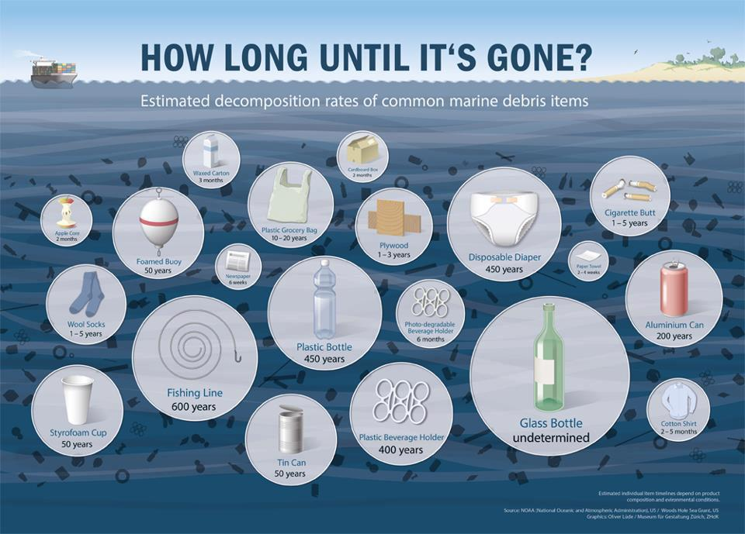
Source
http://education.nationalgeographic.org/encyclopedia/great-pacific-garbage-patch/

Alvise Fusaro

How to clean up the Great Pacific Garbage Patch (GPGP)?

There are countless obstacles to come up with an affordable method for cleaning up the Great Pacific Garbage Patch. However, most ideas that have been developed so far come with high financial costs.

As the Great Pacific Garbage Patch is extremely far from any country’s coastline, no nation will take responsibility or provide the funding to clean it up.

International organizations are taking measures to prevent the patch from growing: they use a method that involves nets or net-like devices to “fish“ for the garbage. However this method is far from ideal because it would mean the capture and death of a lot of animals and plants.
One famous initiative that is trying to fix the problem is The Ocean Cleanup, a project by the Dutch environmentalist Boyan Slat.

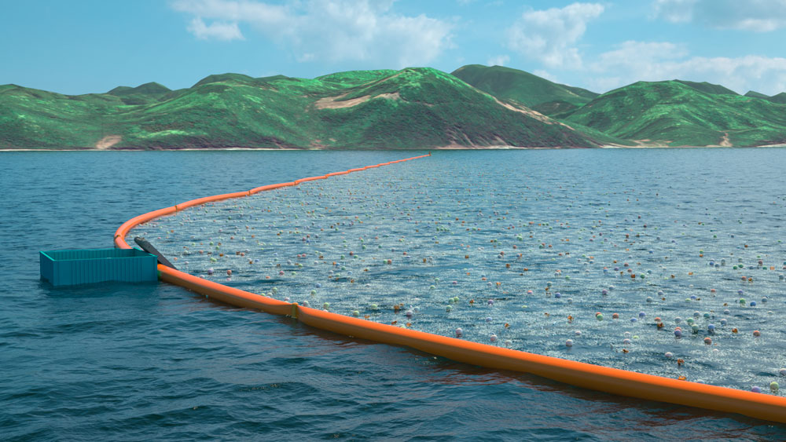

To collect plastic from the oceans Slat has conceived a floating device that uses the power of the same gyres that move the plastic between the Garbage Patches. Because it does not use nets but floating barriers, the device also avoids the entanglement of sea life. The swimming garbage catcher is based on the principle of passive collection, which means that it does not need ships to be moved as it is driven by natural forces such as wind and currents.
and plants.

Many scientists have suggested a plan of action for the future and made recommendations on where to set the emphasis on dealing with the problem. There is a debate whether the primary response to it should be the cleanup of the oceans or preventing the formation of the GPGP: for the latter, most proposals include a range of measures that complement each other. The most commonly mentioned are education, legislation (es.MARPOL: ships are not allowed to drop garbage into the ocean) and economic incentives (es. development of cost recovery systems that provide an incentive to use port reception facilities), while some are speaking about banning plastic (as in Bangladesh and California).

Sources

http://www.schwindelfrei.org/?p=928

http://education.nationalgeographic.org/encyclopedia/great-pacific-garbage-patch/

Elena Brasi

