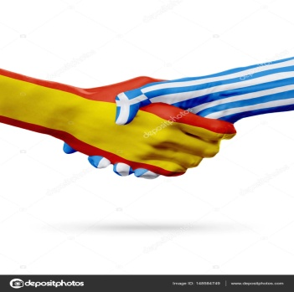

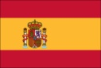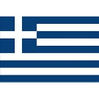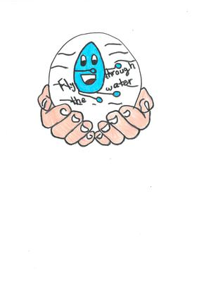PROJECT TIMELINE

**JANUARY 2018.**

* Introducing our schools and countries.
* Introducing ourselves.

**FEBRUARY 2018.**

* Our Project needs a logo. Let´s do it together.
* Talking about river and affluents in our country.

**MARCH 2018**

* Water legends: Using ITC to talk about ancient legends about water in our countries.
* Mixing legends through storybooks.

**APRIL 2018.**

* E Twinning live: Water Legends Quiz.
* Water sayings: Let´s sing together to learn famous sayings about water.

**MAY 2018.**

* The uses of water in our country: Learn strategies to save water. Starting to collect information about the uses of water and water cycle. Tips to protect the water resources and the environment in general.

**JUNE 2018**

* STUDENTS EVALUATION: Let´s evaluate our work.
* TEACHERS SURVEY: Self evaluation is important to improve future projects and the work we did.