ABOUT OUR SCHOOL AND EDUCATION
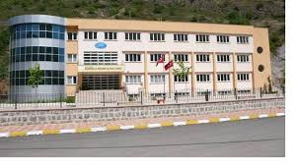
Esiroğlu Kenan Oltan Anatolian High School is a state school. İt is 17 km far from the city center. The school has the capacity of 400 students. The school has 11 classes, a canteen, a library, three science laboraties, three languages classes, a music class, a meeting room and also a teacher room, a school manager’s room, an asistant manager’s room, a system room, a lesson material’s room,an infirmary room, a quidance room and a staff room. At the moment, our school is carrying out its educational process with 272 students, one school manager, one assistant manager and 28 teachers.
Our school term begins in the mid-September and finishes in the mid-June. We have a two weeks Winter break in February and we have a three months Summer break. In our school, our lessons start at 8.40 and finish at 15.50. There are lots of lessons including Maths, Turkish language and literature, Chemistry, Biology, Physic, History, Geography, PE, Philosophy, Music, English, Deutsch and Religious. We have no vocational courses. Our students are between 14-18/19 age.Our students have social activities after school or Saturdays. We have at least two exams for each lesson. We award our students two times in an academic year.
In accordance with the aims and principles of the Turkish national education, we strive to educate our students individuals who comprehend Ataturk’s doctrines and revolutions and think freely. All our students are valuable to us. We treat them affectionately. “To be a school taken model, not model.” This is our vision.
Our teachers are struggling to educate self-confident, productive individuals who are open to inovations. While they are doing this ,it is aimed to train creative, talented and communicative generations.

