Our school

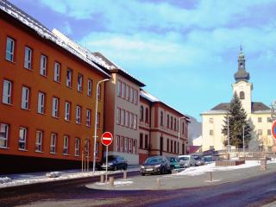
Secondary Vocational school of Trade and Services is situated in the centre of Nová Baňa, Slovakia. The school consists of several buildings: Administrative, the next building with classrooms and laboratories, gym, school canteen and workshops. There are the following departments at school: Business and Trade, Chef, Waiter, Mechanic, Public catering and Entrepreneuring in Craft and Services.
There are nearly 150 students and 25 teachers at school. The main subjects are Maths, Slovak language and literature, English language, German language, Economy, PE, Accounting and Vocational subjects. Students have Vocational prax at some local companies, where they gain some professional skills for future jobs.
There is a school buffet Garfield, where students can buy some snacks. Extracurricular activities are very popular in the afternoons. Students visit some sportclubs, take part in different competitions or work on different projects.

Welcome to our school!

