Secondary Vocational school of Trade and Services, Nová Baňa, Slovakia

Ms.Teacher 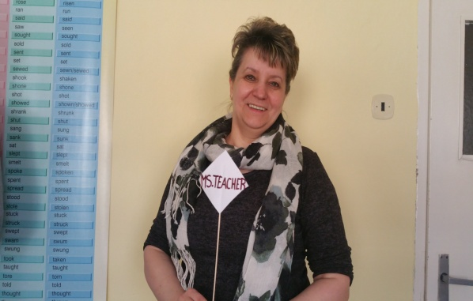

Name: Maria
Surname: Falatova
Age: middle-aged
Occupation: English language teacher
Favourite food: fruit and vegetables, different kinds of meat
Favourite music: pop- music

Hobby: her dog NERA

Students of 1.N Class – department Entrepreneuring in Craft and Services

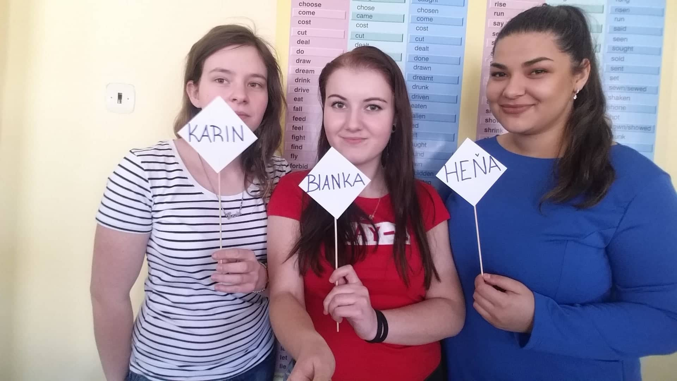

Name: Bianka
Surname: Ciglanová
Age: 19 years old
Occupation: hairdresser, certificate of apprenticeship
Favourite food:
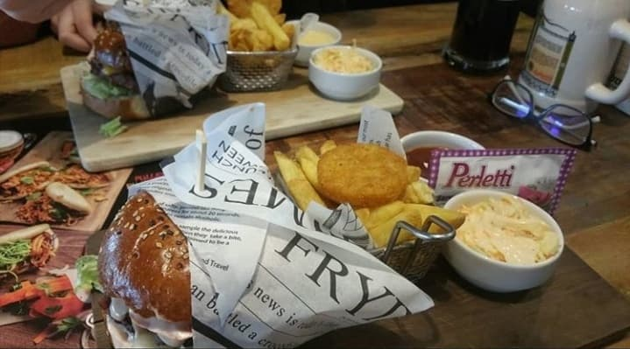

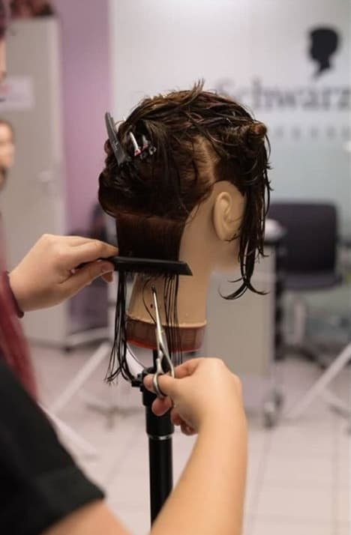
Hobby:

Name: Karin
Surname: Gažiová
Age: 19 years old
Occupation: Chef, Certificate of apprenticeship

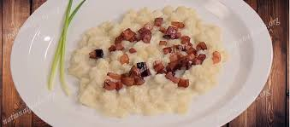
Favourite food: sheep cheese dumpling

Hobby: gardening, I have a part-time job in a Garden centre in our town

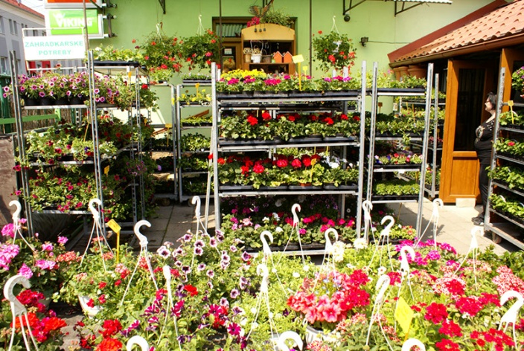
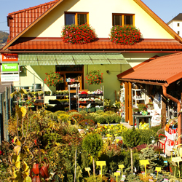

Name: Henrieta
Surname: Kocáková
Age: 18 years old
Occupation: Cosmetician, Certificate of apprenticeship
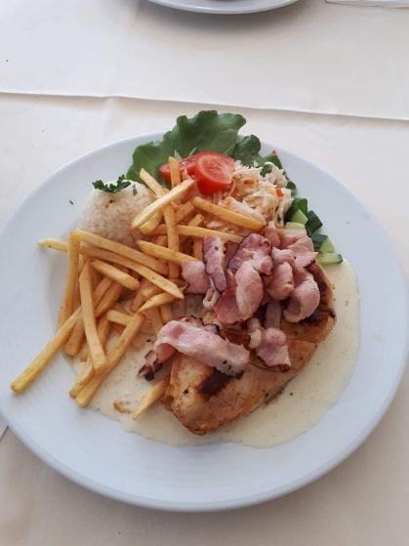
Favourite food:

Hobby: make-up and my little sister
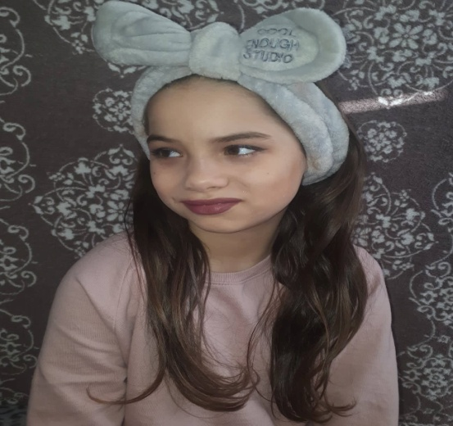

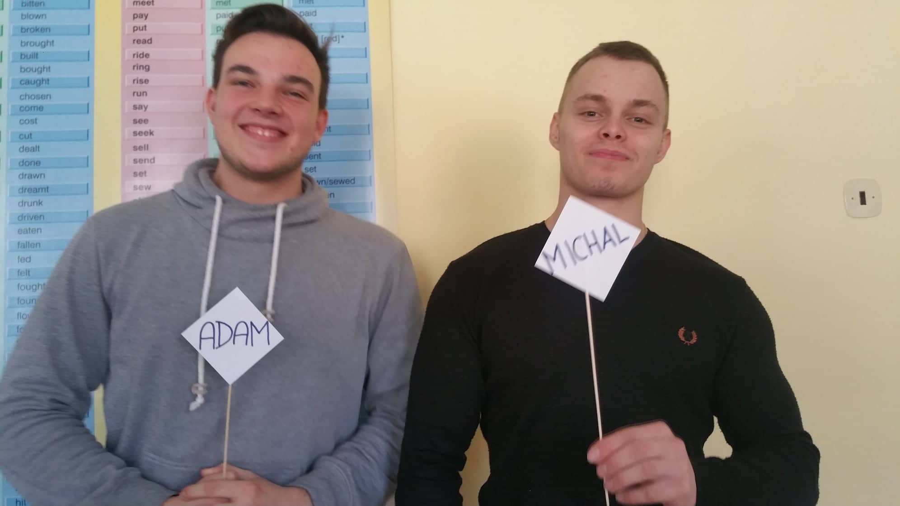

Name: Adam
Surname: Švec
Age: 18 years old
Occupation: Chimney sweeerp, Certificate of apprenticeship
Favourite food: steak with potatoes

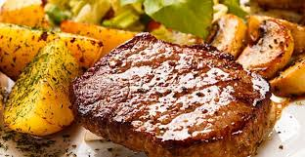

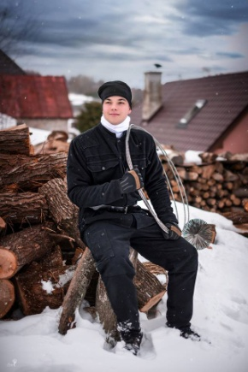
Hobby:

Name: Michal
Surname: Šimkovič
Age: 19 years old
Occupation: Chef, Certificate of apprenticeship

Favourite food: cottage cheese, protein, banana
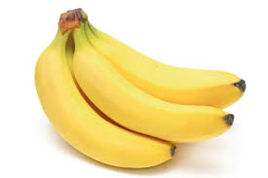
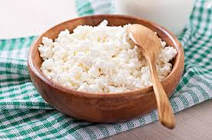

Hobby:

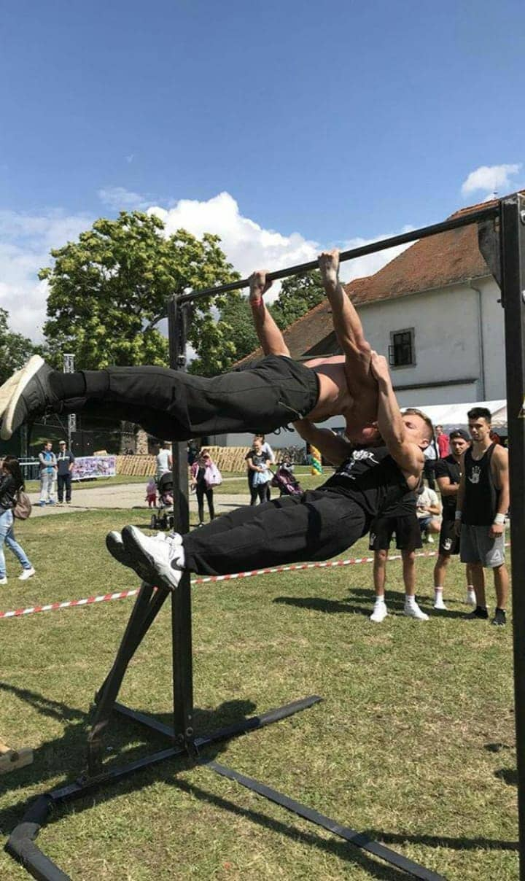
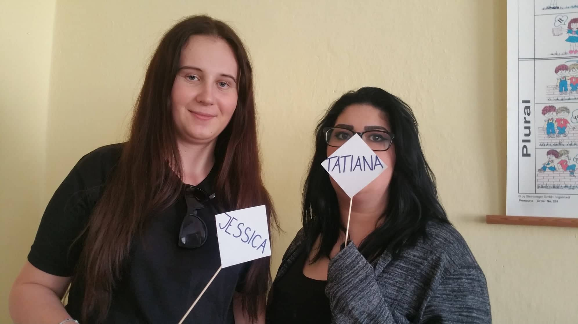

Name: Jessika Kitty Name: Tatiana
Surname: Horvathová Surname: Milkulašková
Age: 20 years old Age: 19 years old

Occupation: Chef, Certificate of apprenticeship Occupation: Chef, Certificate of
apprenticeship

Favourite food: goulash Favourite food: bagette from school buffet
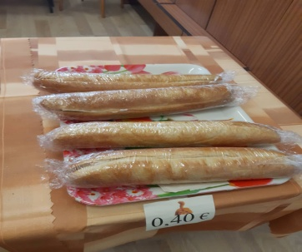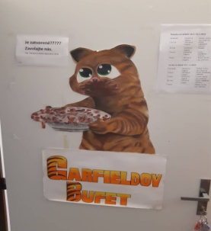
Hobby: sport activities Hobby: cooking
