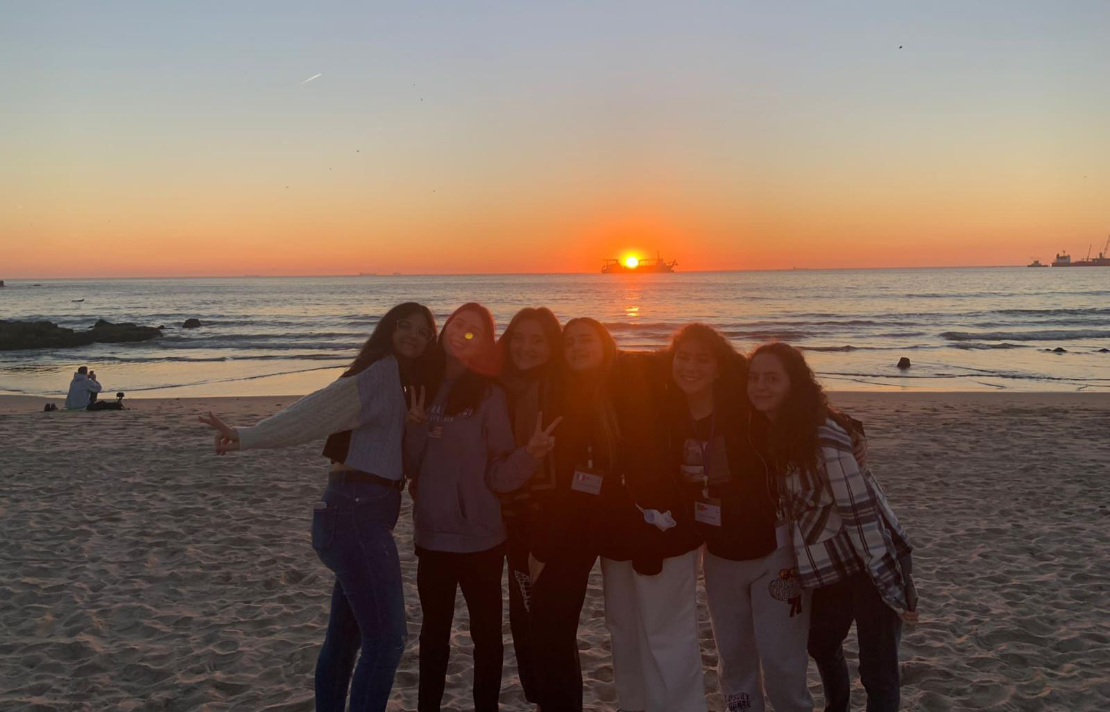

How long we have been longing for this trip! ...and now I find myself here with a pen and some paper in my hands to tell you about the most beautiful experience of my life. I will try to convey as clearly as possible the greatness of this project because, my dear, it is not just a simple journey! You can't explain Erasmus! When I try to do it I can't find the words and I feel the others distant and sceptical as if I were a mad girl who talks about feelings and emotions without a line of logic, trying to rewind a ball of yarn full of memories, laughter, friendships or to rearrange a suitcase full of culture! Well that's right. Erasmus cannot be told , it must be experienced.

It was after various adventures including covid pandemic and desperate waits that we finally set foot in one of the most beautiful cities in the world: Porto. With its sea, its sunshine and its wonderful people it could not help but bewitch us from the first instant. Not to mention how many things we did in just one week! Our time ranged from school activities in "Carolina Michaelis" high school in Porto, to boat rides, walks at sea and parties, everything between a run and the other for fear of missing the subway or the bus since, obviously, the late ones were always us, the Italians !!!

I remember that from the first evening I was aware that on my return I would have a good cry and I must say that my expectations were incredibly exceeded. In Porto I left a piece of my heart, it remains my safe place where I made friends with people who I had never seen before and who, only by chance, have entered my life, boys and girls who are so distant and different from my culture but with whom I have something in common: the desire to know the world and open our minds to new horizons. And this is precisely the purpose of Erasmus, it takes your hand and leads you to discover the world, new cultures, traditions, bonds that we would never want to break again. In the streets of Porto a choir of boys and teachers played continuously: "We love Erasmus" and now at the end of my journey I can really say thank you to Europe and thank you to my high school that has given me the opportunity to be part of an international dream and to represent my country abroad.
Giuliana Flavia Napoletano
Itaòy

