Erasmus in Portugal (Porto)

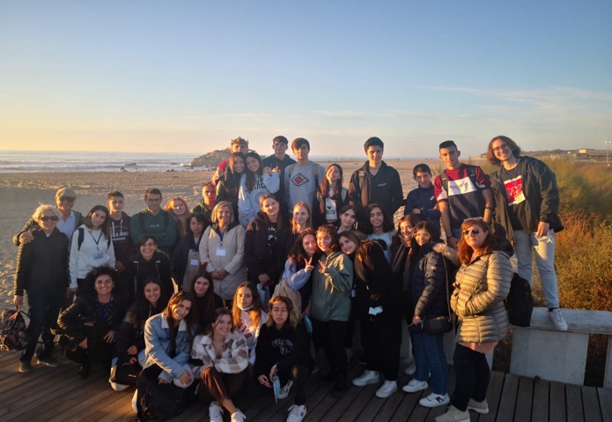

When my English teacher announced that our school was participating in an Erasmus project, I immediately felt that I wanted to be part of it because I have always been eager to know the customs and traditions of other European countries.

Unfortunately, during the quarantine my enthusiasm and energies faded into disappointment and sadness due to the impossibility of travelling but in spite of that, my mind did nothing but think about people, places and traditions that I would have liked to know, always keeping in my heart the hope that one day this ugly pandemic would be over and I could finally experience the best part of an Erasmus programme: the transnational meetings.

Finally, this year, the planned mobility could take place. I was over the moon once I knew where I was going, I spent whole afternoons looking at the photos of Porto and trying to imagine what kind of people I’d meet hoping that I could feel comfortable with them and build deep friendships.

Now, I can fully say that this experience was one of the best I could have had. I met amazing and special people who have entered my heart for their kindness, their warmth and their ability to make me feel at home from the very first moment. I also visited beautiful places in Portugal that won me over like the city hall, the castle of Guimares but also the landscape was breathtaking with its sunsets, the ocean, the river and the joyful colours of the city.

My expectations were also exceeded when it comes to friendships because, as I have already said, I had never met such special people and I felt so sad saying goodbye to them because I already knew that I wouldn't be able to meet all of them again but only those who would come to Italy.

Giada Mattina
Italy

