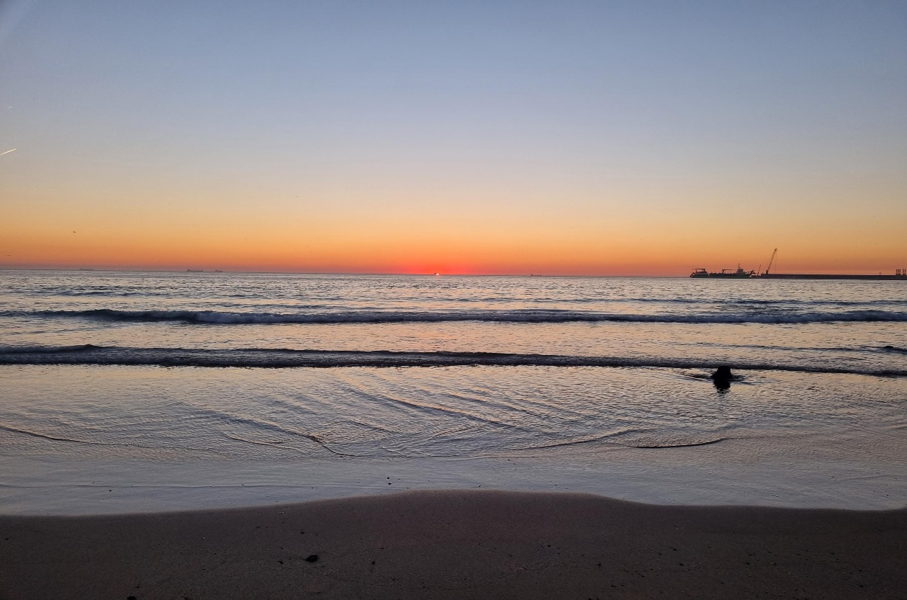
Due to the pandemic, this past year and a half has been difficult for everyone, but thanks to this Erasmus experience, for a week I was able to feel as if the pandemic had never happened, as if I could do everything without worrying about the invisible enemy. This is all thanks to Erasmus, and personally, for that reason, I thank my school.
I had pretty high expectations regarding my mobility to Porto, yet, somehow, reality managed to blow them out! Porto is incredible, full of sights of great interest such as monuments, squares, green areas; I was impressed with how beautiful it was! Navigating the Douro river aboard a boat, or visiting the castle in Guimarães, were also amazing experiences; another important experience was the walk in the forest, as it was sustainable, and, as we know, sustainability is the key.
But the most important thing that came out of the Erasmus experience, for me, was friends. I met lots of people from all over Europe and made friends with Portuguese and Cypriots , before this experience who would’ve imagined all that! But thanks to the project it was made possible, as was the learning of other people’s cultures, the differences and the common aspects between themin order to maybe finally get rid of stereotypes surrounding the different nations.
Flavio Mongiovì
Italy

