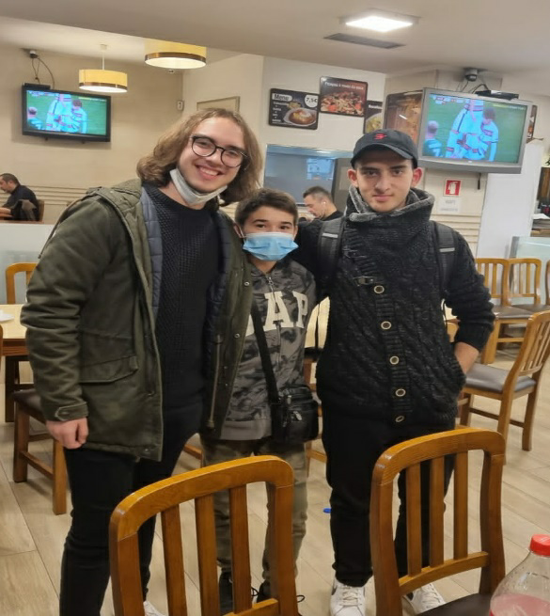
On Saturday, we went to larnaca airport by bus, and 3-4 hours later we arrived at the vienna airport. We had a lot of time, so we visited a lot of attractions, and we also had lunch in a restaurant. Afterwards, we went to vienna airport, from there to frankfourt airport and finally we arrived in Portugal, where we immediately went to the hotel.
On Sunday, we went for a walk in the town center in Portugal and we visited a big park with a lot of trees and then a bridge where it had an amazing view. Continuing, we had lunch in a restaurant, and then me and my friend went to a mall to visit the shops and eat.
On Monday, we went to the Portuguese student's school by walking where every country presented local foods, dances, arts and people. Then, we started doing a digital poster and afterwards all the students went to a mall so that we can have fun, eat and buy some things. At night, we had a party at the school and we danced, ate, sang and had a lot of fun.
On Tuesday, we met at a subway near Portuguese student's school and we visited a lot of museums and historical places. Afterwards, we (Cypriots), Spanish students and some Portuguese students went to the Porto FC stadium, where we went to the stadium inside and we also saw the museum which was breathtaking.
On Wednesday, we went by bus somewhere and we saw some women cleaning clothes in their hand and singing. Then, we saw the fishermen arriving and throwing the nets and then we went a little trip in boat under a lot of bridges. Our next stop, which was my favorite of the whole program, was a church in sand and next to it there were big rocks and ahead it was the Atlantic ocean, with a lot of waves, and it was awesome. At night, we ate at the hotel.
On Thursday, we went to their school and someone showed us a presentation about sustainability and sustainable tourism in Porto and generally in Portugal. Continuing we went to a museum that someone told us a lot of interesting things and a castle.
On Friday, we went for the last time to their school and we finished the digital poster about all the countries' arts crafts and local people and the video about promoting porto. Later we went to the mall with the Italian team and some Portuguese students and then to the Hard rock cafe. At night, everyone gathered at a restaurant where we ate a delicious local food.
Overall, the whole project was amazing and I hoped it would last more. I went to a lot of fun places, places where I learnt a lot of interesting things, I learned the culture and the way of living of a lot of foreign students and most importantly I made some new friends.

