ERASMUS
I m thankful I got into Erasmus because it helped me a lot, it taught me a lot about different countries, their cultures and various interesting things. But the thing that Erasmus helped me the most was to practice my English. Finally the most important of all is that I made friends from other countries and met amazing people.
I love ERASMUS so much.

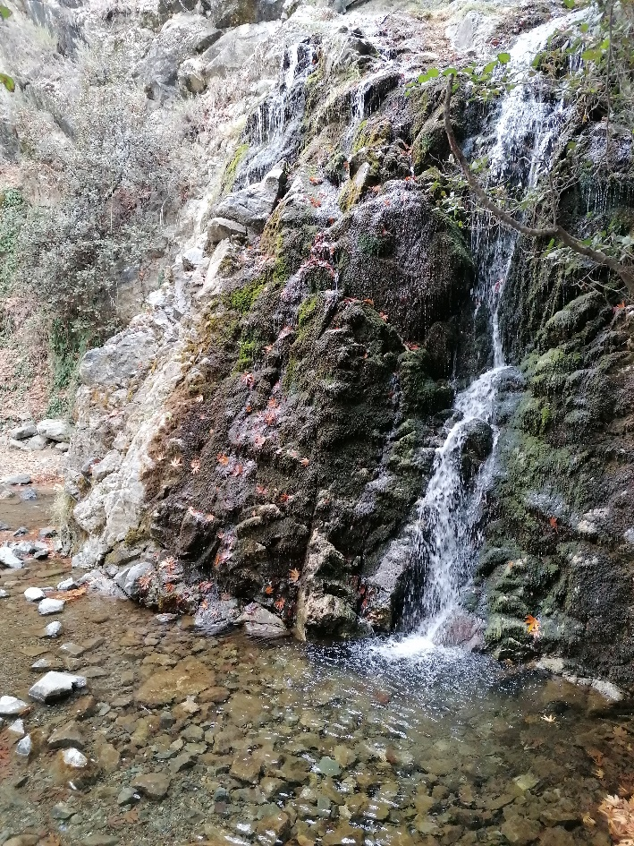
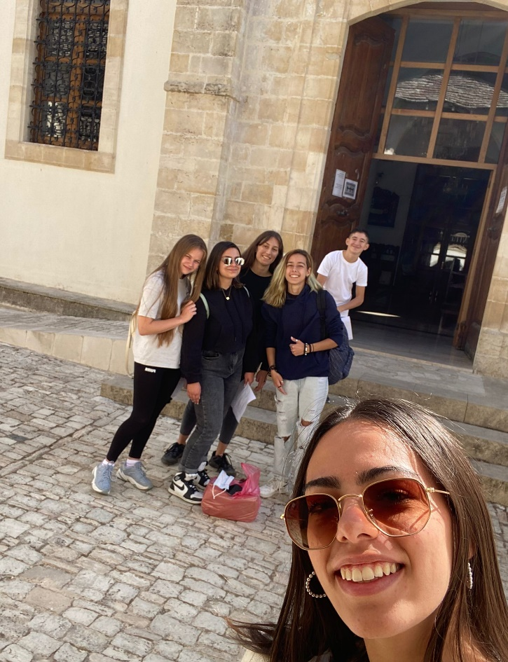

Chrysovalanto Herodotou.

