Erasmus in Portugal (Porto)
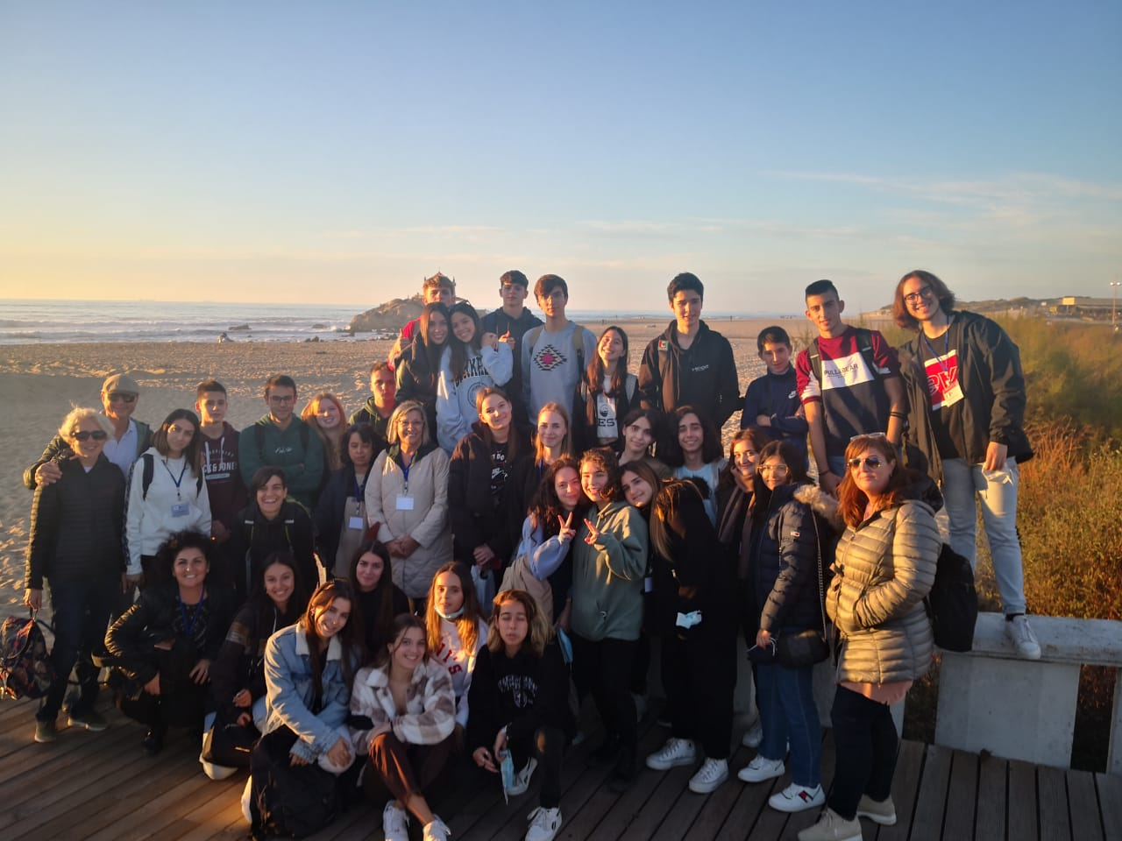
I had been longing for this mobility for more than a year since it was postponed because of the covid-19 pandemic. I was so sad and disappointed but I tried to imagine what it would be like to be there, in Porto. I spent my afternoons trying to improve my English speaking skills to be ready to communicate easily with my unknown Portuguese partners. I hoped they would vibrate at the same frequency as mine and I imagined I would create deep bonds with them
Now, I can fully state that it was an experience that exceeded all my expectations. Undoubtedly, Porto has totally enchanted me with the kindness and warmth of its inhabitants, with its routine, with the beauty of the rivers that overflow into the sparkling ocean, with its warm sunsets that amaze the eyes of all passers-by,with its colourful houses and its typical dishes.
In Porto I left a piece of my heart. I had never met such special people in my entire life. From the first moment they were able to make us feel at home. I will never forget the words of the principal Isabel: "If you decide to come again on Erasmus here at University, you know that we will be always here for you, this is your home".
This trip was particularly emotional for me. Last year, on the 12 November 2020, I blew out my candles at home, alone, in full lockdown. I remember well that the only wish I made was to get back to travel. A year later I realize that many things have changed, I am a different person and I found myself celebrating my 18th birthday in Portugal. I can't be more grateful !!
Rossana Vella
Italy

