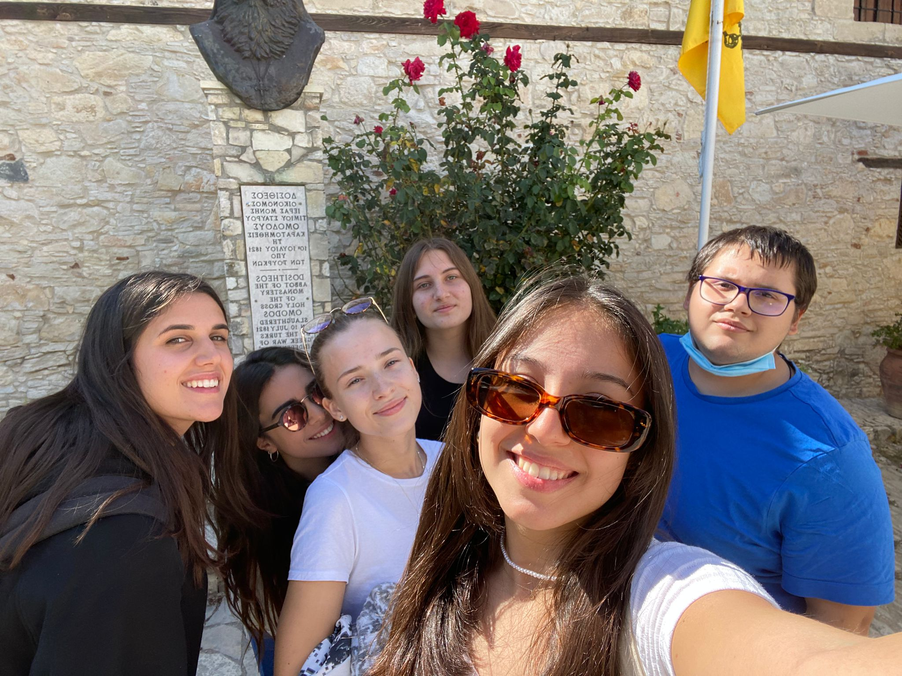
This was the best day because we worked a lot together and we did a good job. It was the second day when I saw them and we were all stressed but after we get very good together and we started to work like a team . Also all of us had a brilliant ideas and we had a lot of fun I hope it would happen again in the future

