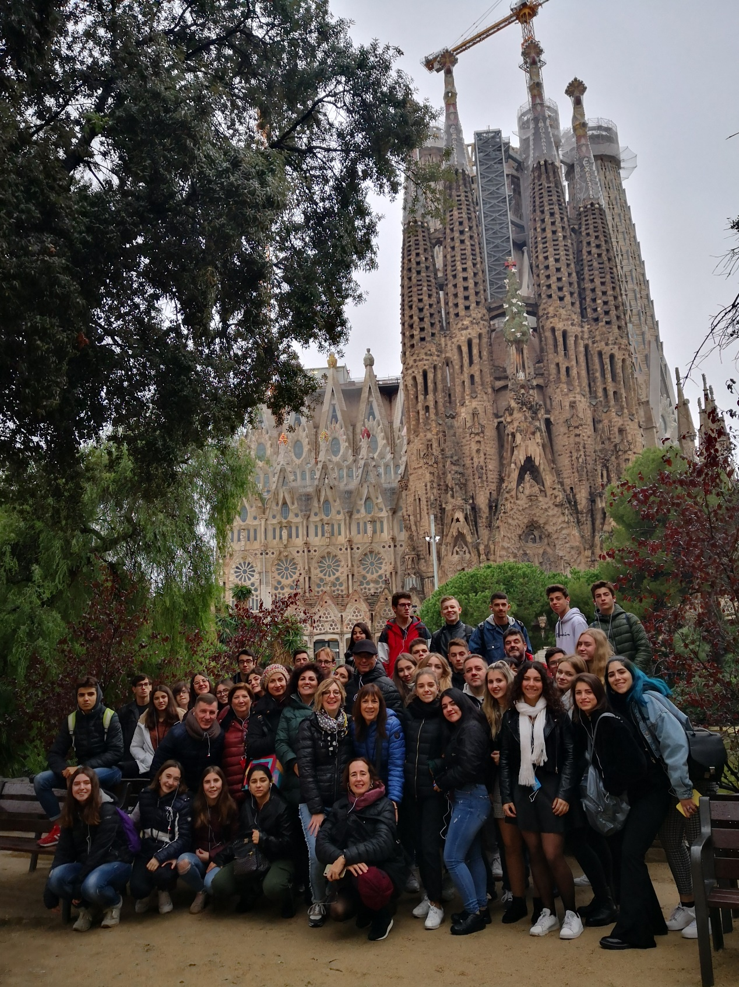

This November I have been at Catalonia with Erasmus for a project about sustainable tourism. We arrived with a little anxiety and fear ... we left with wonderful memories, important lessons, unremitting experiences and of course amazing friends. My host family make me feel so good. This exchange taught me interesting things about other countries, we came in touch with different places, cultures, traditions I wish I could live every single moment over again, thank you Erasmus+ I will never forget those days.

