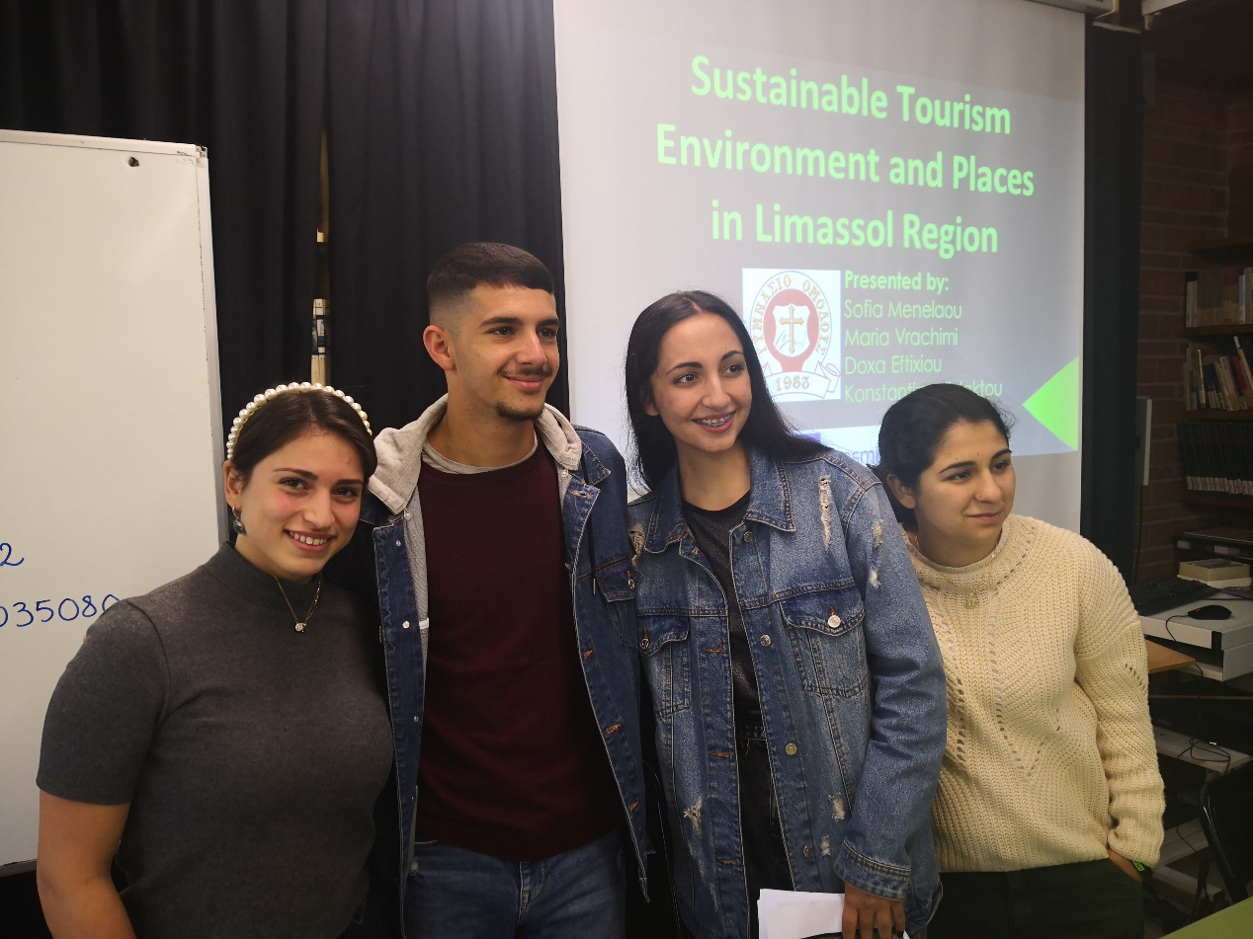
The journey that we had in Catalonia was an amazing experience. It was one of the most beautiful trips I've ever had. There are a lot of reasons that made me so happy and lucky to be there. First of all I had to say the best for the adorable family that hospitalized me. I was feeling that I knew all of them for a long time because they made me feel very comfortable with them. I'd like to add that they also were very polite to me. About the trip I have to mention that I got a lot of knowledge that I didn't know before. We also have visited unique places between the beautiful green colours of the nature. Furthermore during the beautiful trip we had with us amazing people with whom we had a lot of fun. All of them were so special and helpful. I hope I could go back and relive those and unforgettable moments. Wish we could meet again in the future.

