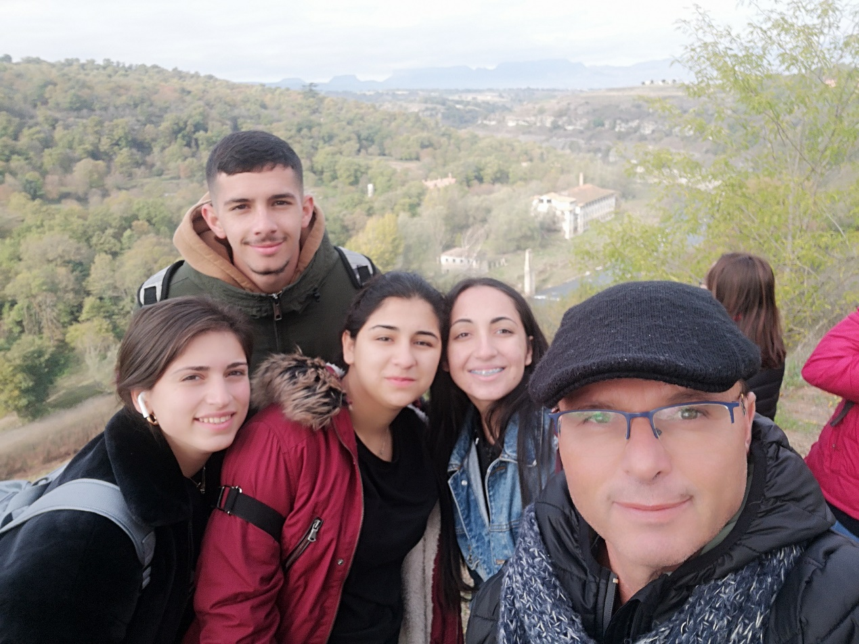
When we talk about student exchanges, we refer to exchanges of culture, emotions, concerns and memories. Thanks to Erasmus+ we have lived an unbelievable experience in Catalonia which will forever be etched in our hearts. A week full experience, working with students from other countries, sight-seeing and lots of smiles. Firstly the incredibly hospitable and good-hearted families made us feel welcome and comfortable from the first moment and students from across Europe became dear friends. With our teenage Catalonian hosts we went to places worthy of admiration with exuded civilization, culture and fun. With these memories we bid farewell to our hosts awaiting our next encounter in Cyprus next year.

