Erasmus gave me a lot of advantages, like best oral in English, good ideas for future businesses and good memories. It was something different but interesting. As a team we spent good time with a lot of memories. I made a lot of new friends from different countries. We needed to do small exercises but I liked it because I heard a lot of new ideas. I love Erasmus!
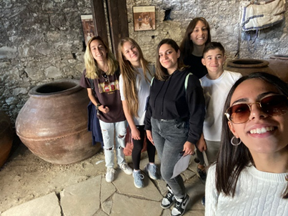

Anastasia Korotka

