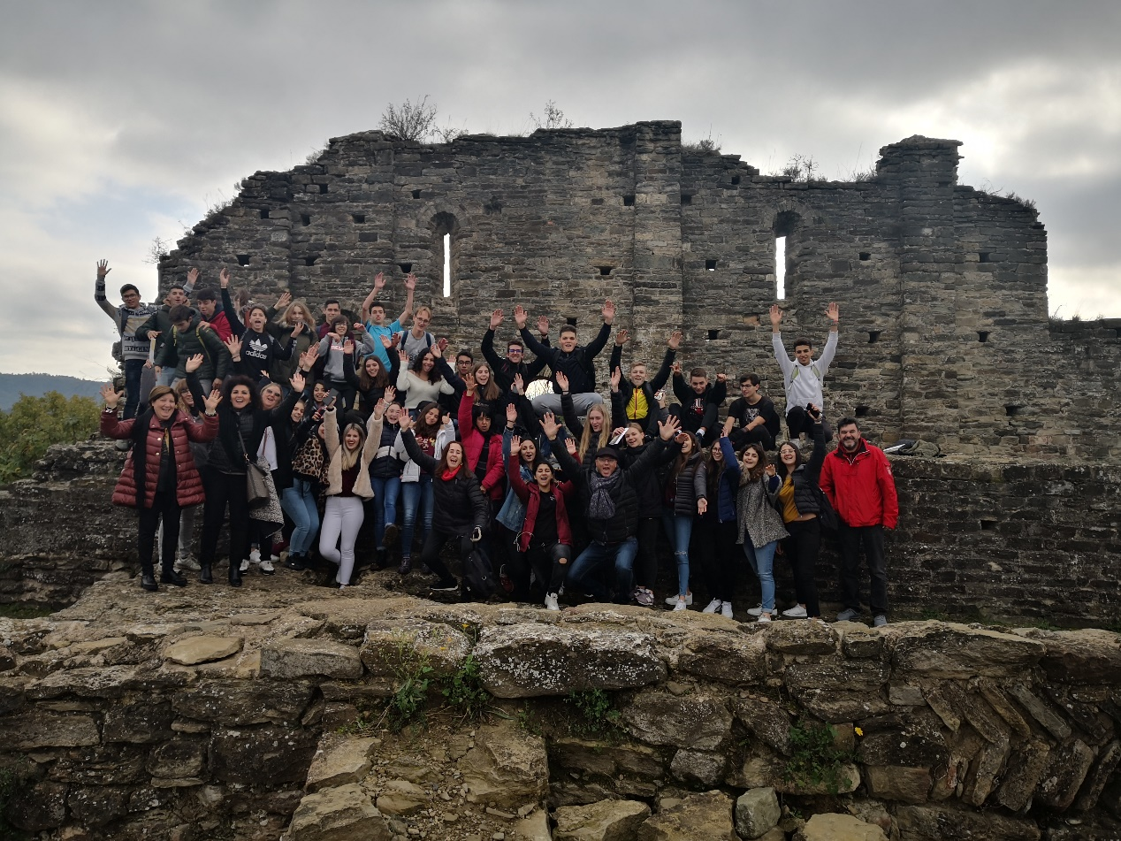

Our trip in Barcelona was amazing! It was an amazing experience because we saw new places and new cultures! We made new friends who became a family! The family who hosted me was very friendly and I felt part of their family from the beginning! With our teenage Catalonian hosts we went to places worthy of admiration with exuded civilization, culture and fun. With tears in the eyes, we bid farewell to our hosts awaiting our next encounter in Cyprus next year

