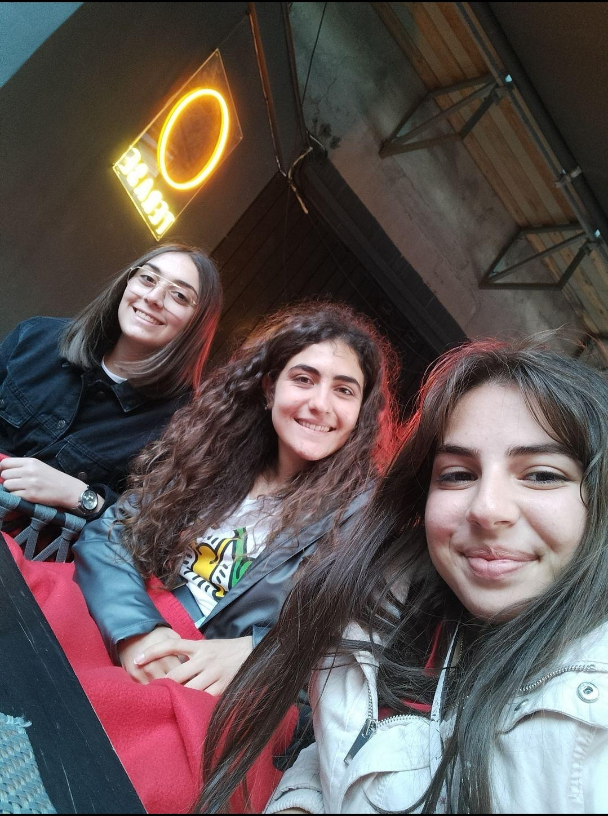
The experience to travel with the Erasmus+ project, helped us to improve our communication skills after those 3 years of covid-19 pandemic. A lot of people came to Cyprus too in October 2021 from Lithuania. With those students we keep talking with the most of them until the day we went to Lithuania. We were so excited to see our friends again after many months passed. At first I was a little worried about the new students that we will meet in Lithuania, after the first hours passed we became really good friends and it was so easy to find things to talk about. The best thing of our communication is that we stayed at the same hotel because in Latvia we stayed in different hotels from other countries and it wasn’t that easy to hang out with them, but at the end of the day we figure out the way to make it. It was an amazing experience that I wish to have the chance in the future to live it again. For sure in the long future I will try to visit and other friends that I’ve made countries.

