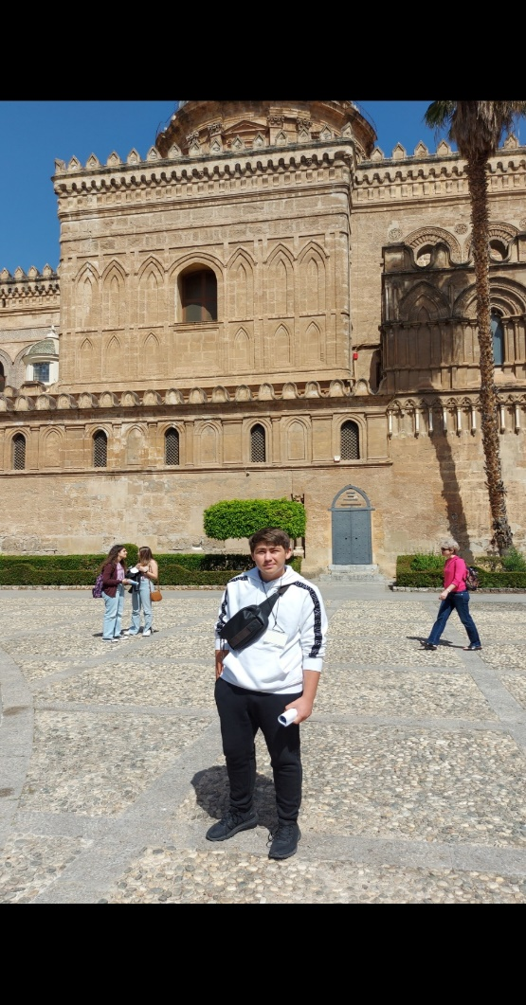

I liked very much the trip in Sicily. It was very interesting. I made many new friends from many different countries. In Sicily we went in to many places and landmarks but my favourite place that we went was the church of San Nicola dei Greci . Also we made to many activities. My favourite activity was the tour around Palermo. The food was delicious and the hotels were good.

Stelios Papaioannou

