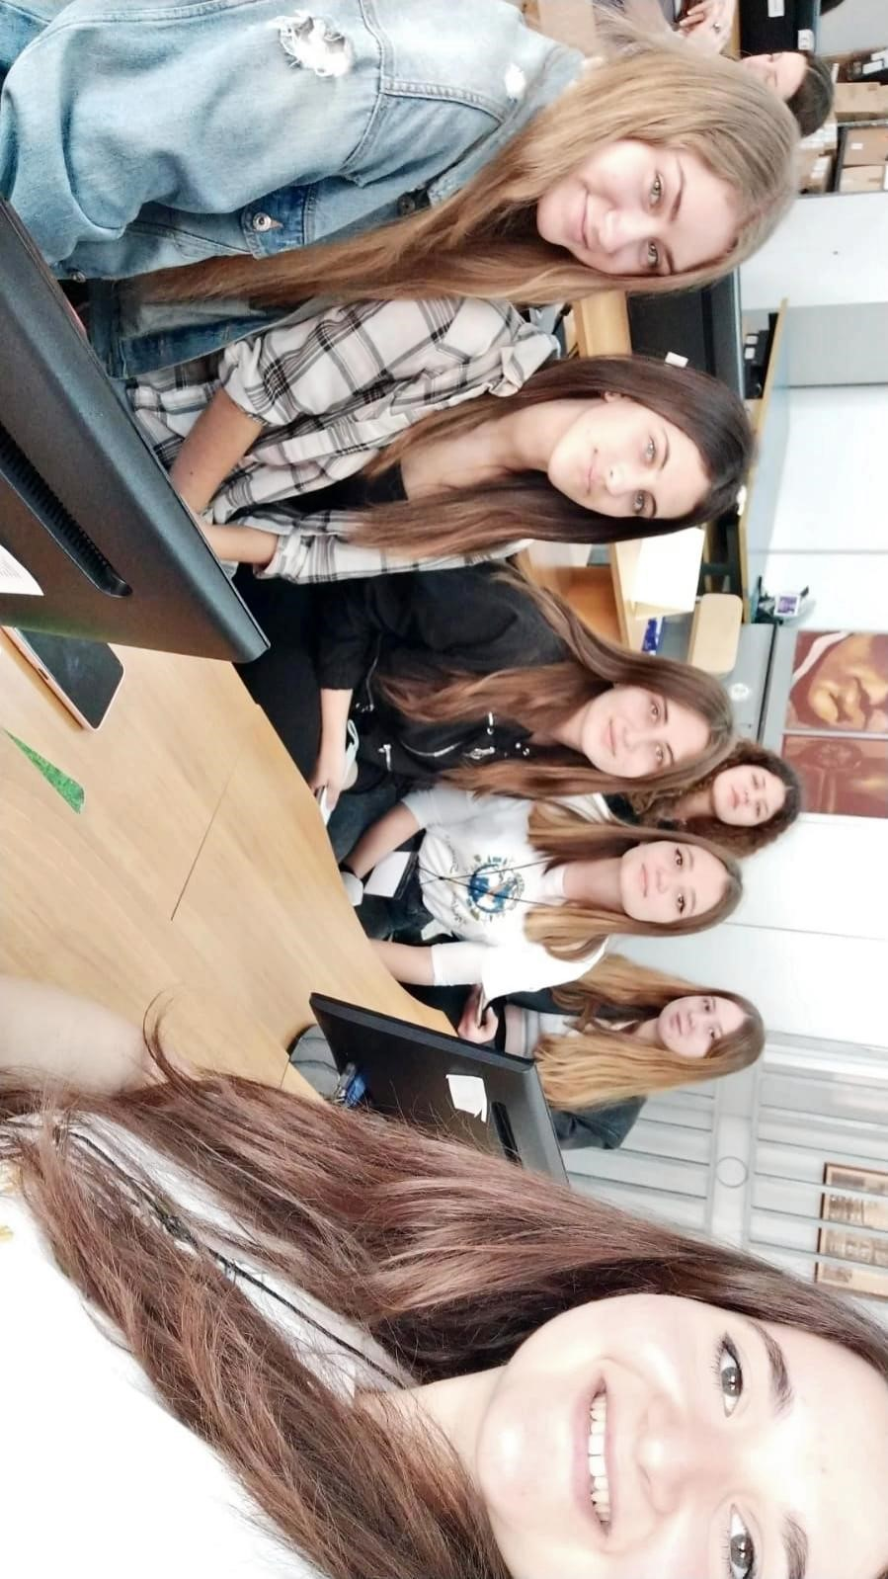
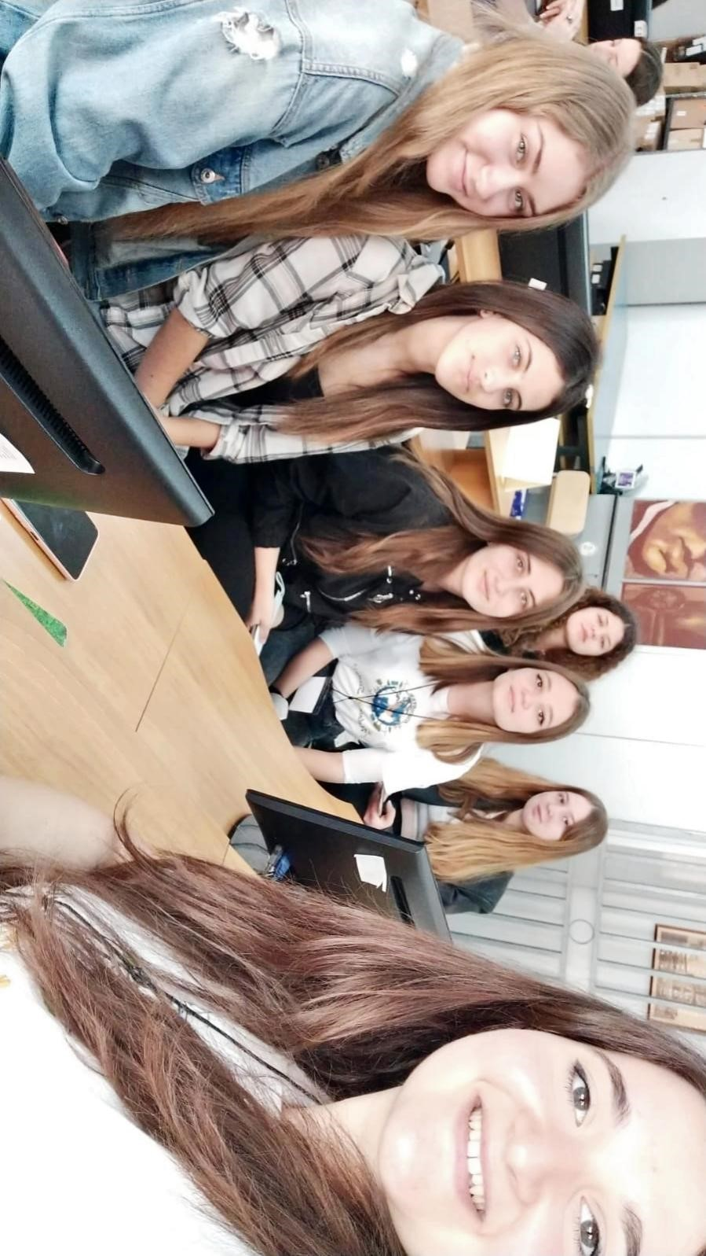
My favorite time was when we went to their school and made a post in canvas. It was my first time doing that, so it was really interesting for me, also all my group was trying to do their best and we got really close. In Sicily I found a lot of friends that I talk and text them very often, even now when I am in Cyprus. I hope I will visit them again.

Nina Papaioannou

