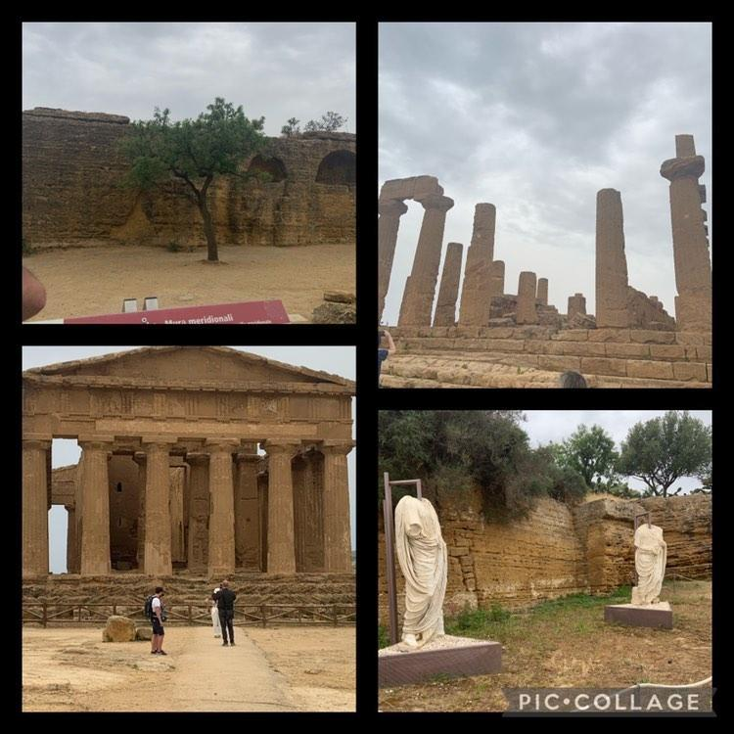

One of my favourite places in Sicily was the Valley of the Temples which is an archaeological park characterized by an exceptional state of conservation and a series of important Doric temples from the Hellenic period. The archaeological park contains among others:
1. Temple of Concordia
2. Temple of Juno
3. Temple of Hercules
4. Temple of the Dioscuri
5. Temple of Olympian Zeus
I found it so interesting because we learned about the history of Sicily and its connection with greek history and culture and i think it’s very important for us!
In Sicily i met new people… I loved them because they’re so kind and social. At first i was a little bit anxious, but then we became friends and I’m so grateful. They make me happy and this is really important for me. I love Erasmus because i had the chance to meet interesting new people and make new friendships!

Christina Charilaou

