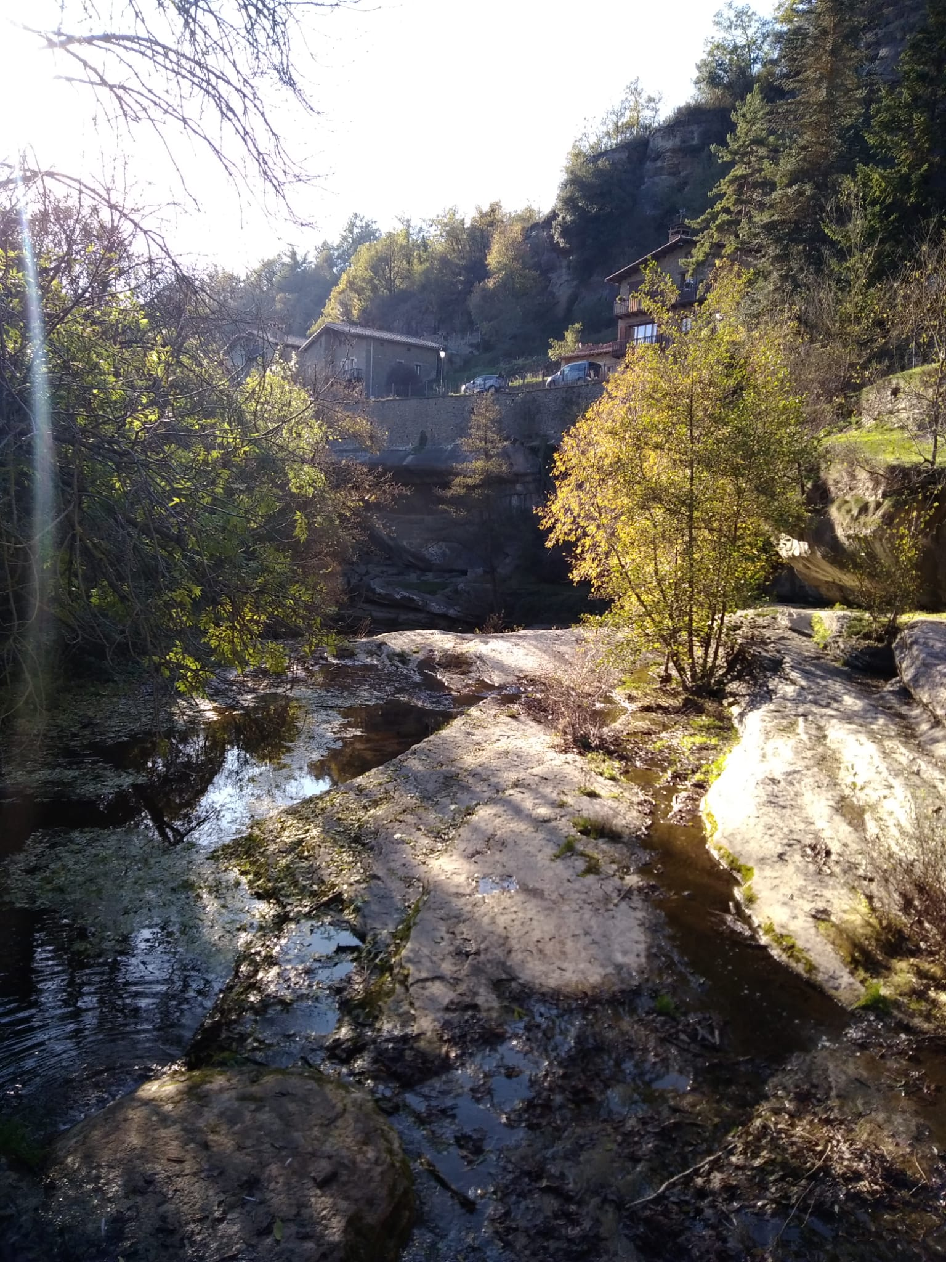
I loved this Erasmus experience!
I learnt lot of things about sustainable tourism and how it is the best way to respect the environment. I discovered new touristic places like Rupit, l’Avenc, Vic, l’Esquerda in Roda de Ter, Tavertet and I visited Barcelona for the first time. I adored these places and, one day, I will return there.
I really loved my host family, too. They were very nice and friendly people and welcomed me very warmly. Thanks to this Erasmus project, I met people from different countries and it was really interesting to find out similarities and differences among us, our countries and our cultures.
I truly think this experience has changed my life because it taught me how to adapt in different situations on my own and helped me becoming a more open-minded person.
I think everybody should take part in Erasmus projects like this to improve themselves and become better people.

Teresa Oglialoro
ITALY

