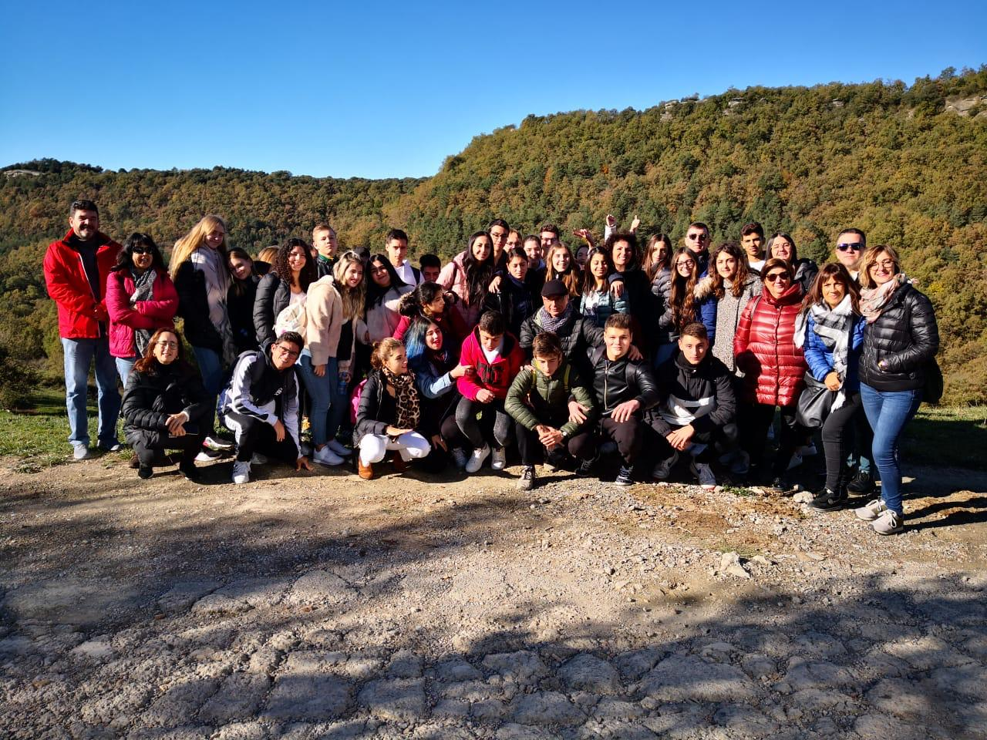
In this picture we are in Avenc . It’s a 16th century rustic farmhouse, and it’s an example of sustainable tourism because it uses natural resources in a more rational manner and minimises the environmental impact. Avenc tries to promote a more responsible form of tourism.
It was our first visit and I think this pic can represent perfectly my experience because we are all together like a real group.
Alice Costa
ITALY

