Erasmus + Smart schools for smart age
 | Sports school G. S. Rakovski  Dobrich, Bulgaria  Lesson 3:  Literature – Hristo Botev | 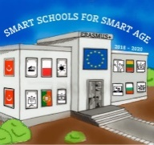

Lesson 3 HRISTO BOTEV
Class 7
Topic: HRISTO BOTEV.
Objectives:
- Introduction to Bulgarian writer Hristo Botev
- Introduction to the work of Hristo Botev
- Showing some of Hristo Botev's works

Resources:
- computer with internet access
- multimedia projector

Lesson source:
https://docs.google.com/presentation/d/1yPtHsKawnxQsdS9iiJMQLOFnaUJgx4bN/edit?usp=sharing&ouid=108790201128611252560&rtpof=true&sd=true

